EPON OLT Equipment

FD1216S/FD1208S User Manual
- EMS Software Part
Version：V1.0

Copyright ©2017 Shenzhen C-Data Technology Co., Ltd. All Rights Reserved.

No part of this manual may be reproduced or transmitted in any form or by any means without the prior written consent.

The information in this document may be update at any time due to product versions upgrade or any other reasons. Unless otherwise agreed, this manual is for reference only. All statements, information and recommendations in this manual do not constitute the warranty of any kind, express or implied.

Please contact your suppliers to get the latest version of this document.

About This Manual
This manual is applicable to C-Data FD1208S, FD1216S EPON OLT products,The contents of this document include EMS software installation and operation guidelines. Users should learn this document first when beginning to operate EPON OLT device.

The related documents for EPON OLT device are:
《FD1208S,FD1216S User Manual-Device Installation User Manual》
《FD1208S,FD1216S User Manual- CLI Operation User Manual》
《FD1208S,FD1216S User Manual- Configuration Guide》

Table of Contents
©Statement 2
About This Manual 2
1 Software Introduction 5
1.1 Software Information 5
1.2 Functional Features 5
2 EMS Software Installation 5
3 EMS Startup 6
3.1 EMS Server Startup 6
3.2 EMS Client Startup 6
3.3 login EMS 6
4 EMS Software Frame Introduction 7
4.1 Main Frame Overview 7
4.2 Device Management Window 9
5 Management Object Add/Delete 9
5.1 Location Add/Delete 9
5.2 Add/Delete Device 11
6 EPON OLT Management 13
6.1 OLT Chassis Management 13
6.2 Switch and Control Card Management 14
6.2.1 View System Status 15
6.2.2 OLT Management Configuration 16
6.2.3 OLT And ONU Upgrade Management 17
6.2.4 OLT Uplink Port Attribute Configuration 17
6.2.5 OLT Trunk (LACP) Configuration 19
6.2.6 OLT Port Mirror Configuration 21
6.2.7 OLT Mac Address Management 22
6.2.8 Uplink Port Broadcast Storm Suppression Configuration 24
6.2.9 OLT Port VLAN Management 26
6.2.9.1 OLT VLAN View 26
6.2.9.2 OLT VLAN Modify 27
6.2.9.3 OLT VLAN Add 28
6.2.9.4 OLT Port VLAN Configuration 28
6.2.9.4.1 OLT Access Mode VLAN Configuration 31
6.2.9.4.2 OLT Trunk Mode VLAN Configuration 32
6.2.9.4.3 OLT Hybrid Mode VLAN Configuration 33
6.2.9.5 OLT Translation Mode VLAN Configuration 35
6.2.9.6 OLT QinQ Mode VLAN Configuration 36
6.2.10 OLT IGMP Management 39
6.2.11 OLT STP Management 46
6.2.11.1 STP Global Config 47
6.2.11.2 STP Port Set 48
6.2.12 ACL Management 50
6.2.12.1 Configure ACL rule 50
6.2.12.1.1 Basic ACL Configuration 50
6.2.12.1.2 Advance ACL Configuration 52
6.2.12.1.3 Link ACL Configuration 54
6.2.12.2 View OLT ACL Rule 55
6.2.12.3 View OLT Port Applied ACL Rule 56
6.2.13 OLT QoS Configure 56
6.3 OLT PON Card Management 59
6.3.1 OLT PON Port Basic Management 60
6.3.2 PON Port Broadcast Storm Suppression 61
6.3.3 ONU Registration Authentication 62
6.3.4 View OLT PON port optical Power Information 72
6.4 Single PON Ports Manage 73
7 ONU Device Management 76
7.1 ONU Device Management Introduction 76
7.2 ONU Basic Information Management 77
7.2.1 ONU Indicator Status 77
7.2.2 ONU Basic Information View 77
7.3 ONU PON Port Optical Power Information 78
7.4 ONU Capability Information 79
7.5 ONU Sla Configuration 80
7.6 ONU Port Configuration 82
7.7 ONU Port Rate Limit Configuration 83
7.8 ONU Port VLAN Configuration 84
7.9 ONU IGMP 90
8 Operation Logs Management 92
9 Alarm Logs Management 94
10 Database Backup And Restore 96
11 User Management 97
12 Device Upgrade 98
13 Device Search Function 99
14 End 101

Software Introduction

Software Information
EMS (Element Management System) software is a C/S architecture integrated
device management platform, which is designed based on SNMP protocol. Now, it
is mainly used for managing EPON ang GPON series products.
EMS need following runtime environment：
➢ OS： Windows2000、 Windows XP、 Windows NT
Hardware： CPU 2.4GHz , 512M memory
➢ Software： JAVA 1.5, MySql 5.0

Functional Features
EMS software has following main features:
- Based on standard SNMP protocol
- Support multiple client access, C/S architecture
- Support integrated management all our EPON series products
- Support auto topology or modify manually, and multi-layer map view
- Support configuration operation on all EPON products functions
- Support multiple level operation authority
- Real-time and history alarm record view, search and save
- Operation history record trace and save
- Use independent database and support data backup and import
- Support performance monitor and traffic counters statistic
- Support third-party database platform

EMS Software Installation
After the release of EMS V2.4.1, EMS software has been able to integrate the database software into a single file by default, so as long as the EMS is installed, the corresponding database software is also installed simultaneously.if your computer have installed the database software,you doesn’t need to uninstall, it doesn’t matter to the EMS software installation.
It’s easy to install EMS,Click ‘Next Step’,and you will finish it.
Finish the installation of EMS , you will find two Shortcuts in the installation directory or desktop for server and client, typical Shortcuts as follows:
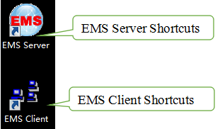
Note:Finish the installation of EMS, you can start it directly.

EMS Startup
The architecture of EMS is C/S (Server and Client), Server and Client. You should start Server program before start Client program.

EMS Server Startup
Run the EMS Server program,we will find icon after the Server runs successfully , icon as follows:
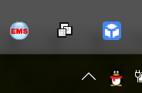
Note:EMS Server startup time is not longer than 30 seconds. If the program runs more than 30 seconds means the program doesn’t start properly.

EMS Client Startup
Run the EMS Client program After the EMS Server starts. We can run EMS Client and EMS Server on the same computer, also can run on two independent computer, as long as two computer’s network communication.
Note:To ensure the operating performance of the software, it is recommended that the Server and Client be installed on the computer with same LAN or the same computer.
After the Client has started successfully, the login page as follows:
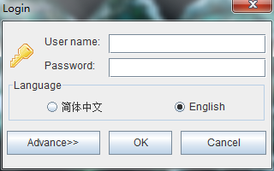.

login EMS
If the Server and Client are installed on the same computer, enter the user name and password and login directly. If the Server and Client are installed on different computers, you must click the ‘Advance’ and configure, page as follows:

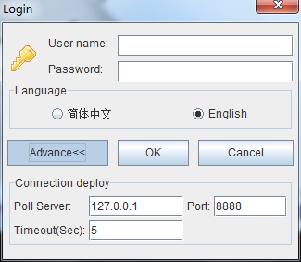
Configuration as follows:change poll server’s ip same to the server’s ip which start EMS server, port and Timeout Keep the default.
Note:The default user is "admin", password is "1234"for client to login.
After login the Client successfully,you will see the main page. The typical page follows:
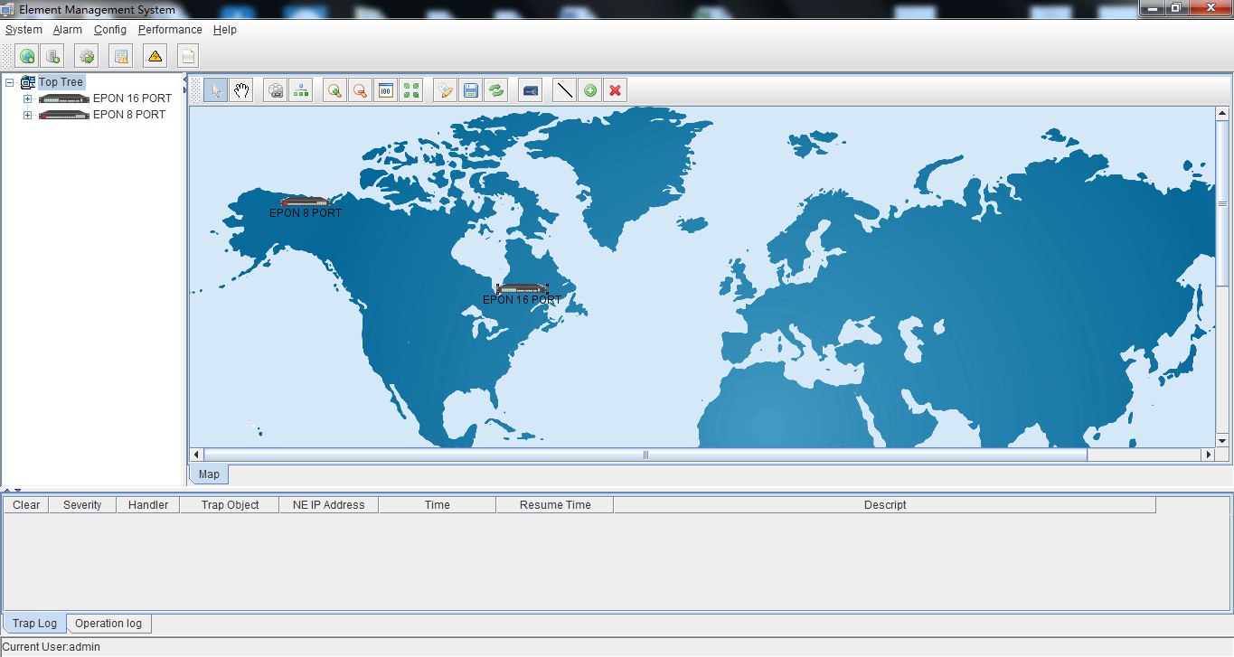
At this point, EMS software server and client programs have been started normally.

EMS Software Frame Introduction

Main Frame Overview
After successfully login, software comes to main frame. Following is a typical page.
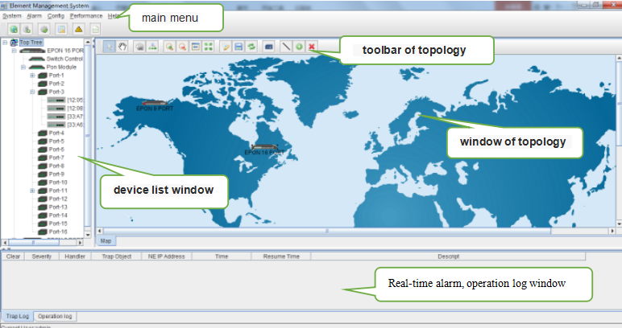
As shown above, the EMS client main window is divided into the following sections:

Main menu:
Main menu contain System, Alarm, Configure,Performance and Help parts. Their main features are as follow:
- System Menu
Including System Configuration, MIB Browser,Database Maintenance and User Manage, etc.
- Alarm Menu
Alarm Query, Configure Trap Rule and System Log are within this menu.
- Configuration Menu
Top-tree update, device add/delete, device configuration, map update and device upgrade features are located in this menu.
- Performance Menu
Including performance monitor and alarm threshold configuration.
- Help Menu
Change software skin, language and About information.

Device list window
The device list window shows all the devices under management currently. The device list can directly observe whether the device is online, whether there is an alarm, and double click device can enter into the management window of the device.
The EPON/GPON OLT device has 5 management object in the device list window,the machine box, exchange control module, PON module, PON port and ONU level.

Windows of topology
Windows of topology is the main display area of the EMS software, according to the management device, user can move device to right postion on regional background map for visual management. Double click the device object on the topology diagram, you can enter the device management window to perform various operations on the device.
The administrator can add or modify the passive network part of the topology diagram manually,such as the optical shunt in EPON/GPON network, to make the topology same to the actual network layout.

Real-time alarm,operation log window
The real-time alarm window shows the abnormal alarm information of the current management device, such as alarm object, alarm time, alarm content, etc.
The operation log window records all the operations of the EMS,so it’s convenient to trace who has operated it.

Device Management Window
For device management, EMS is mainly through the corresponding device EPON OLT User Manual-EMS Software management window to operate. Through the Configuration menu or double click the device icons located on Top-tree or topology map, manager can open the device management windows. Following are several typical examples:
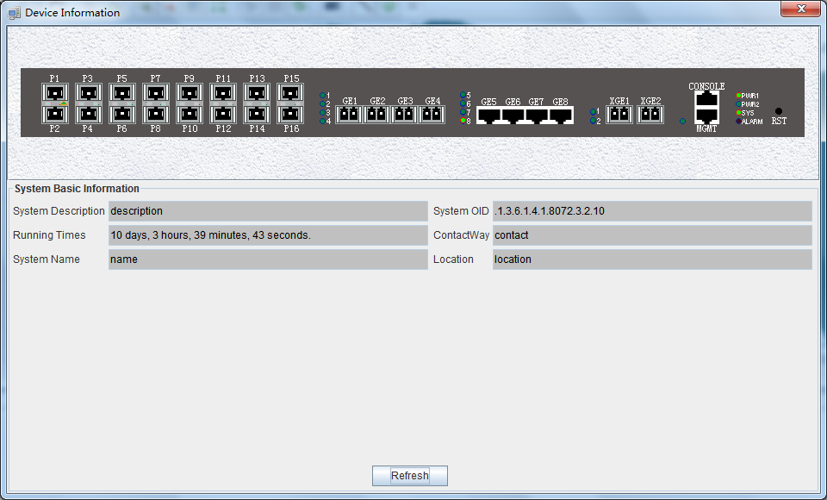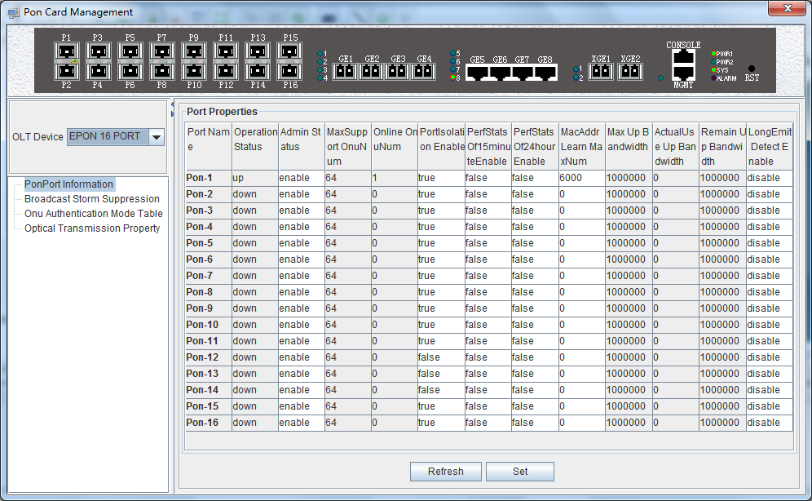
Device Basic Information Windows PON Card Windows
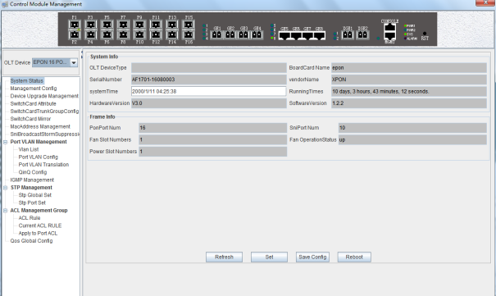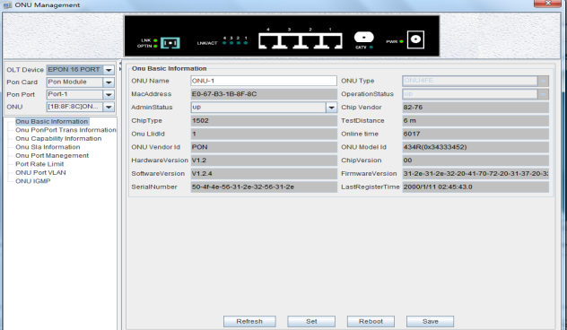
Switch and Control Card Windows ONU Management windows

Management Object Add/Delete

Location Add/Delete
For convenience of managing numerous devices, divide them in different regions according to their deployed locations is normally needed. According to following steps to divide management regions:
1) Add a Location node on the Top-tree list. Showing as follows:
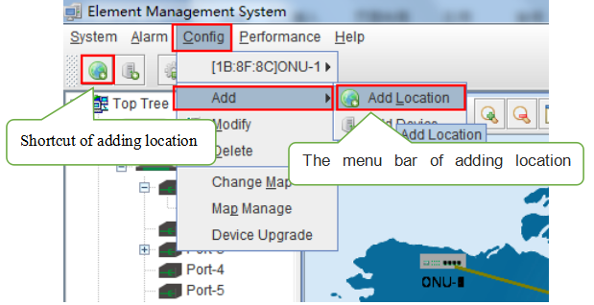
As above figure, through ‘Add Location’ menu or its shortcut, open add location operate window, as following:
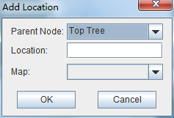
Operation steps:
i. Select the parent node for new added node;
ii. Input the name of new node;
iii. Select map for the new location node (The map should be upload first), when select this node on top-tree, the topology area will apply this map;

2)Location node delete
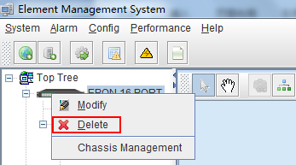
As above figure, right click the selected location node and delete it.

Add/Delete Device
Note:Before using EMS to manage an EPON device, you need to login OLT system to enable SNMP functions and to configure the read-write community, read the community is public, and write community is private.
Configuration and view commands are as follows: (see cuser Manual- CLI Operation User Manual for more relevant configuration view commands)
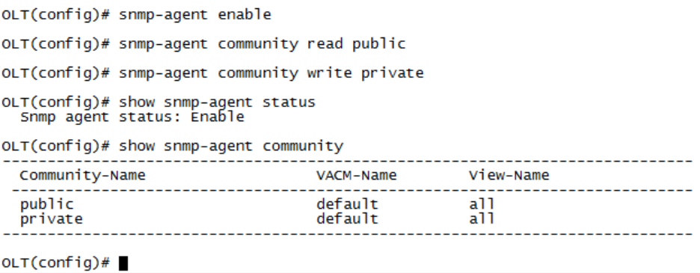
Next, you need to add the device on the EMS manually, and the operation of adding an EPON device is as follows.
1)Add OLT
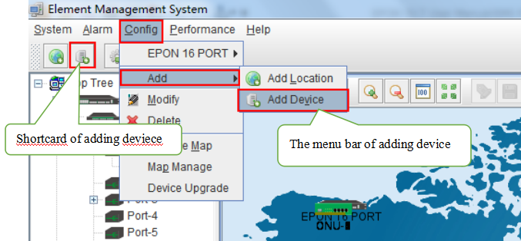
As above figure, through ‘Add Device’ sub-menu or its shortcut to open the device add window and add device. As shown in the figure below:
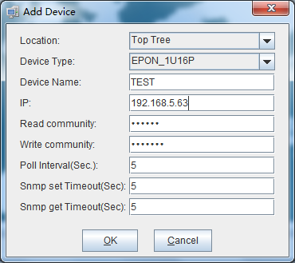
As above figure, the new added device need configure following parameters:
- Location
Select the location node where the added device should be located.
- Device Type
Select the device type for the new added device. EMS can manage EPON OLT and other EPON products. So, it is needed to select correct device type. Select EPON_1U type for FD1108S OLT device.
- Device Alias
In order to recognize the managed device easily, a suitable alias is normally needed instead of IP Address or MAC Address. This device alias will be displayed on top-tree list.
- IP Address
Input the management IP Address of the new added element device, which can be in-band or out-band IP Address.
- Read and Write Community
EMS software is designed based on SNMP protocol to communicate with managed devices. Read and write community is used by SNMP protocol as access password. Community value input here should be the same with which configured in managed device, such EMS can communicate with the managed device successfully.
- Polling Interval and SNMP Read and Write Timeout Value
EMS software will poll the managed device periodically with a configured time interval. Normally, the poll interval can use the default value. SNMP read and write timeout values are the longest wait time for EMS to wait response from managed device. Usually, the default value is suitable. Manager can also revise these values according to the real network performance situation.
When the above parameters are configured, click OK button to finish the device add operation. When success, the new added device’s icon will appear on top-tree list and topology area. Showing as following figure:
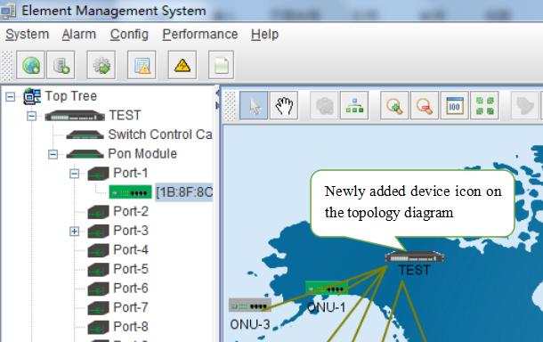
Note: For EPON OLT device, only the chassis node need to be added manually,other part such as equipped card and accessed ONU device need not to be added. These devices will be detected automatically.
- Delete OLT
Obsolete or unwanted device on top-tree list can be deleted from EMS. Right click on the selected device icon and select Delete option to delete a device.
Note：
i. Deleted device can’t be restored and need to be added when need.
ii. All the information of the deleted device will also be removed from EMS.
iii. None any configurations on the deleted device itself will be changed.

EPON OLT Management
OLT device mainly consists of OLT chassis, exchange control module, PON business module and PON port.The following sections describe the management of EMS software for these parts.

OLT Chassis Management
Double click the OLT chassis icon to open the chassis management window. Typically as following figure：
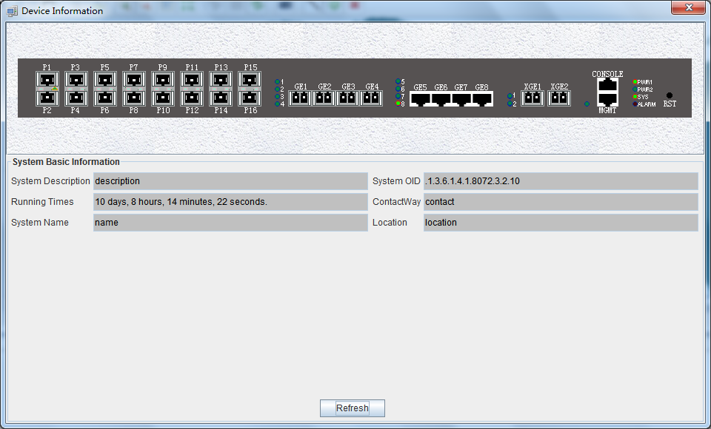
OLT chassis management includes following several parts.
Front Panel
The equipment panel parts display the power supply of the machine box in real time and the status of each port indicator light. The meaning of the indicator is subject to the panel label.
When EMS can’t connect with the OLT the windows will change to gray color.
Basic Information
This section shows the system description, system OID, running time,contact information, system name, location and other basic information. click "refresh" button can refresh the above information.

Switch and Control Card Management
Double click 'Switch Control Card' icon on top-tree list to open the 'Control Module Management' window . Typical as following figure:：
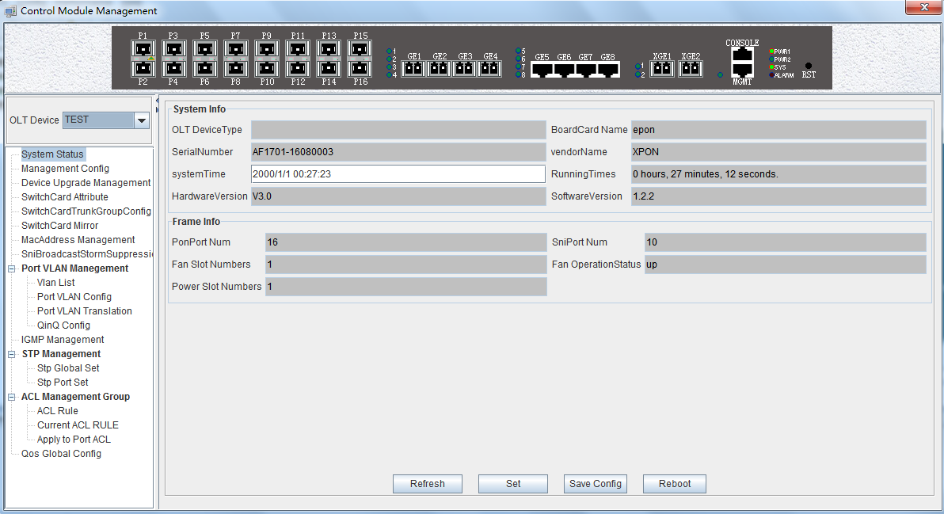
Following management features are contained on this window:
- view or set device basic information；
- view or set the IP address, the trap address, SNMP management parameters and etc;
- upgrade OLT and ONU device;
- view and set the upper connection port, such as the admin status of port, and the port rate;
- Swap TRUNK functionality (link aggregation) configuration;
- MAC address table management;
- Upper port storm suppression management;
- OLT port VLAN configuration management;
- OLT igmp configuration;
- OLT STP configuration;
- ACL management configuration;
- QoS configuration;
Following sections in this part introduce the management features contained on the switch and control card management window.

6.2.1 View System Status
Double click the 'Switch Control Card' icon on the left side of the main page to open the 'Control Module Management' window and enter the 'System States' to view the page.
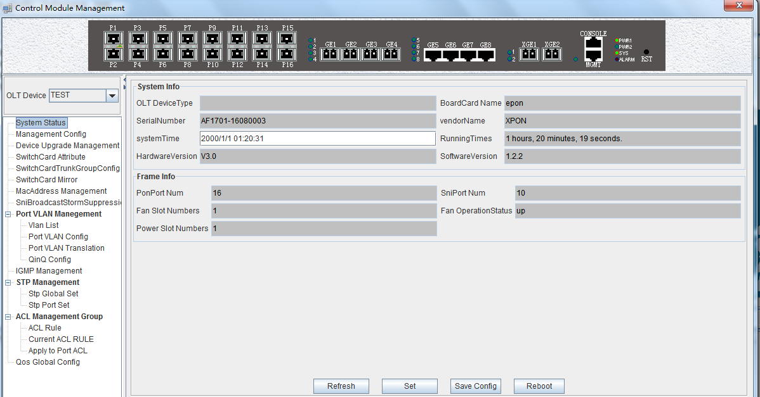
System info
Display Board card name, serial number,vendor Name,system time, software and hardware version number, device running time and other information.
Frame info
Display pon port number,sniport number,fan slot numbers,and fan operation status.
Save config
The button of ‘Save Config’ is mainly for saving all configuration of OLT.
Reboot
Click ‘Reboot’ button,and OLT will reboot.
Set
The button of ‘Set’ is used for setting system time.

6.2.2 OLT Management Configuration
Double click the 'Switch Control Card' icon on the left side of the main page to open the 'Control Module Management' window and enter the 'Management Config' page:
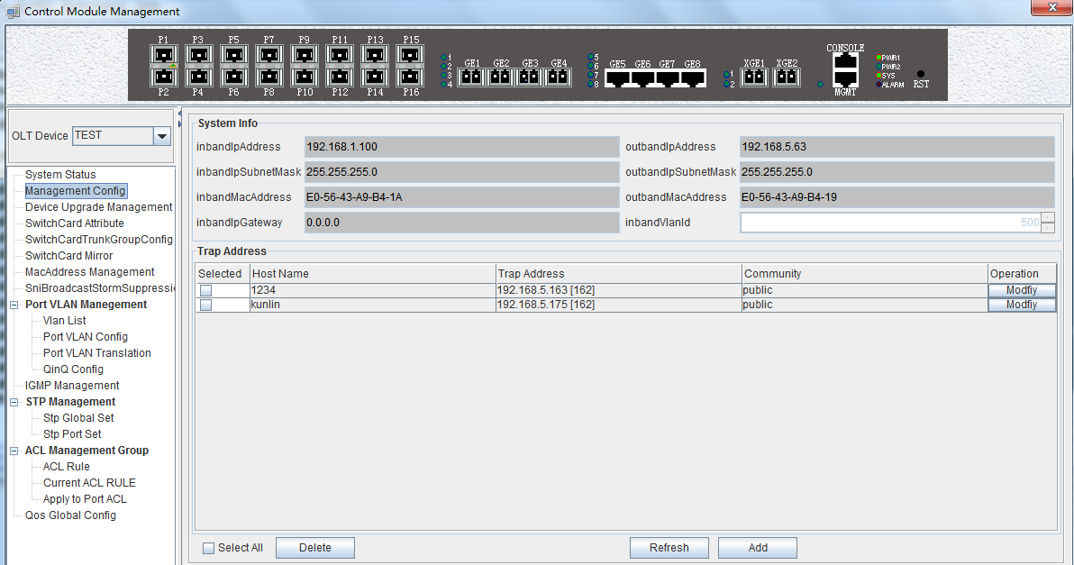
System info
View inband ip address,outband ip address, netmask , getway , inband VLAN.
Instructions:
- Inband management comes from upper port and needs to add management VLAN for upper port.
- Outband management comes from MGMT port and needs to add ip for MGMT port.
- Normally, modify the IP of management and device parameters, EMS will lose connection with device, user need to modify management ip of device in EMS,only in this way,can we connect device again.
Trap address
Alarm receiving address is the destination IP address which alarm information sent to, when the alarm occur, OLT will sent Data Packet of ‘SNMP TRAP’ to the management PC,usually,trap address is same to the PC’s ip which start EMS,Users can set four trap addresses mostly.
[Example of onfigure trap address]
Example:configure trap information as follows:host name is 1234,Alarm reception address is 192.168.5.135，The alarm port is 162，community is public.
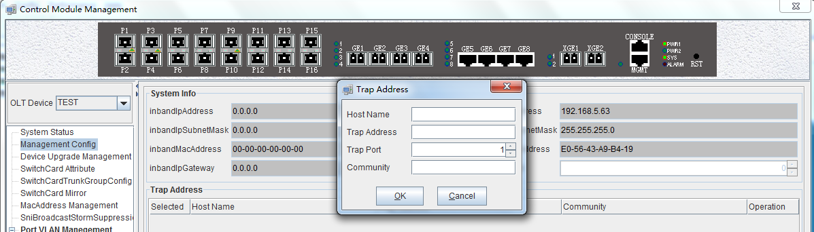

6.2.3 OLT And ONU Upgrade Management
Double click the 'Switch Control Card' icon on the left side of the main page to open the 'Control Module Management' window and enter the 'Device Upgrade Management' page.
The configuration management interface can upgrade the software of OLT and ONU.
Note: before upgrading, you need to ensure that there is an upgrade file. The FTP server can connect with OLT.
[Example of upgrade]
Example:Upgrade firmware via FTP server,which ip is 192.168.5.153
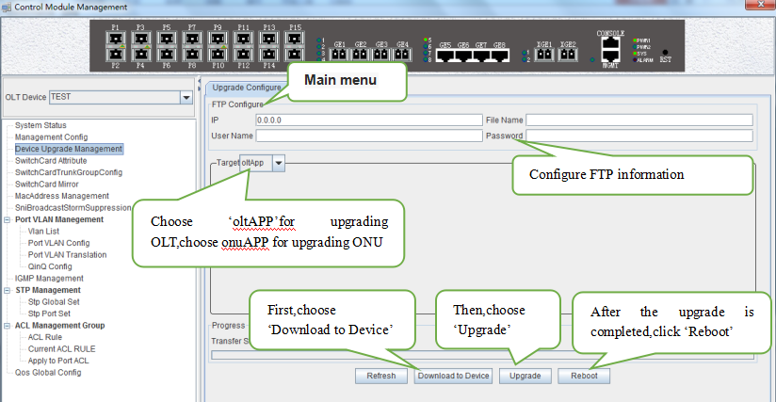

6.2.4 OLT Uplink Port Attribute Configuration
Double click the 'Switch Control Card' icon on the left side of the main page to open the 'Control Module Management' window and enter the 'Switch Card Attribute' page.
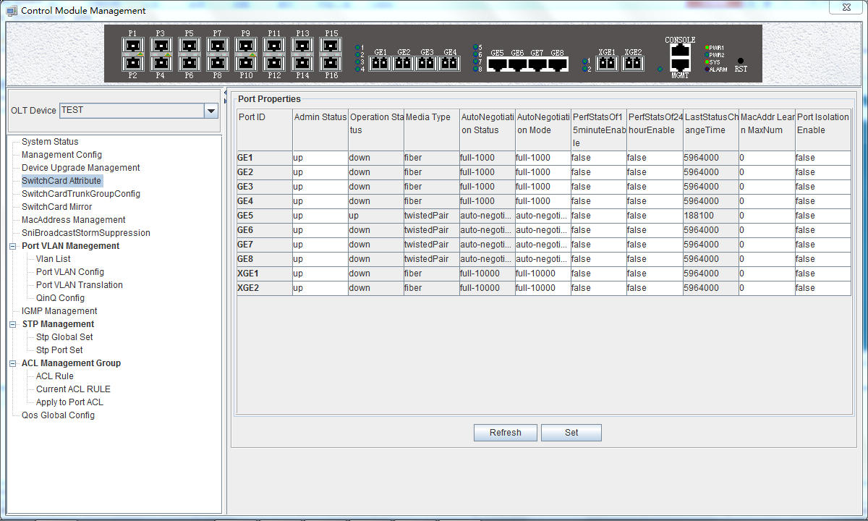
The ‘Switch Card Attribute’ management page is mainly used to configure and view the attribute parameters of OLT 's uplink port (GE photoelectric port and 10GE uplink port). The parameters are described as follows:
- Admin Status
Set up the uplink port state to enable or disable. When the port is set to 'Up',the port is opened and when the port is set to 'Down', the port is closed, 'testing' status is not available currently.
- Operation Status
Displays the current link state of the uplink port, when the uplink port connect with the end devices, the operation state is displayed as 'Up '; when the uplink port disconnect with the end devices, the operation state is displayed as 'Down ', and the running state only shows but can’t be configured.
- Media Type
Show the media type of the uplink port, the default interface of ge1-ge4 is the optical interface, and the media type is shown as 'Fiber'.the default interface of ge5-ge8 is the electrical interface, and the media type is shown as 'Twisted Pair '; XGE1 and XGE2 are uplink port of 10GE.
- Auto Negotiation Status
Display the uplink port rate of duplex mode, 1000M full duplex, 100M full duplex, 10M full duplex and auto negotiation status.
- Auto Negotiation Mode
Configure the uplink port rate of duplex mode, 1000M full duplex, 100M full duplex, 10M full duplex and auto negotiation status.
- PerfStats Of 15 minute Enable
Configure PerfStats Of 15 minute Enable of uplink port,’False’ means stop properties statistics of every fifteen minutes on uplink port.’True’ means start properties statistics of Every fifteen minutes on uplink port.
- PerfStats Of 24 hours Enable
Configure PerfStats Of 24 hours Enable of uplink port, ‘False’ means stop properties statistics of every 24 hours on uplink port. ‘True’ means start properties statistics of every 24 hours on uplink port.
- Last Status Change time
Show the change cycle of properties statistics time, and the time of properties statistics change every 300ms.
- Mac Addr Learn Max Num
Limit the number of MAC addresses (0-8092) that are permitted to pass by the uplink port, set to '0' means no limit,set to '1-8092' to limit the number of MAC addresses which permitted to pass by the uplink port.
- Port Isolation Enable
Set up data isolation or not between one uplink port and others. ‘False’ means uplink port can access to each other. ‘True’ means uplink port can access to each other.

6.2.5 OLT Trunk (LACP) Configuration
The device supports the link aggregation protocol,lacp for short, which conforms to the IEEE802.3 ad standard. The lacp protocol is used to bundle multiple uplink ports together to form a single logical connection to increase the bandwidth of the link and realize backup functions of uplink port,which means when a port is broken, other ports can still communicate.
Double click the 'Switch Control Card' icon on the left side of the main interface to open the 'Control Module Management' window and enter the 'Switch Card Trunk Group Config' page.
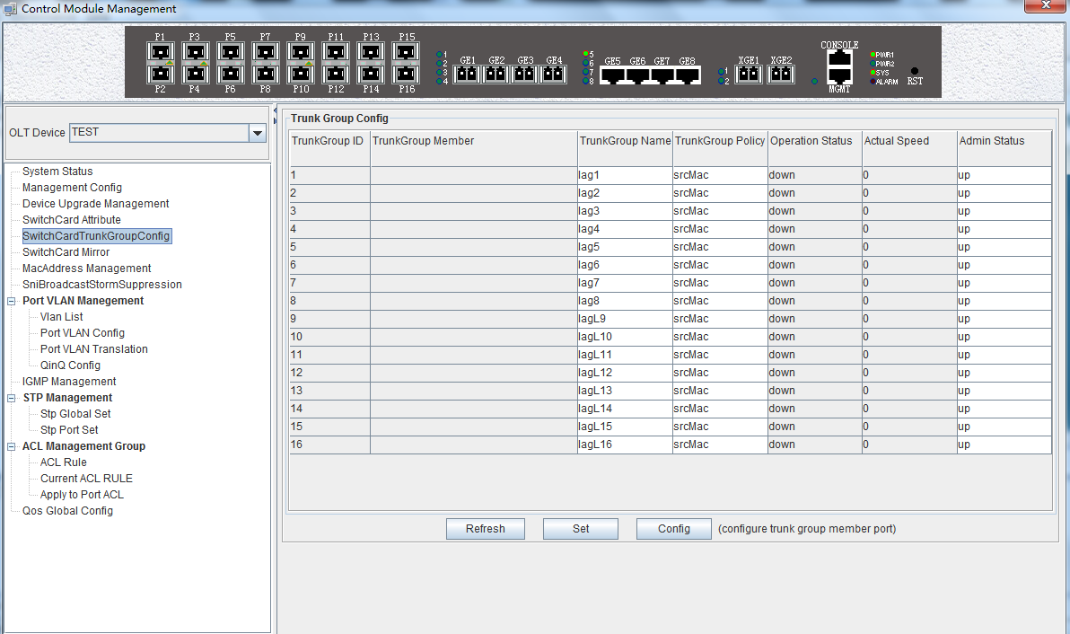
The features of EPON OLT lacp are as follows:
- Link aggregation function is mainly applied to all uplink port;
- The def ault aggregation group is 16;
- All port can be added to a aggregation group ;
- Support several equalization algorithms based on the source and destination MAC address, source and destination IP address;
- Each port can be assigned to only one aggregation group and cannot be assigned to multiple aggregation groups at the same time.

Lacp Function parameter on EMS are as follows:
Trunk Group ID
Show number of link aggregation groups available by default on OLT, default number is 1-16,link aggregation groups can’t be added, only can modified and configured on the default link aggregation group.
Trunk Group Member
Show which uplink port members are already in the link aggregation group.
Trunk Group Name
Name and set the link aggregation group.
Trunk Group Policy
Select a strategy of link aggregation negotiation, which can be negotiated in several ways, such as the source and destination MAC address, source, and destination IP address.
Operation Status
Show the configuration state of the link aggregation group , the 'Up' indicates that the configured link aggregation group is successful and has take effect, 'Down' indicates that the configured link aggregation group is unsuccessful and hasn’t take effect.
Actual Speed
Shows the current negotiation rate of the link aggregation group.
Admin Status
Configure the management status of the link aggregation group and configure 'Up' to run the link aggregation group; Configure 'Down' to not run the link aggregation group.

[Example of link aggregation configuration]
Example:Add ge1 and ge3 to link aggregation group 1, named 1234, with source MAC and destination MAC nagotiation.
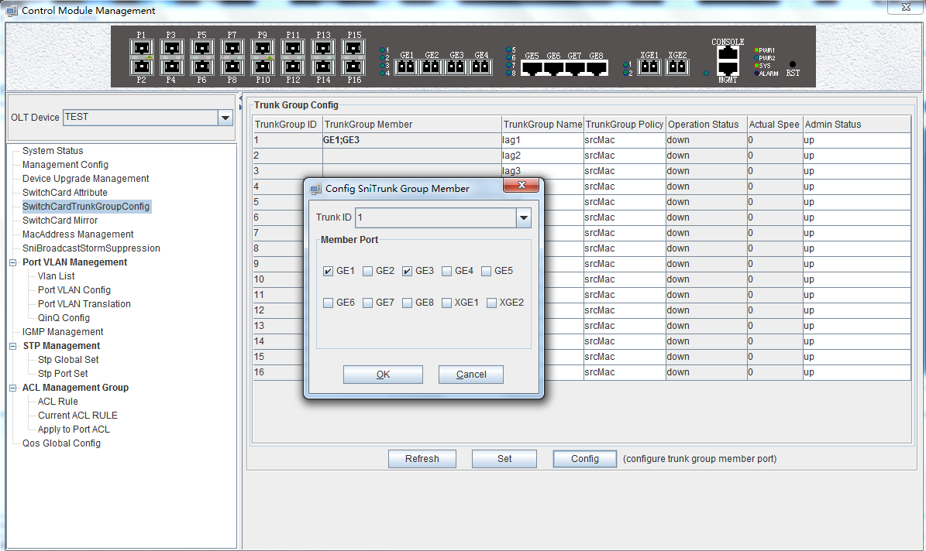

6.2.6 OLT Port Mirror Configuration
Port mirror function is that copy the message of Source port to other port (destination port), the user can monitor the message which copy to the destination port to monitor network and debug. All uplink port and PON port can be set to source or destination ports.
Double click the 'Switch Control Card' icon on the left side of the main page to open the 'Control Module Management' window and enter the 'Switch Card Mirror' page.
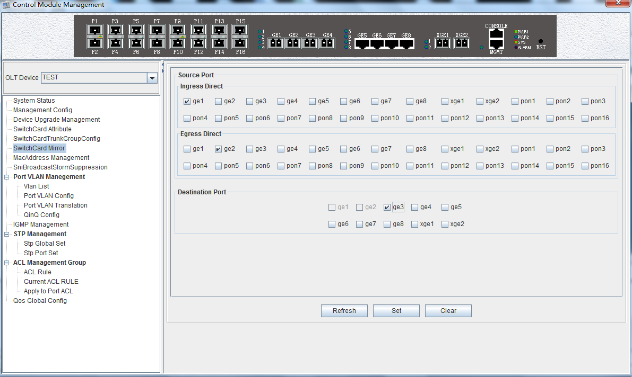
Source port
Specify the source port that needs to be captured and analyzed. User should know the concepts of 'Ingress Direct' and 'Egress Direct' first :
'Egress Direct' means the direction of the message leaving the port; ‘Ingress Direct’ means the direction which the message enters the port.
When only one direction is checked, OLT will copy message of one direction to the destination port. When both directions are selected, all message are mirrored to the destination port.
Destination port
The port that receives message of the source port.
The configuration of the port image is as follows:
1) select the source port. Port1 ~ Port16 can be selected as the source port, each port has 'Ingress Direct’ and 'Egress Direct'. The former refers to the port which receive message, The latter refers to the port which sent message.
2) specify the destination port. You can specify one of the ge1 ~ ge8 ports as the destination port, and all source port data will be forwarded to the specified destination port.

[Example of port mirroring configuration ]
Example: check ge2 in the 'Ingress Direct' and 'Egress Direct' and select ge8 in 'Destination port' then click 'Set' button. All traffic of ge2 are mirrored to ge8 port.
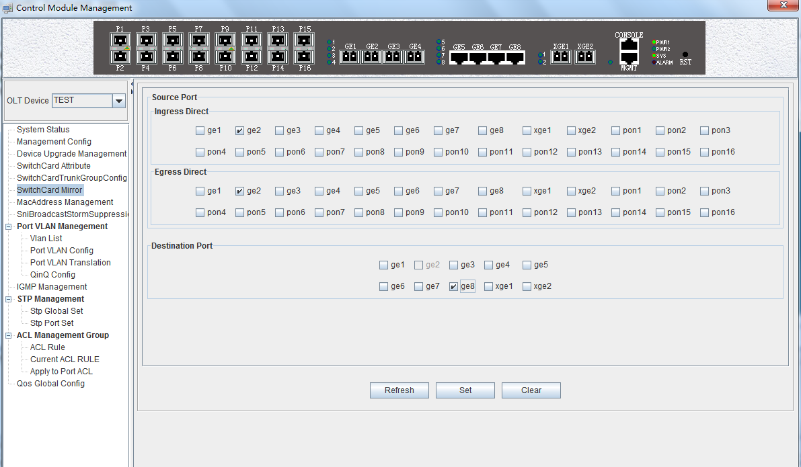

6.2.7 OLT Mac Address Management
Double click the 'Switch Control Card' icon on the left side of the main page to open the 'Control Module Management' window and enter the 'Mac Address Mangement' page.
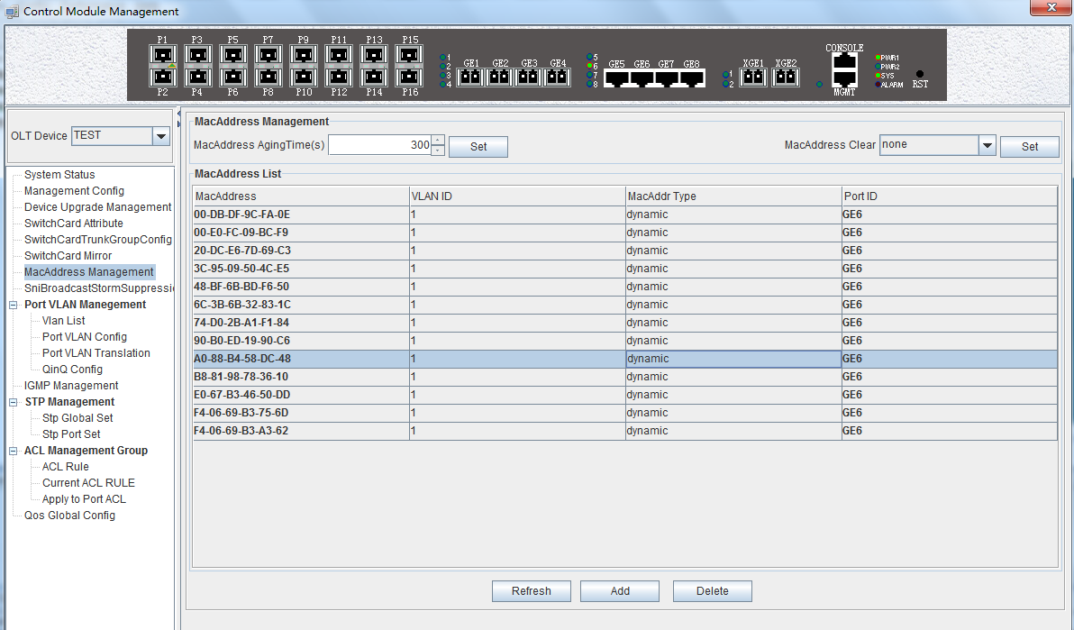
MAC Address Management
MAC management interface can configure OLT’s mac address aging time and clear MAC address, view the MAC address information which OLT has learnd, including MAC address, VLAN ID, type of MAC address, port ID, parameters are as follows:
- Mac address aging time
Set OLT's MAC address aging time. The MAC address that OLT learned will be cleaned automatically after this time.
- Mac address clear
Choose a type of mac addresss in ‘Mac Address Clear’ then click the the ‘Set’ button, the MAC address of the specified type will be clear.
Mac Address List
The MAC address list mainly displays the MAC address that have learned by OLT, including the VLAN of the MAC address, the type and the port where the MAC address is learned.
Click the ‘Add’ button to bring up a window of ‘Add MAC’. We can add static MAC address, the parameters we can view or configure in the MAC address listare as follows:
- Mac address
Display the MAC address learn from the uplink port,the PON port, and static MAC address we configure manually on OLT.
- Vlan ID
Display the vlan of mac address which from uplink port or pon port and the the vlan which we set for static mac address.
- MacAddr Type
There are three options, static, blackhole, and dynamic.
Static represents a static MAC address. As long as the source MAC address of the message matches this static MAC address, you can use the port.
Blackhole represents the black hole of the MAC address. If the source MAC address of the message is matched with this MAC address, it is discarded and not allowed to be circulated.
Dynamci represents the MAC address learned dynamically by OLT.
- Port ID
Show the port which MAC address learned from.

[Example of static MAC address configuration ]
Example: Configure a static MAC address "00-11-22-33-44-55" on OLT, and forward it from the vlan500 in ge1.
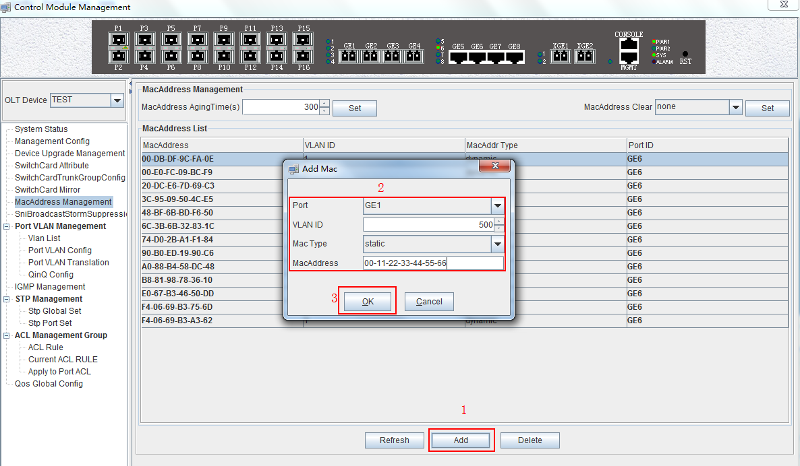

6.2.8 Uplink Port Broadcast Storm Suppression Configuration
Exchange storm suppression is mainly to enable the uplink port to suppress unicast storms, multicast storms and broadcast storms to prevent these storms from adversely affecting the current network environment.
Double click the 'Switch Control Card' icon on the left side of the main page, open the 'Control Module Management' window, enter the 'SNI Broadcast Storm Suppression' management page configuration.
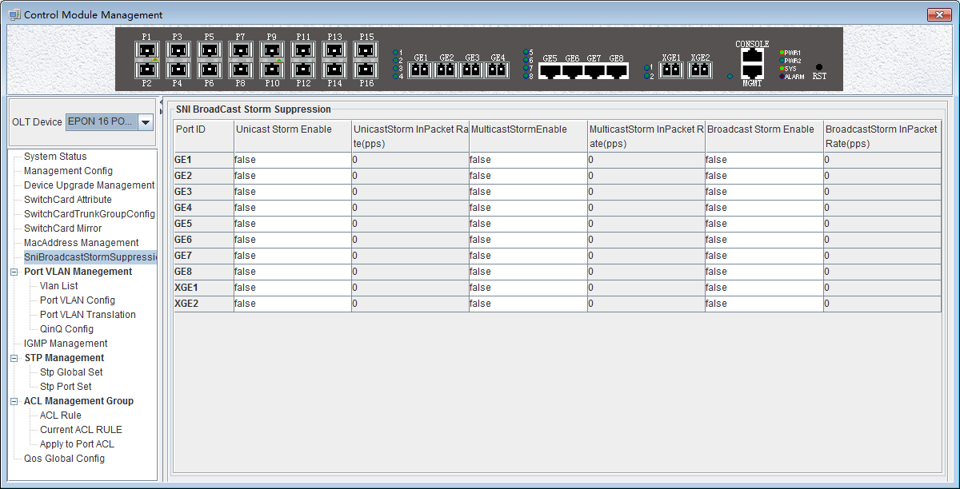
Exchange broadcast storm suppression support 'Unicast Storm Enable', 'Multicast Storm Enable' and 'Broadcast Storm Enable' three functions. There are several checkbox above.
- Unicast / multicast / broadcast storm suppression enabled
When ‘True’ is selected, the unicast / multicast / broadcast storm suppression function of the port is enabled.
When ‘False’ is selected, the unicast / multicast / broadcast storm suppression function of the port is disabled.
- Unicast / multicast / broadcast inpacket rate
This option can be configured with traffic limit values, which can be between 1-1488100 pps.
【Example of storm suppression configuration】
Example: The unicast storm suppression function is set to True and the unicast inpacket rate is 5000 pps. The multicast storm suppression function is set to True and the multicast inpacket rate to 1000 pps. The broadcast storm suppression function is set to True and the broadcast inpacket rate to 2000 pps. Click 'Set' button after the configuration, a prompt window will pop up and click the 'OK' button to complete the configuration.
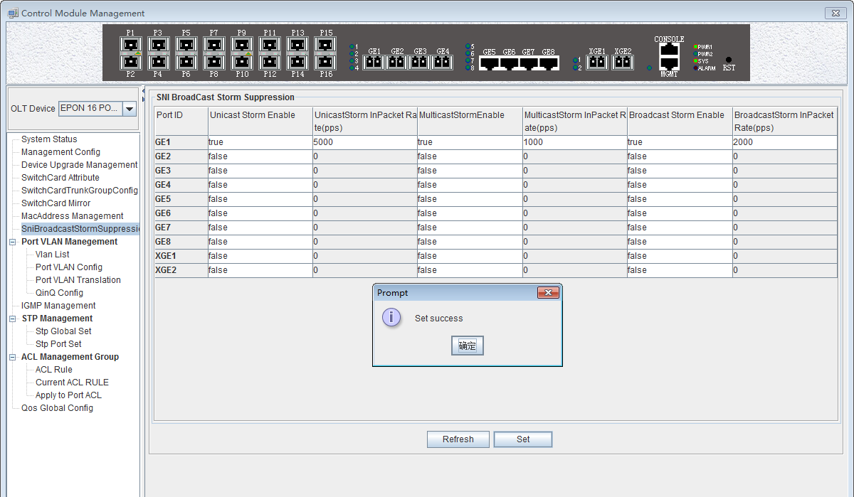

6.2.9 OLT Port VLAN Management
VLAN (Virtual Local Area Network), is a kind of based on user demand (functions, departments or applications, etc.) logically divided the LAN into multiple segments without considering the physical location of the virtual network technology. VLAN technology allows a network administrator to divide a physical network into different logical segments (VLAN), each containing a set of devices with the same requirements.
The advantage of VLAN technology is that the broadcast and unicast traffic within VLAN will not be forwarded to other VLAN, thus helping to control network traffic, simplify network management and improve network security.
The VLAN configuration of the OLT EPON system is divided into the VLAN configuration of the OLT and the VLAN configuration of the ONU part. The VLAN management of the ‘Switch Control Card’ section refers to the VLAN configuration and management of the OLT part.
The VLAN function of the OLT part of the EPON device is as follows:
- Support Port-based VLAN and IEEE802.1Q VLAN.
- Support full 4K VLAN group, VID range 1~4095.
- VLAN 1 is the system reserved VLAN, it includes all switch ports, all ports is UNTAG mode.
- All switch ports, including uplink ports and downlink ports support VLAN Partition.

6.2.9.1 OLT VLAN View

Double click the ‘Switch Control Card’ icon on the left side of the main page, open the ‘Control Module Management’ window, and enter the 'VLAN List' page. Typical page is as follows:
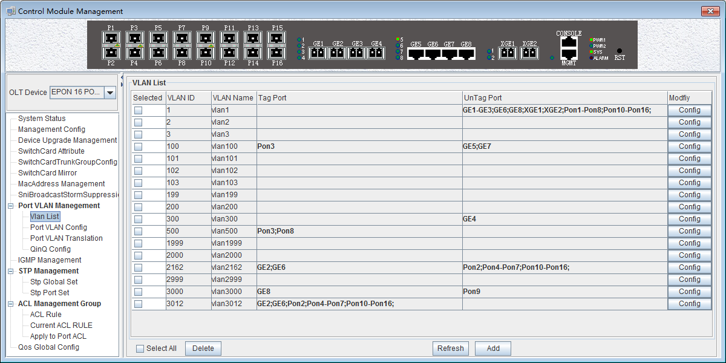
The VLAN list has ‘Selected’, ‘VLAN ID’, ‘VLAN Name’, ‘Tag Port’, ‘Untag Port’, ’Modify’ and other items. Here's a brief introduction to these projects:
Select
This is mainly to delete the specified VLAN. We can select the VLAN ID we want to delete, and then click on 'delete' button on the left corner of the page to delete the VLAN. In addition, select the 'Select All' button next to the 'Delete' can select all the VLAN entries to delete all the VLAN.
VLAN ID / VLAN Name
VLAN ID Displays all the VLAN ID that are available on the current OLT. VLAN Name Displays the name of the current existing VLAN.
Tag Port / Untag Port
In the Port of Tag Port, the forwarded message will be tagged with a VLAN Tag. In the Port of Untag Port, the message that is forwarded will be stripped of the corresponding VLAN tag (no VLAN tag).

6.2.9.2 OLT VLAN Modify
Each VLAN has a 'Config' button, which can be double-clicked to modify the VLAN 's 'Tag Mode’ and ‘Member Port' as shown below, click 'Confirm' button to complete the configuration after setting up.
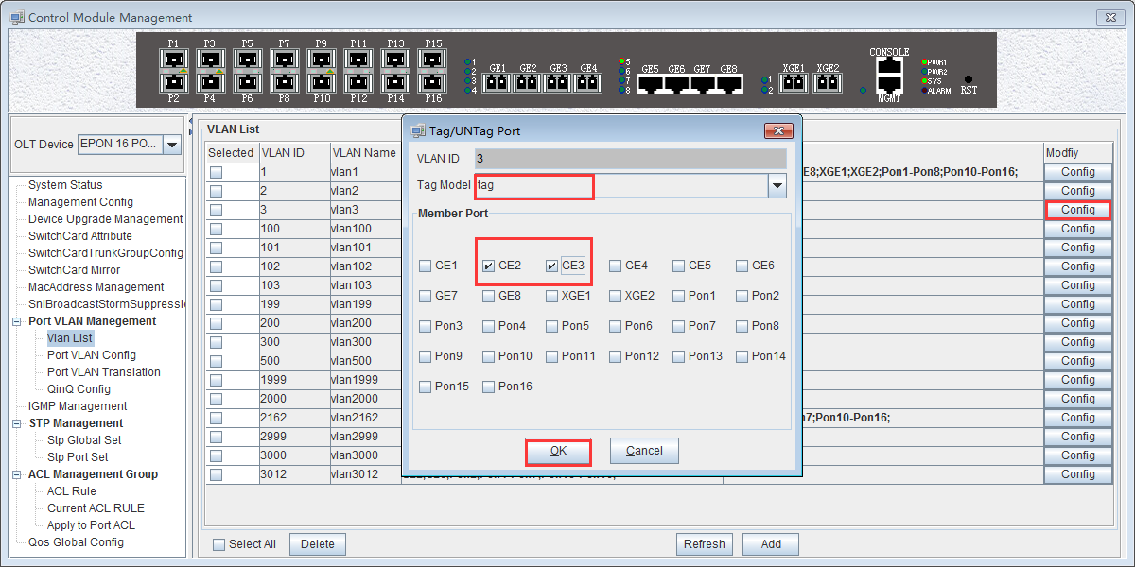

6.2.9.3 OLT VLAN Add

There is a ‘Add’ button in the ‘VLAN List’ page. Click the button to add a VLAN ID to the OLT, and the configuration completes after click 'Ok' button.
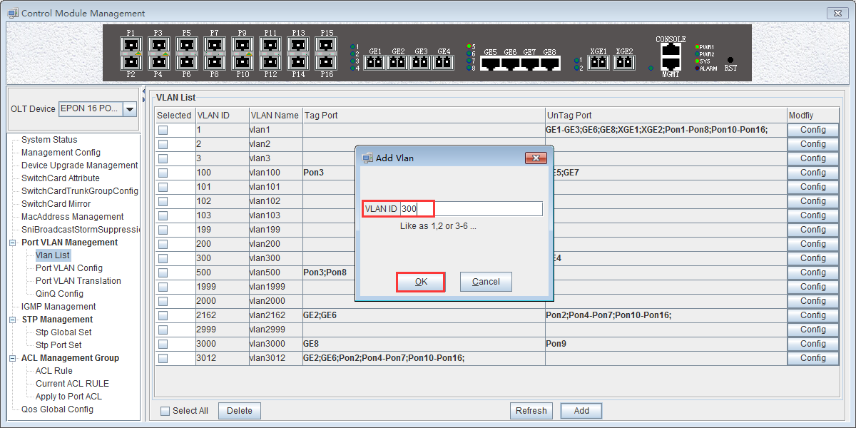

6.2.9.4 OLT Port VLAN Configuration
Double click the ‘Switch Control Card’ icon on the left side of the main page, open the ‘Control Module Management’ window, and enter the port 'VLAN Configuration' page. Typical page is as follows.
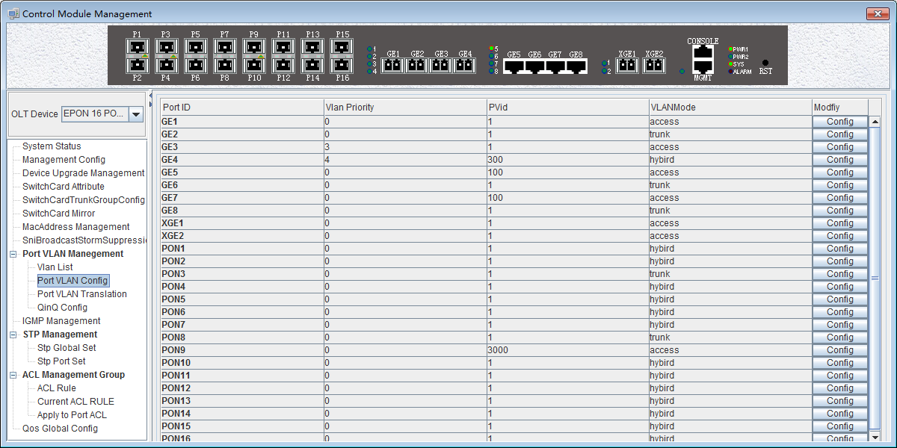
The port VLAN configuration can primarily view and configure Port ID, VLAN Priority, Port VLAN (PVID), and VLAN Mode. The following will be a brief introduction.
Port ID
Display the corresponding port number, GE represents the uplink port, XGE represents the Gigabit port, PON represents the PON interface, the serial number represents the number of ports behind.
VLAN Priority
Displays the priority of the current port VLAN, which shows the value of 0-7, the minimum priority of 0, and the highest priority of 7.
Port VLAN（PVID）
Displays the default VLAN for the current port, which shows the value of 1-4094. If you need to configure the VLAN of the port , you need to add VLAN to the OLT ahead of #6.2.9.3.
VLAN Mode
Displays the VLAN mode of the current port, where the modes that can be displayed are: access, hybrid, trunk.
Modify
Double click the ‘Config’ button to configure the VLAN priority, port VLAN (PVID), and VLAN mode of the corresponding port. Click the ‘Set’ button to complete the configuration. As shown in the following figure.
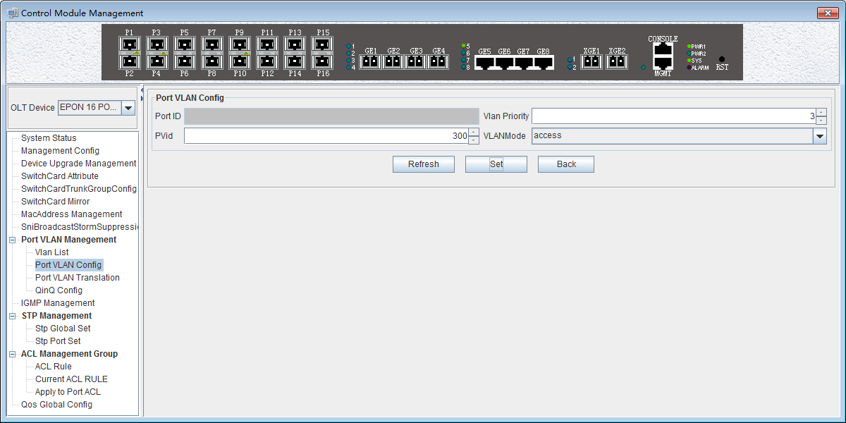

The packets in different VLAN modes are handled as follows:

VLAN mode | Actions(in the inbound direction) |  | Actions(in the  outbound direction)
VLAN mode | Untagged  frame | Tagged frame | Actions(in the  outbound direction)
Access | Tag the frame with  the native VLAN  tag. | - Receive the frame if its VLAN id is the same as the native VLAN id.  - Drop the frame if its VLAN id is different from the native VLAN id | Remove the native VLAN  tag and send the frame
Trunk | Tag the frame with  native VLAN tag. | - Receive the frame if its VLAN is carried on the port  - Drop the frame if its VLAN is not carried on the port. | - Send the frame and removing the tag if the frame is the same as native VLAN id.  - Send the frame without removing the tag if its VLAN is carried on the port but is different from the native VLAN.
Hybrid | Tag the frame with  native VLAN tag. |  | Send the frame if its VLAN is carried on the port. The  frame is sent with the VLAN tag removed or intact depending on your configuration with the VLAN hybrid command.

6.2.9.4.1 OLT Access Mode VLAN Configuration

Example: Configure GE1 port as access mode, priority is 2, PVID is 100. The steps are as follows: (PON port configuration is the same)
Step 1：
Double click the ‘Config’ button at the back of this column of GE1 in the port VLAN configuration page.
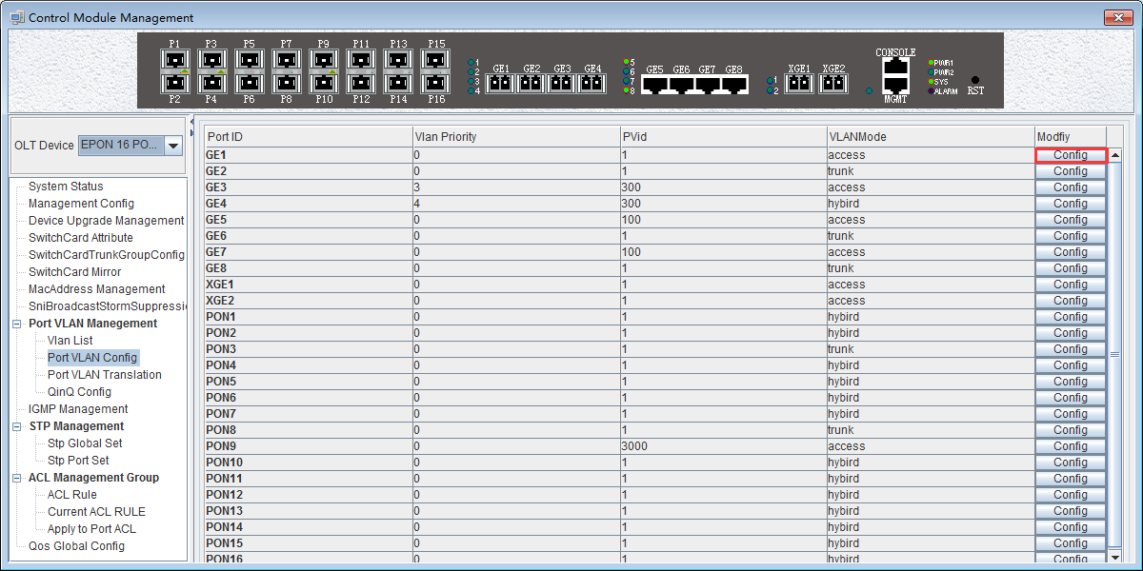
Step 2：
At this point, the following page will appear. Under this page, set the VLAN priority to 2, the PVID to 100, and the VLAN mode select to access. Click the ‘Config’ button and click the ‘OK’ button to complete the configuration.
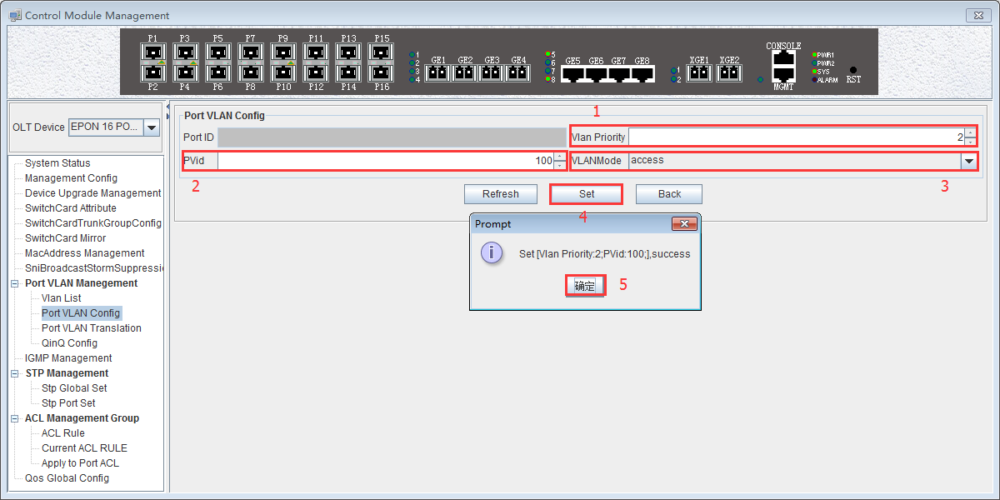Step 3：
Click the 'Back' button to view the modified configuration.
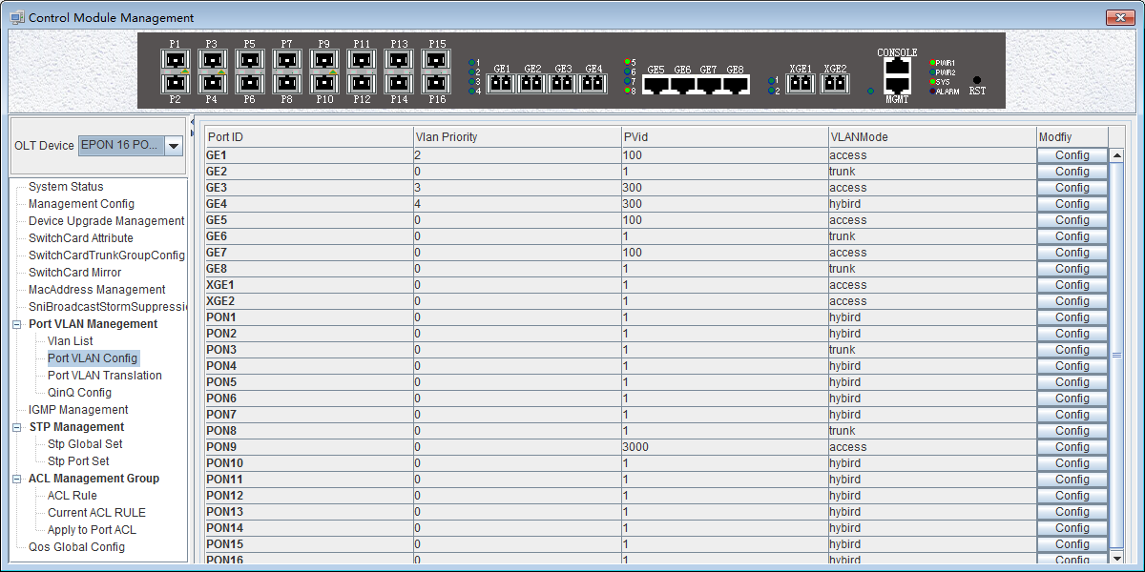

6.2.9.4.2 OLT Trunk Mode VLAN Configuration

Example: Configure GE3 port as trunk mode, priority is 2, PVID is 200, trunk VLAN is101-103. The steps are as follows:
Step 1：
Double click the ‘Config’ button at the back of this column of GE3 in the port VLAN configuration page.
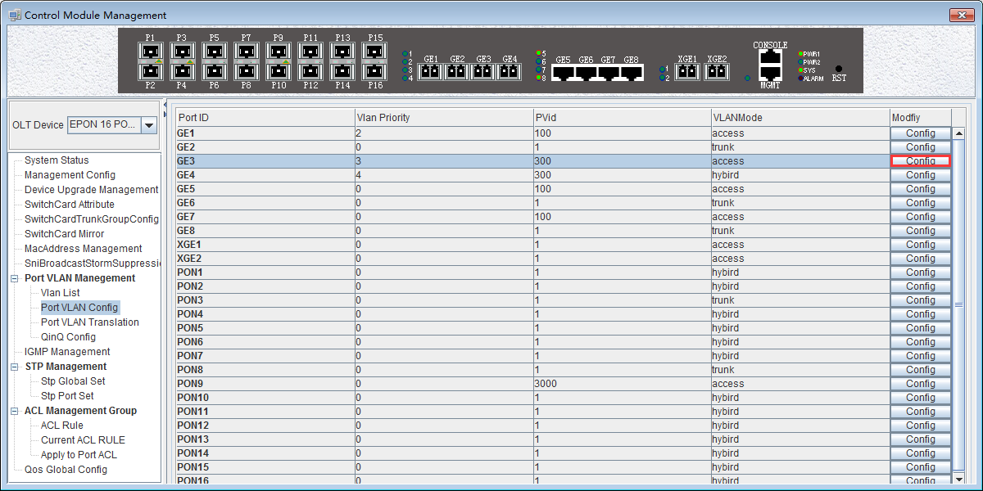
Step 2：
At this point, the following page will appear. Under this page, set the VLAN priority to 3, the PVID to 200, and the VLAN mode select to trunk. Click the ‘Config’ button,add '101-103' at the 'Add Trunk VLAN' window and click the ‘OK’ button to complete the configuration.
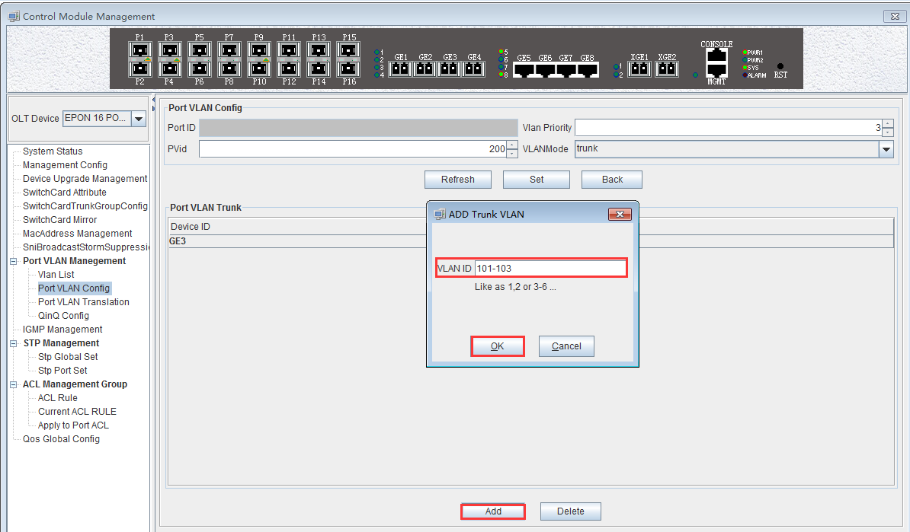
Step 3：
Click the 'Back' button to view the modified configuration, and enter the 'VLAN List' page to view the VLAN101, VLAN102, and VLAN103 that have been added to the GE3 port.
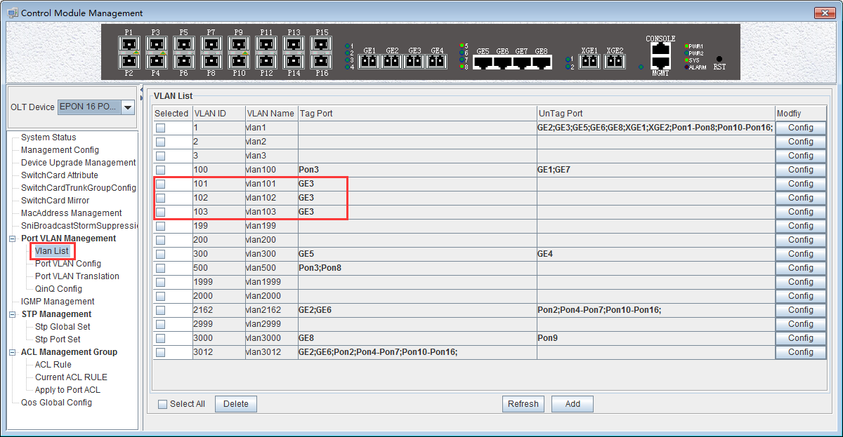

6.2.9.4.3 OLT Hybrid Mode VLAN Configuration

Example: Configure GE4 port as hybrid mode, priority is 4, PVID is 300, The hybrid mode allows VLAN 301 with tag, VLAN 302 without tag. The steps are as follows:
Step 1：
Double click the ‘Config’ button at the back of this column of GE4 in the port VLAN configuration page.
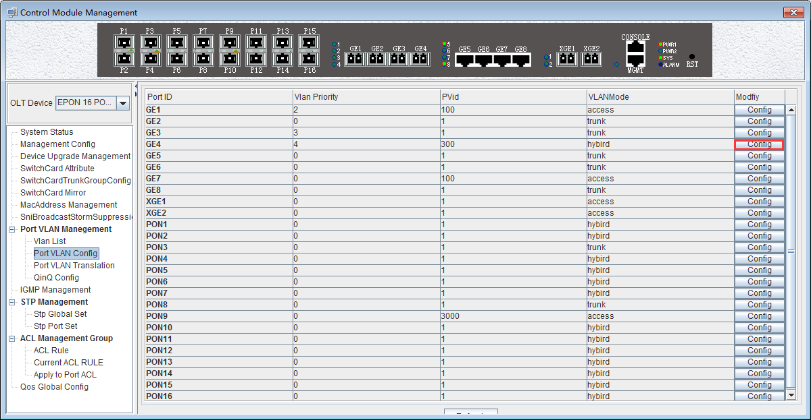
Step 2：
At this point, the following page will appear. Under this page, set the VLAN priority to 4, the PVID to 300, and the VLAN mode select to hybrid. Click the ‘Config’ button and click the ‘OK’ button to complete the configuration.
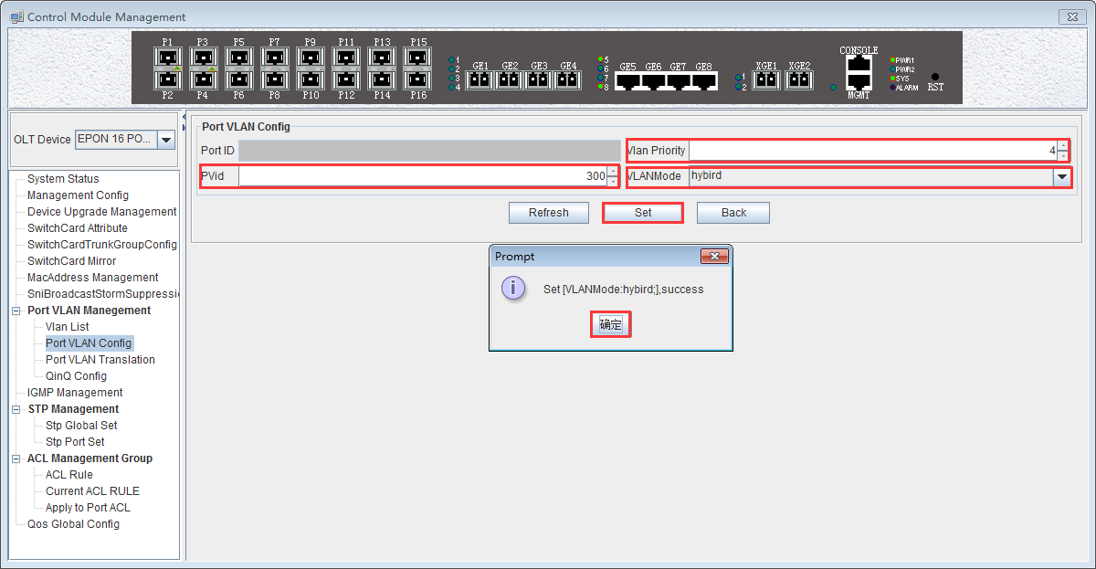
Step 3：
Click the 'Back' button to view the modified configuration.
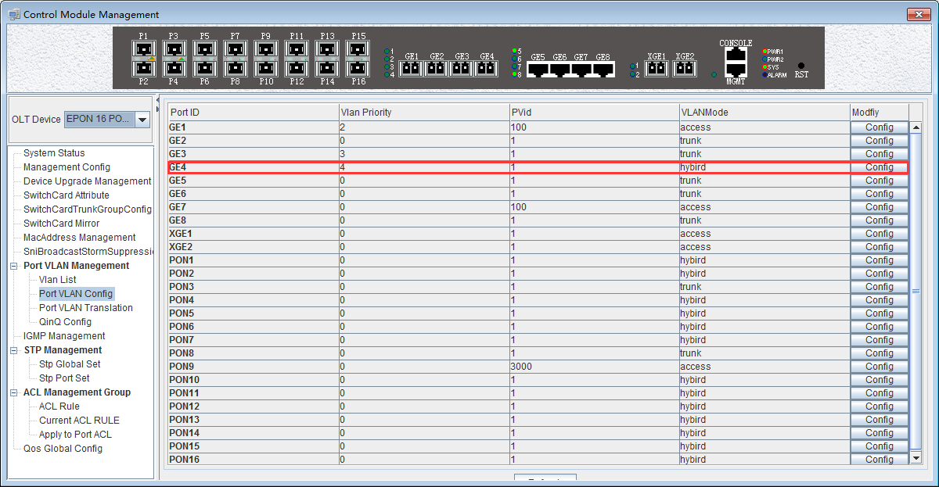
Step 4：
The allowed untag and tagged VLAN of the hybrid mode need to be added in the 'VLAN List' of # 6.2.9.2 and # 6.2.9.3.

6.2.9.5 OLT Translation Mode VLAN Configuration

The OLT port VLAN translation is actually the CVLAN from the OLT side of the user translate into the SVLAN on the network side. Details are as follows.
Double click the ‘Switch Control Card’ icon on the left side of the main page, turn on the ‘Control Module Management’ window, and enter the ‘Port VLAN Translation’ page. Typical page is as follows.
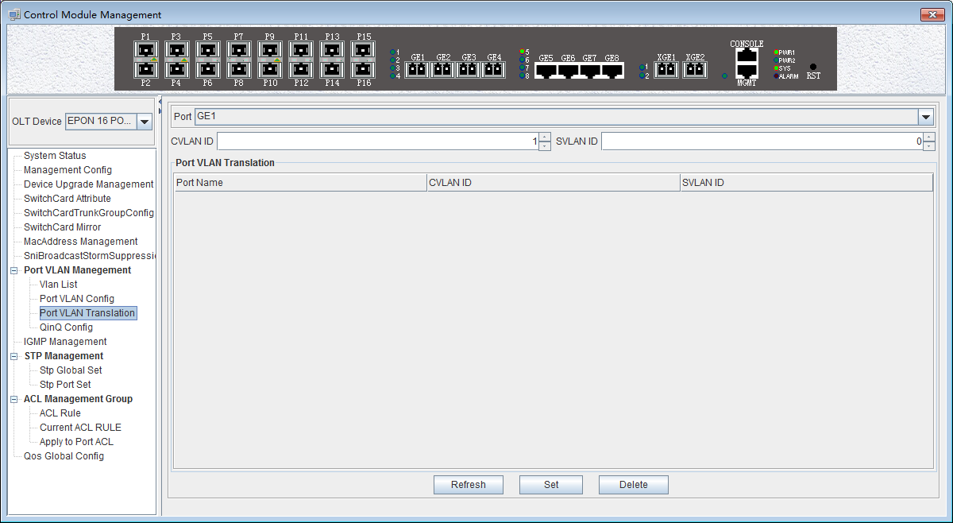
Port VLAN Translation can be used to view and configure the port ID, CVLAN ID, and SVLAN ID. The following will be a brief introduction.
Port ID
Display the corresponding port number, GE represents the uplink port, XGE represents the Gigabit port, PON represents the PON interface, the serial number represents the number of ports behind.
CVLAN ID
Represents the VLAN before the translation (VLAN that enters the port), with a value of 1-4094.
SVLAN ID
Represents the converted VLAN (VLAN that out of the port), with a value of 1-4094.
‘Set’ button
When you have configured the above items, you can click the ‘Set’ button to complete the configuration. At this point the translate list will appear in a configuration item.
‘Delete’ button
Select the entry you want to delete in the conversion list and click the ‘Delete’ button to delete the specified entry.
【Example of VLAN Translation Configuration】
Example: Converts a packet with a VLAN of 100 on the user side of the GE1 port to VLAN 200 on the network side. The configuration steps are as follows.
Step 1：
Click on the 'Port VLAN Translation', Select GE1 in the right page, CVLAN set to 100, SVLAN set to 200, click on the following 'Set' button, and then in the 'Prompt' window click on the 'OK' button to complete the configuration.
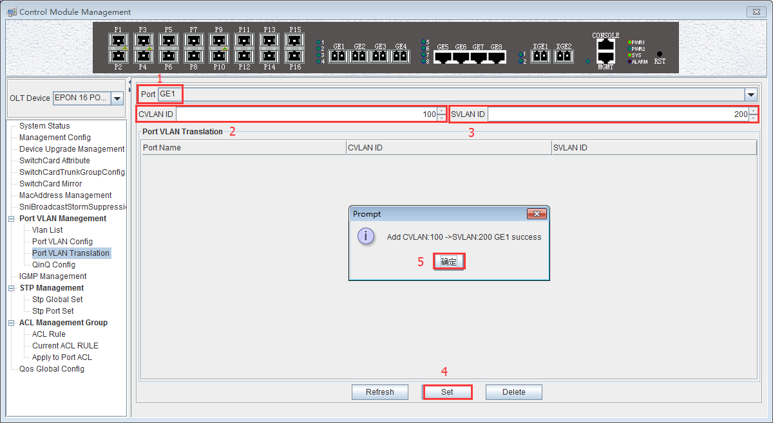
Step 2：
Click the 'Refresh' button to view the VLAN translation entry that you just configured.
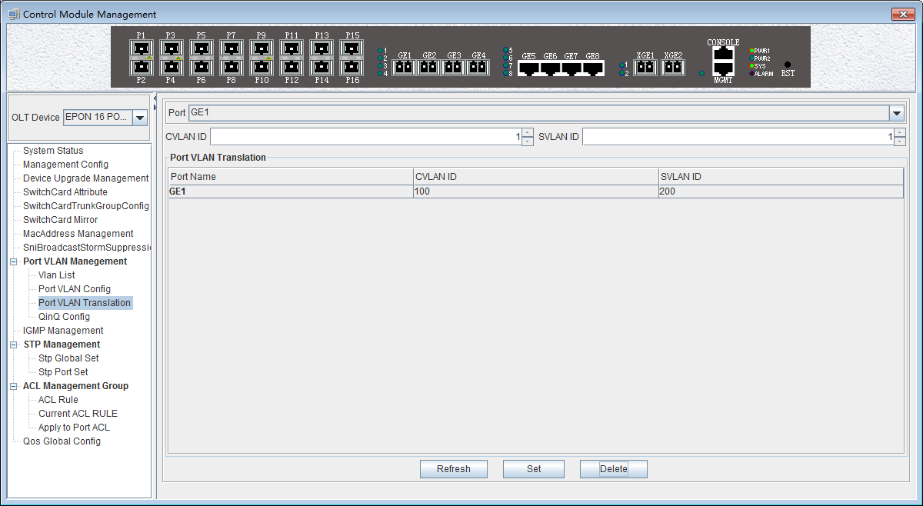

6.2.9.6 OLT QinQ Mode VLAN Configuration

QinQ technology (also known as Stacked VLAN or Double VLAN). The standard is from IEEE 802.1ad, which encapsulates the user's private VLAN tag in the public VLAN tag, so that the packet carries the two-layer VLAN tag through the operator's backbone network (public network).
QinQ technology effectively extends the number of VLANs by stacking two 802.1Q headers in Ethernet frames so that the number of VLANs can be up to 4096x4096.
Double click the 'Switch Control Card' on the left side of the main page to open the 'Control Module Management' window and enter the 'QinQ Config' page. The typical page is as follows.
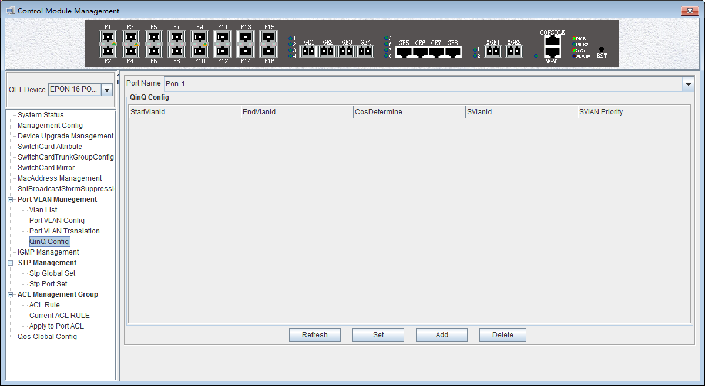
The QinQ configuration can view and configure the PON port ID, Start VLAN ID, End VLAN ID, Outer VLAN ID, and Outer VLAN Priority. The following will be a brief introduction.
Port ID
Displays the corresponding port number, PON represents the PON interface, the serial number followed by represents the port number. This column can only select PON port.
Start VLAN ID, End VLAN ID, Outer VLAN ID
Start Customer VLAN ID (CVLAN)：Represents the initial VLAN ID (when entering the port) of the inner layer VLAN, with the value of 1-4094;
END Customer VLAN ID (CVLAN)：Represents the termination VLAN ID (when entering the port) of the inner layer VLAN, with a value of 1-4094;
Service provider VLAN (SVLAN): Represents another layer of VLAN after the inner layer VLAN, with a value of 1-4094;
When a packet enters the port range from the start VLAN to the end VLAN, a layer of outer VLAN (SVLAN) is added to the port, and the message at this time is a message with double layer VLAN.
SVLAN Priority
Represents the priority of SVLAN, with a value of 0-7, in which 0 is the lowest priority and 7 is the highest priority.
‘Add’ button
Click the 'Add' button pops up the window as shown below. In this window, you can configure the start CVLAN, end CVLAN, SVLAN, and priority. Click ‘OK’ button to complete the configuration.

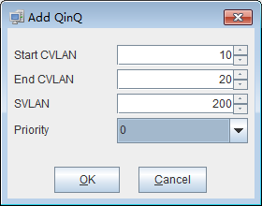

‘Set’ button
When you have configured more than that, you can click the ‘Set’ button to complete the configuration.
‘Delete’ button
Select the items to be deleted in the translation list, and then click ‘Delete’ button to delete the specified entry.

【Example of VLAN QinQ Configuration】
Example: PON 8 received VLAN100-103 packets are marked with a layer of outer VLAN 200, the priority of 0.
Step 1:
Click the 'Add' button, pop up the 'Add QinQ' window, configure the start VLAN to 100, end VLAN to 103, SVLAN to 200, the priority to 0.

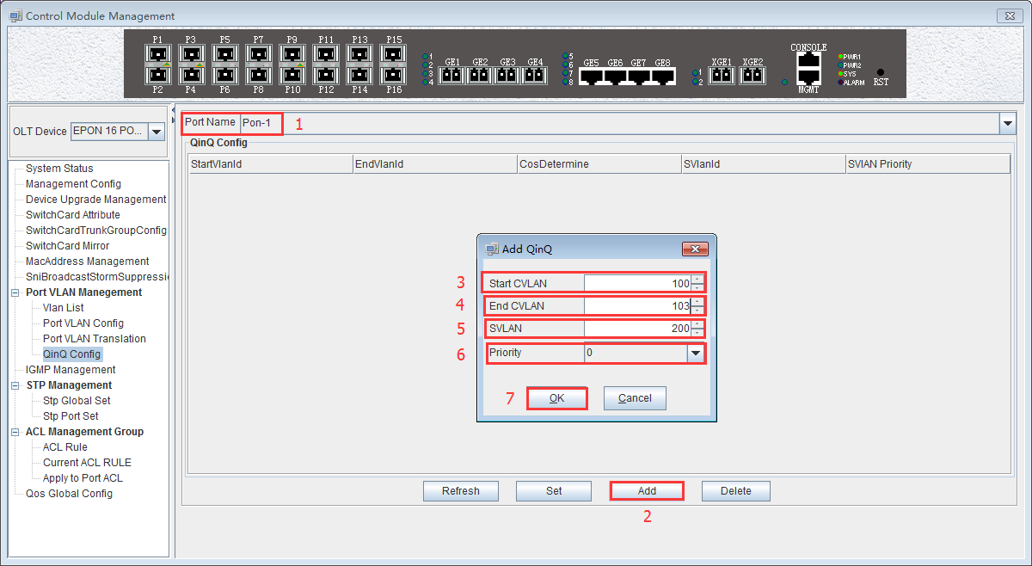
Step 2：
Click the 'OK' button in the prompt window that appears.
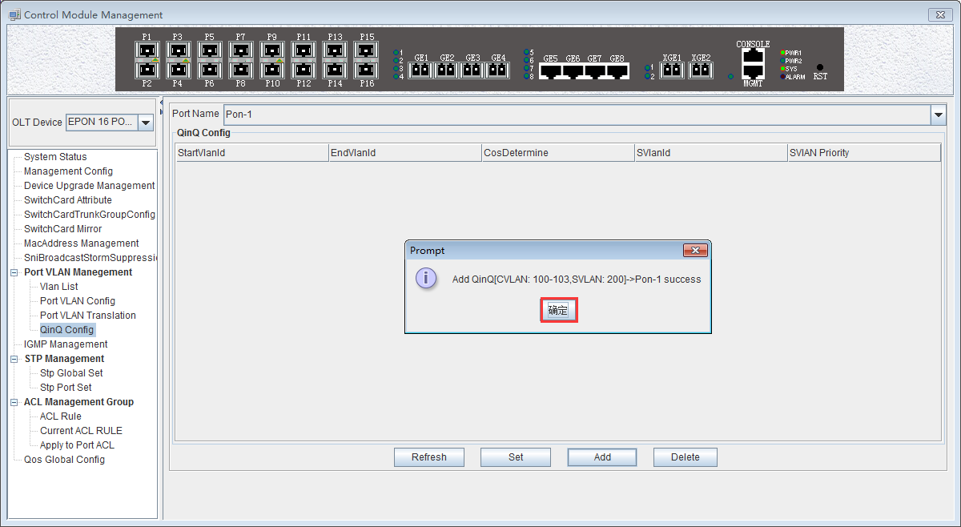
At this point we can see our newly added QinQ entries.
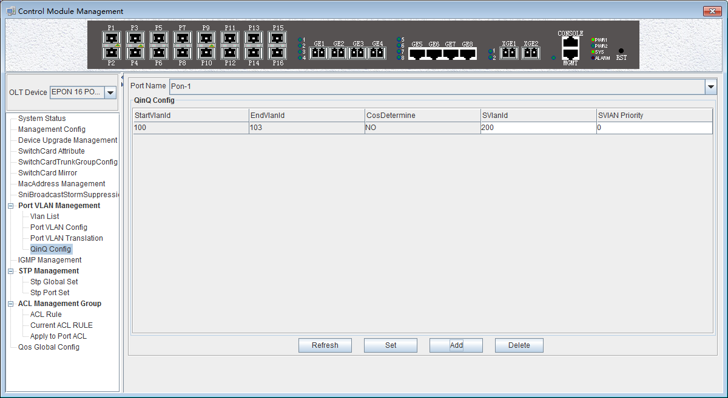

6.2.10 OLT IGMP Management
If a host wants to receive multicast packets sent to a particular group, it needs to monitor all packets that are sent to that particular group. In order to solve the routing problem of multicast data packets on Internet, the host needs to join or leave a group by notifying the multicast router on its subnet, and IGMP is used in multicast to accomplish this task. Thus, the multicast router can know the members of the multicast group on the network and decide whether or not to forward the multicast packets to their network. When a multicast router receives a multicast packet, it checks the multicast destination address of the packet and forwards it only if there is a member of that group on the interface.
The OLT on the IGMP provides the information needed to forward the multicast data packet to the final stage of the destination, and implements the following bidirectional functions:
1. The host notifies OLT through IGMP that it wants to receive or leave about a particular multicast groups.
2. OLT periodically queries the group members in the LAN whether is in a activity status, and realizes the collection and maintenance of group membership in the network segment.

The multicast configuration of our company's FD1216S OLT is as follows.
Double click the 'Switch Control Card' icon on the left side of the main page to open the 'Control Module Management' window and enter the 'IGMP Management' page. Typical page are as follows:.
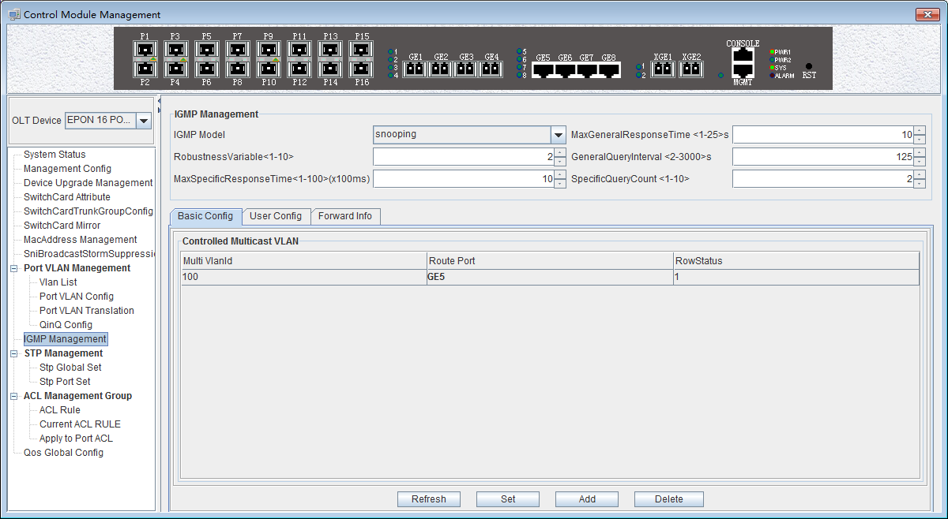
In the 'IGMP Management' page, you can set the following configuration parameters.
IGMP Management
- IGMP Working Mode
IGMP working mode is：’proxy’、‘snooping’、‘ctc’、‘disable’
- Proxy
Set the IGMP mode of the multicast VLAN as proxy.IGMP proxy is the multicast agent. The IGMP proxy forwards the IGMP message between the user and the multicast router and then forwards it to the upper multicast router. From a user perspective, the system is equivalent to a multicast server; From an upper point of view, the system is equivalent to a multicast user. The IGMP proxy mode reduces the traffic of the network side multicast protocol.
- Snooping
Set the IGMP mode of the multicast VLAN to IGMP snooping. IGMP snooping is multicast intercept. The IGMP snooping obtain the relevant information to maintains the multicast forwarding table entry by intercepting the IGMP communicated message between the user and the multicast router. The system does not do any processing to multicast messages which belongs to the multicast VLAN, only transparent.
- CTC
When IGMP mode is ctc, that is, controllable multicast mode. The traditional multicast service is uncontrollable. You can send a IGMP report message to join a multicast group to receive the multicast packets of the multicast group. The core idea is to control the privileges of a user to join a multicast group. When a user requests to join a multicast group, the OLT must authenticate the request and refuse requests for unauthorized or unauthorized access.The controllable multicast of OLT controls the generation of two layer multicast forwarding table entries by intercepting the IGMP report messages sent by ONT, so as to achieve multicast control purposes.After receiving the IGMP report packet from the multicast user, it finds the privilege template for the VLAN according to the VLAN to which the packet belongs. If the multicast group is not in the list of the privilege template, the user thinks that the user has no authority to block the IGMP report Messages that are not allowed to generate forwarding entries, so that the user can not receive the data flow of the multicast group. If the multicast group is under the list of permissions templates, it depends on how the list is added to the template, and if the list is added to the template by viewing, the IGMP report message is passed. If the list is added to the template by preview, the IGMP report message is passed, but a timer is started. When the preview time expires, the forwarding entry of the multicast group is deleted and the subsequent IGMP report packet of the multicast group is blocked. So as to achieve the preview function.
In this mode, the ONT multicast mode must be configured as a controllable multicast. In this mode, when the multicast user passes the authentication, the corresponding extended OAM packets are sent to maintain the ONT multicast entries to achieve control of the multicast service.
- Disable
Disable multicast function
- Max General Response Time
The maximum response time is used to limit the maximum time of query waits for the host to respond to the group query message (i.e. to send report messages). The value can be 1-25s.
- Robustness variable
The robustness variables are configured to send query packets and the number of proxy messages to prevent network topology from being unstable and not receiving packets. The range is 1-10 times.
- General Query Interval
The general query interval is primarily used by the system to verify whether the user is watching a program by sending an general query for all programs. If the system does not receive the user's report message, the user is not considered to have watched the program and no longer sends the program stream.Avoid users who do not watch programs, but still receive multicast streams and waste bandwidth. The value is 2-3000s.
- Max Specific Response Time
The system send a specific group query according to the setting interval for the specific program to confirm whether the user is watching the program and does not receive the report message from the user feedback, thinks that the user is not watching the program,the system will not send the program stream to the user,to avoid the user did not watch the program but still received the multicast stream and wasted the bandwidth. The value is 1-100, the unit is 100ms.
- Specific Query Count
The system for a specific program by sending N times (N through this command to set) of the specific group query to confirm whether the user is watching the program and does not receive the report message from the user feedback, thinks that the user is not watching the program,the system will not send the program stream to the user, to avoid the user did not watch the program but still received the multicast stream and wasted the bandwidth.
After the above parameters are configured, you need to click the ‘Set’ button to complete the configuration to make the configuration take effect.
Basic Config
Click on the 'Basic Config' of the 'IGMP Management’ page will appear a multicast program table.
The table can view or configure some parameters, such as ‘IGMP Proxy ID', ‘Multicast VID', ‘Source IP Address', 'Multicast IP Address', ' Route Port’.
- IGMP Proxy ID
The ID of multicast table items, that is, the number of multicast programs, can be valued at 1-2000.
- Multicast VID
Corresponding multicast VLAN. The legal range is 1-4094.
- Source IP address of IGMP Proxy ID
Represents the source address of the IGMP query message, and the address format is X.X.X.X.
- Multicast IP address
Multicast IP address of the multicast program, and the address format is X.X.X.X.
- Route Port
The routing port of the multicast program specifies the source port of the multicast stream.
In addition, we can click on the ‘Add’ button to add multicast program table entries, where we can configure IGMP Proxy ID, routing ports, MVID (multicast VLAN), IP address these items. Click ‘OK’ to complete the configuration, and the newly added multicast program list will appear in the multicast program table.
'Delete' button: Select the multicast program entry you want to delete, click the 'Delete' button to delete the specified multicast program.
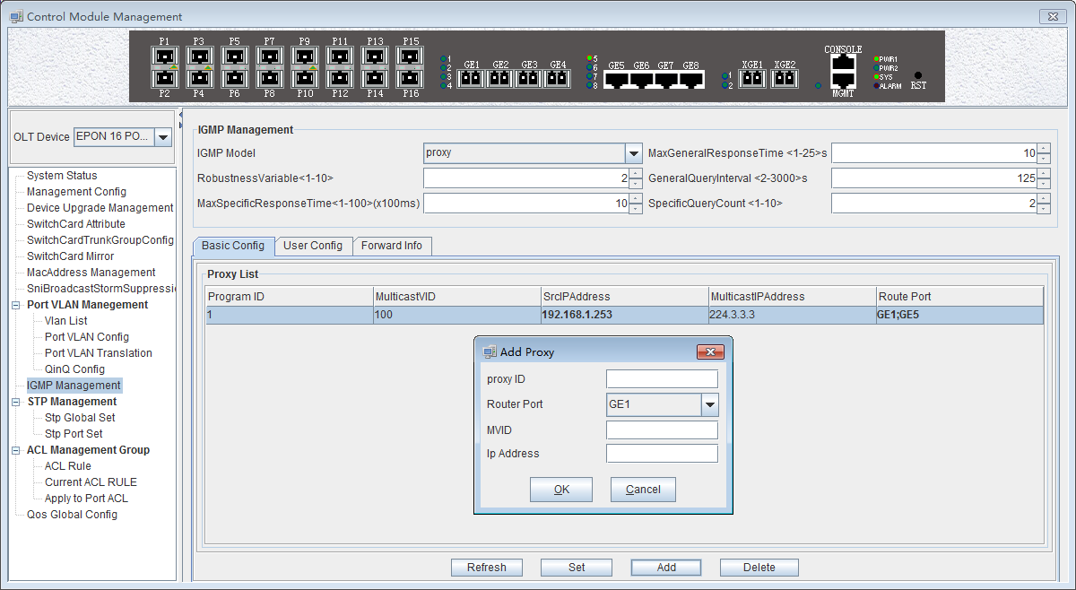
User Config
Click 'User Config' in the 'IGMP Management’ page, there will be two tables (the premise is to configure the IGMP working mode to CTC), the left is the ‘Controlled Multicast Package’, and the right is the ‘Controlled Multicast User Authority’.
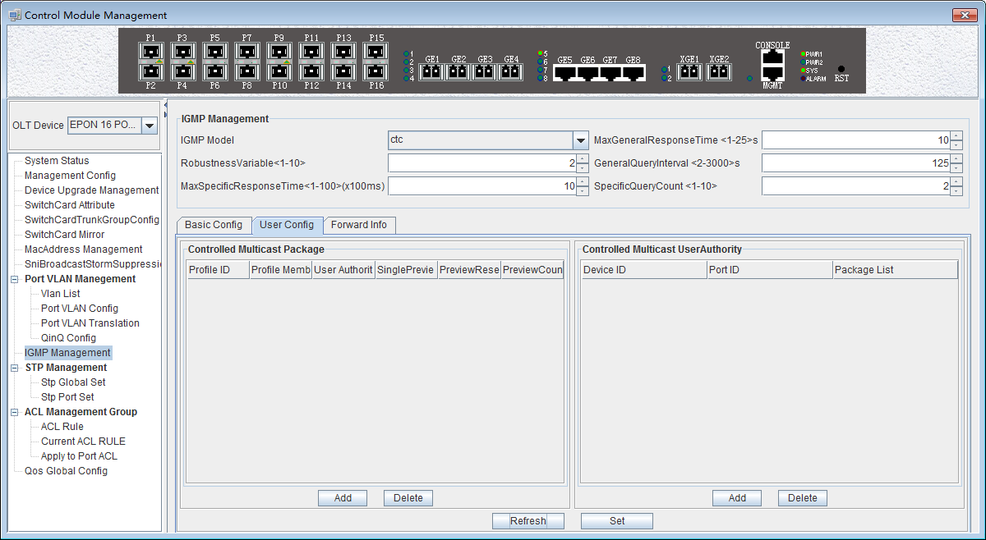
（1）Controlled Multicast Package
- Profile ID
Profile ID of the controlled multicast package, The value is 0-31.
- Profile Member
Profile members are multicast program table entries, which can be viewed in the basic configuration. Range of value is 1-2000.

- User Authority
There are three options for user rights: 'Preview', 'Permit', 'Deny'
Preview: the user can only watch the specified program and the content of the specified time period.
Permit: that allows the user to watch the program.
Deny: users are not allowed to watch programs.
- Single Preview Time
The user can watch the duration of the program, the range is 10-6000, the unit is seconds.
- Preview Reset Time
After a multicast preview, a preview of the reset time is taken before the program can be re viewed. The range is 1-7650, and the unit is seconds.
- Preview Count
The number of times you can preview the multicast program, in the range of 1-255.
Click the 'Add' button will bring up a 'Add Controlled Multicast Package' window where we can configure the package ID, proxy list, user right, single preview, preview reset and preview times. Click 'OK' and a project will appear in the window on the left.
Select the controlled multicast packet entry to be deleted and click the 'Delete' button to delete the specified entry.
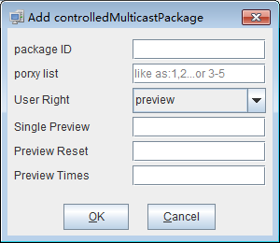
- Controlled Multicast User Authority
- Device index
The specified ONU under the corresponding specified PON port. The ID of the PON port can be 1-16, the ID of the ONU can be 1-64.
- Port index
That is ONU port ID.
- Controlled Multicast List
That is the multicast packet profile ID, in the range of 0-31.
Click the 'Add' button under the 'Controlled Multicast User Authority' table on the left to bring up the following ‘Add Controlled Multicast User Authority’ dialog box. Here you can configure parameters, such as ONU ID, PON port, ONU port, and package list. Click the 'OK' button.At this point, the corresponding entry will appear in the list.
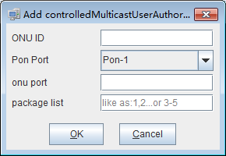
Select the item you want to delete, and click the 'Delete' button to delete the specified entry.
Forward Info
Click on the 'Forward Info' under the 'IGMP Management’ page will appear a list of forwarding entries. Here you can view the corresponding multicast program entries. As shown below.
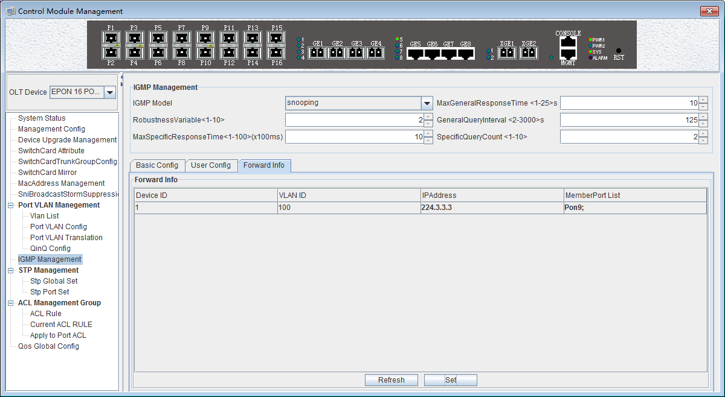
- Device index (Multicast table entry)
Refers to the index number of the multicast program table entry that exists in OLT.
- VLAN ID
Refers to the VLAN ID of the multicast group.
- IP Address
Refers to the multicast IP address for multicast programs.
- Member Port List
Refers to the member port of the multicast group.
Click the 'Refresh' button to refresh the multicast entry.

【Example of OLT IGMP Management configuration】
Example: Add a multicast program entry, set the IGMP mode to proxy mode, the multicast entry number to 2, the multicast VLAN to 300, and the multicast address to 224.3.3.3. The configuration steps are as follows.
Step 1：
Enter the 'IGMP Management' page, select proxy in 'IGMP Model' , the other parameters can be the default value (see below).
Click the ‘Add’ button,configure the proxy ID to 2, the routing port to GE1, the multicast VLAN (MVID) to 300, and the multicast address to 224.3.3.3. Click the 'OK' button to complete the configuration.
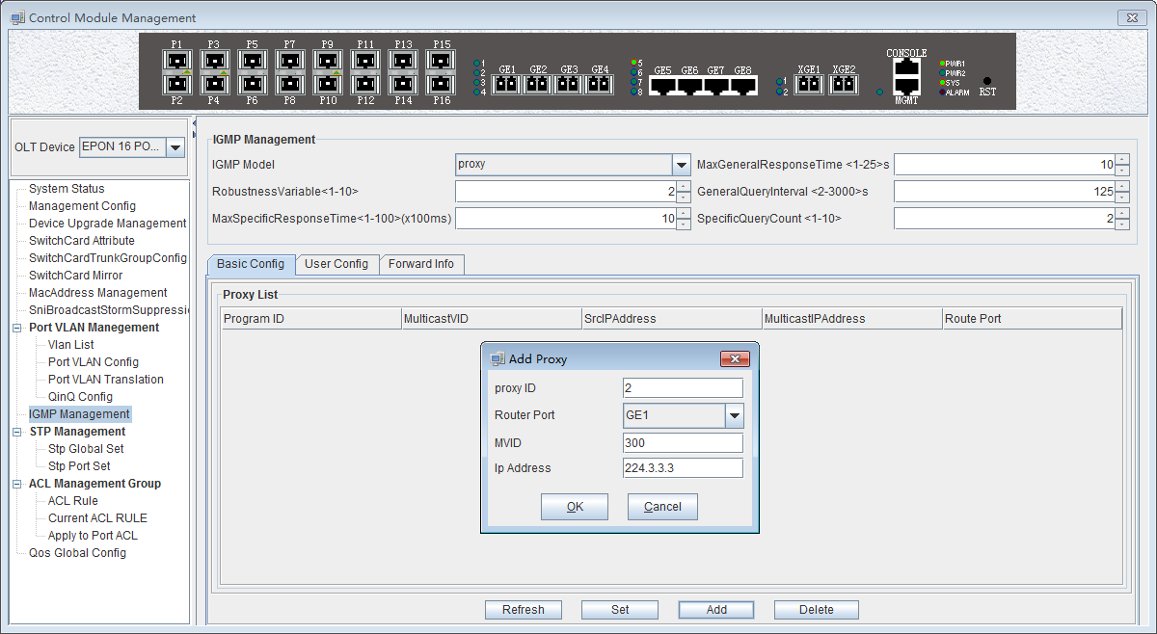
Step 2：
Click the 'OK' button when the prompt window appears at this time.
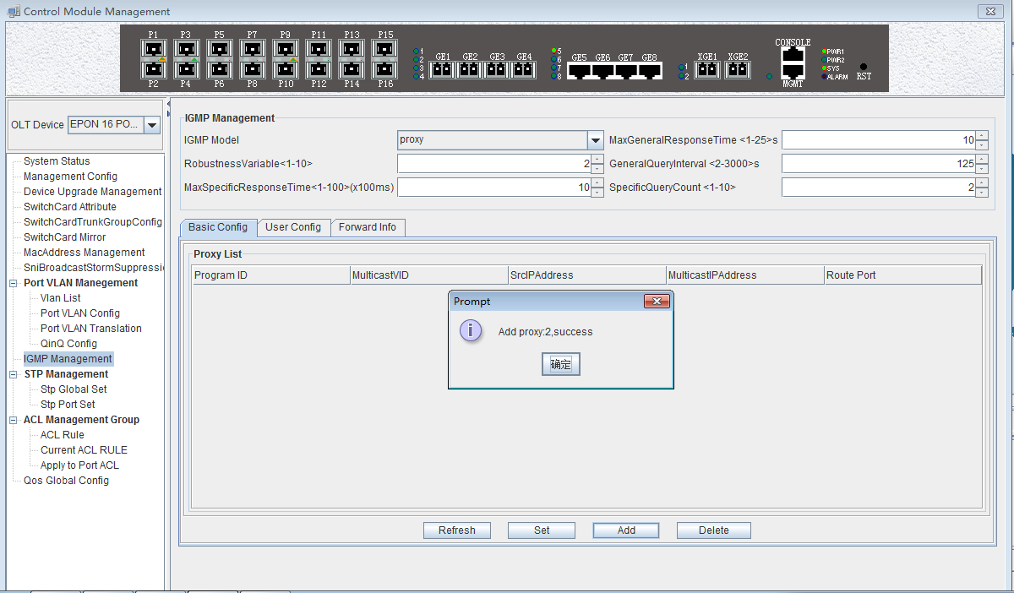
Step 3:
Then we can see that there is a list of items we just configured in the program.
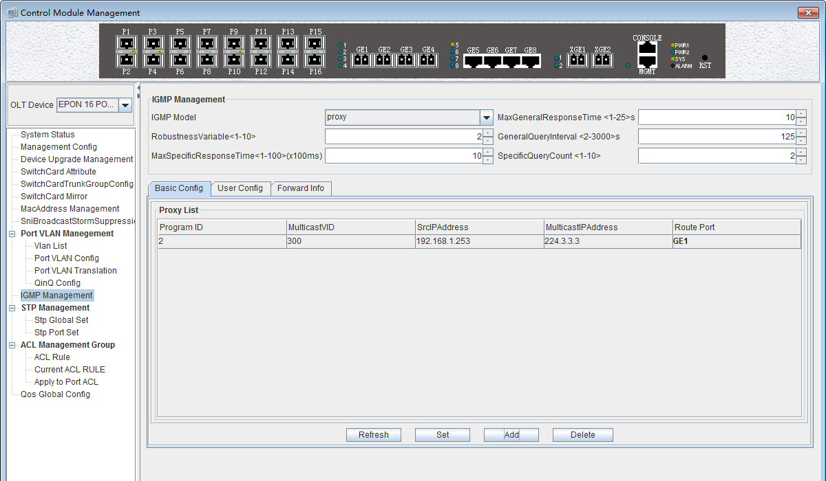

6.2.11 OLT STP Management
STP (Spanning Tree Protocol) is the abbreviation of spanning tree protocol. The protocol can be applied to the loop network, through a certain algorithm to achieve path redundancy, while the loop network is trimmed into a loopless tree network, so as to avoid the message in the loop network proliferation and infinite loop.
The main application of the spanning tree protocol is to avoid the network loopback in the LAN and solve the "broadcast storm" problem of the ring-to-ring Ethernet network. In a sense, it is a kind of network protection technology that can eliminate the loop connection caused by mistake or accident .

6.2.11.1 STP Global Config

Double click the 'Switch Control Card' icon on the left side of the main page, open the 'Control Module Management' window and enter the 'STP Global Set' window of ‘STP Management’ page .
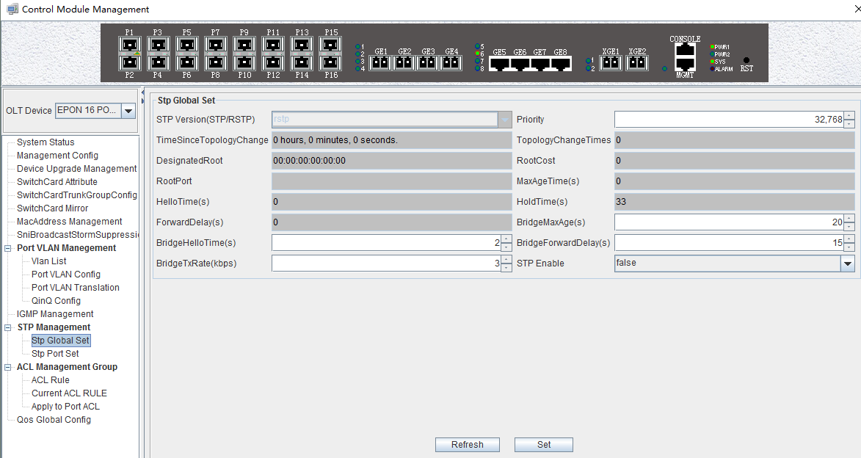
As shown above, in ‘STP Global Set’ page, you can view the STP Version, Priority, Time Since Topology Change, Topology Change Times, Designate Root , Root Cost, Root Port, Max Age Time(s), Hello Time(s), Hold Time(s), Forward Delay(s), Bridge Tx Rate(kbps)and STP Enable State. Among them, Priority,Max Age Time(s) ,Hello Time(s) , Forward Delay(s), Bridge Tx Rate(kbps) and STP Enable State can be modified . Specific parameters are introduced as follows:
STP Global Set
- STP Version
The default setting of system is RSTP.
- Priority
Bridge priority is used to select the root bridges of the network. The smaller the value, the higher the priority, the greater chance of being elected as the root bridge. You can set a bridge with a priority value of 0, 4096, 8192, 12288,16384, 20480, 24576, 28672, 32768, 36864, 40960, 45056, 49152,53248, 57344 and 61440.
- Time Since Topology Change
The duration of switching from the previous topology state to the current state .
- Topology Change Times
The number of topology changes caused by the change of the port or link state in the network topology.
- Designate Root
You can designate root bridge through bridge priority. In case of not designating priority, the smaller the MAC address, and the greater the chance of being the designated root bridge.
- Root Cost
To calculate the link cost, the port with the lowest root link cost will become the forwarding port in case of forwarding the same network bridge ID . The legal range is 1 ~ 20000000.
- Root Port
The number of ports that are passed by the path of from non-root bridge to the root bridge.
- Max Age Time
The lifetime of the BPDU message received from the adjacent bridge of Designated port. The legal range is 6~40, in s.
- Hello Time
Set the bridge how often to send a BPDU message. The setting range time is 1~2, in s.
- Hold Time
When the network bridge changes in topology, maintaining the time of monitoring and learning state before sending packets.
- Forward Delay
With downward compatibility STP network bridge, for port of working in the STP mode, forwarding delay timer designated the port before the transition to the learning state the time of in discarding state , and before the learning state transition to the forwarding state in the time of learning state. The legal range is 4~30, in s.
- Bridge Tx Rate
Set the number of maximum sending BPDU messages in 1 second. The setting range of 1~10, in frame/s.
- STP Enable State Configuration
Open or close the RSTP function by setting the 'RSTP State’ to ‘Enable’ or ‘Disable’.
Attention：When you set Max Age Time, Hello Time, Forward Delay, first input setting value, then click ‘Set’ button, finally click ‘Refresh’ button, thus configuring successfully. And consistent with three contents shown below.

6.2.11.2 STP Port Set
Double click the 'Switch Control Card' icon on the left side of the main page, open the 'Control Module Management' window and enter the 'STP Port Set' window of ‘STP Management’ page .

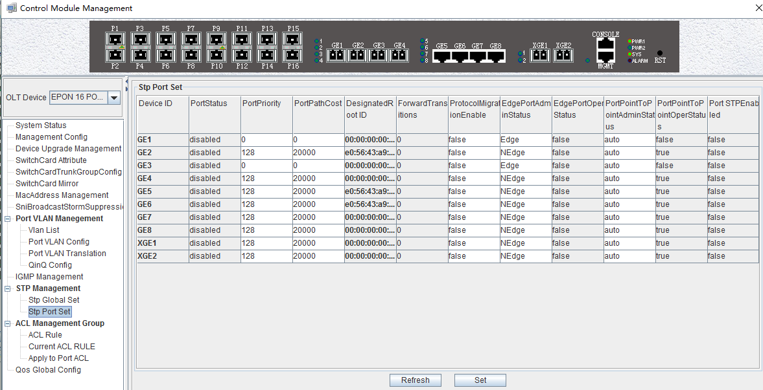

As shown above, in ‘STP Port Set’ page, you can view Device ID, Port Status, Port Priority, Port Path Cost, Designated Root ID, Forward Transitions, Protocol Migration Enable, Edge Port Admin Status, Edge Port Oper Status, Port Point to Point Admin Status, Port Point to Port Oper Status and Port STP Enabled Status. In addition,you can modify Port Priority, Port Path Cost, Protocol Migration Enable, Edge Port Admin Status and Port Point to Point Admin Status. Specific parameters are introduced as follows:
- Port Status
STP Port Status has five types, including disable, learning, listening, forwarding and blocking.
Disable: In the invalid status, to be a valid port, first switch to the blocking port.
Learning: In the learning state, the port is adding addresses to its forwarding database, but does not forward packets.
Listening: In the listening state, the port is waiting to receive BPDU packet, and BPDU may tell the port to return to the blocking state.
Forwarding: In the forwarding state, the port is forwarding the packet.
Blocking: In the blocking state, the port is blocked and can not forward or receive packets.
- Port Priority
When the link cost and the sending network bridge ID is the same, the lowest priority port will be the forward port. The parameter value can be set to 0 ~ 440, and the step length is 16.
- Designated Root ID
The BID in the BPDU message consists of two parts, the bridge priority and the bridge MAC. The bridge ID is only. Switches selects the smallest BID switch as the root bridge in the network.
- Forward Transitions
The port consists of five status.Status transitions need to go through status transition time.
- Protocol Migration Enable
This means that the device supports RTSP, and if the port is enabled, the port will automatically migrate to STP compatible mode when the port is connected to the device running the STP protocol. 'True' means opening this function, and 'False' means closing this function.
- Edge Port Admin Status
You can use this option to set whether it is an edge port. 'Edge' is an edge port, and ‘NEdge’ is a non - edge port.
- Edge Port Oper Status
This option indicates whether the current port is in the edge port state. ‘False’ indicates that the port is not in an edge state, and ‘Ture’ indicates the status of the port on the edge. The edge port does not need to go through the ‘Discarding-learning-forwarding’ step and directly switch to the forwarding status.
- Port Point to Point Admin Status
You can use this option to set whether the port is a point-to-point port, including 'Auto', 'Ture' and ‘False’ three options. 'Ture' is to set this port to point-to-point port, and 'False' is to set this port to non point-to-point port. ‘Auto’ is dependent on the STP protocol itself. Point-to- point ports allow fast switching to forwarding status, and non point-to-point ports need to go through discarding-learning-forwarding step to switch to forwarding status.
- Port Point to Port Oper Status
The option is to specify the point-to- point port state in which the current port is actually located.
Prompt: Some of the parameter explanations are described in the previous section, which are not repeated here. You can go to the previous section to inquire.

6.2.12 ACL Management

ACL is ‘Access Control List’ . Through configuring a serial of matching rules to filter specific data packets, thus identifying objects that needs to be filtered. After identifying specific objects, according to preset policy permitting or denying the corresponding data packets pass. The process of ACL filter message flow prepares for Qos.

6.2.12.1 Configure ACL rule

ACL has three types, including basic ACL, its Id range from 2000 to 2999,only matching source IP address; advanced ACL, its Id range from 3000 to 4999, being able to matching source IP address, destination IP address, source port, destination port, DSCP and IP massage type; link ACL, its Id range from 5000 to 5999, being able to match source mac, destination mac, VLAN Id and Ethernet type.

6.2.12.1.1 Basic ACL Configuration

Double click the 'Switch Control Card' icon on the left side of the main interface, open the 'Control Module Management' window and enter the 'ACL Rule' window of ‘ACL Management’ page . Click the pull-down menu of ACL Type, and choose basic acl(2000-2999) option.
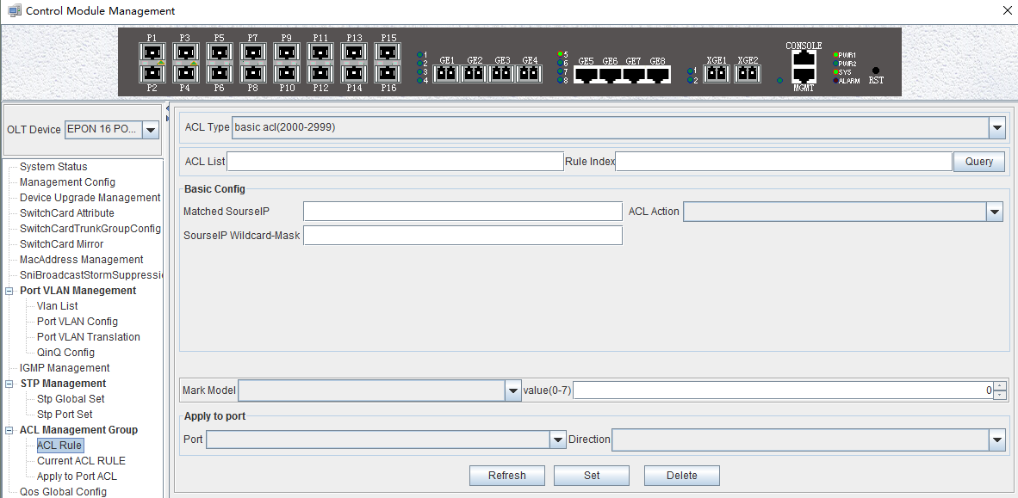
As above ‘Basic ACL’ page, you can set the following configuration parameters:
ACL List
ACL List，the set of ACL entries, this can inquire one of ACL according to inputting ACL Id and rule id.
Rule Index
ACL Rule Index，also rule id, and the range of value is 1-16.
Basic configuration
- Matched source IP
Configure matched source IP address of ACL Rule, in this format: A.B.C.D.
- ACL Action
ACL Action configuration, including ‘permit’ , ‘deny’ and ‘mark’ three options, indicates specific parameters of permitting or denying matching.
- Source IP Wildcard-Mask
Configure matched source IP Wildcard-Mask address of ACL Rule. IP Wildcard-Mask address is reverse address of IP sub-net mask. Example for: IP is 192.168.5.123, and its IP Wild-Mask is 0.0.0.225.
Mark Model
This is Mark Model, only applied in when ACL Action is ‘mark’ , including ‘null’ , ‘802.1p’ , ‘VLAN id’ ,’ TOS PRECEDENCE ’ and ‘ DSCP ’ .
- 802.1p
For the traffic priority LAN level 2 QoS/CoS protocol, the protocol header includes a 3-bit priority field with a value range of 0-7, which supports grouping packets into various traffic types.
- VLAN id
VLAN identifier，with a value range of 0-4094.
- TOS PRECEDENCE
TOS is a field of IP Message, with indicating type of service, a total of 8bit. PRECEDENCE is IP priority, and it’s at 0, 1, 2 three fields with a value range of 0-7.
- DSCP
DSCP is ‘Differentiated Services Code Point’, Which provides the standard of differentiated service for Qos, occupied before 6 bit of TOS, with a value range of 0-63.
Apply to port
- Port
ACL Rule applies to ports, including 10 ge port and 16 pon port.
- Direction
ACL Rule applies to direction of port, including ‘ ingress’ and ‘ egress’ two options.

【Example of Basic ACL configuration】
Example：Configure a basic ACL, and ID is 2001. Source IP is 192.168.5.205, and Rule Action is ‘permit’ ,as show below:
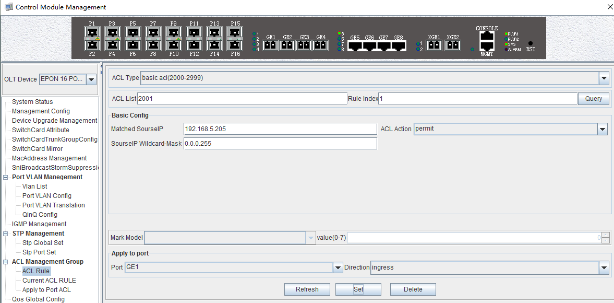
After completing those configurations,The configuration takes effect through the 'Set' button at the bottom of page, thus creating a basic ACL Rule successfully. Deleting a ACL rule created through the ‘Delete’ button. Updating a ACL Rule created through the ‘Refresh’ button.

6.2.12.1.2 Advance ACL Configuration

Double click the 'Switch Control Card' icon on the left side of the main interface, open the 'Control Module Management' window and enter the 'ACL Rule' window of ‘ACL Management’ page . Click the pull-down menu of ACL Type, and choose advanced acl(3000-4999) option.
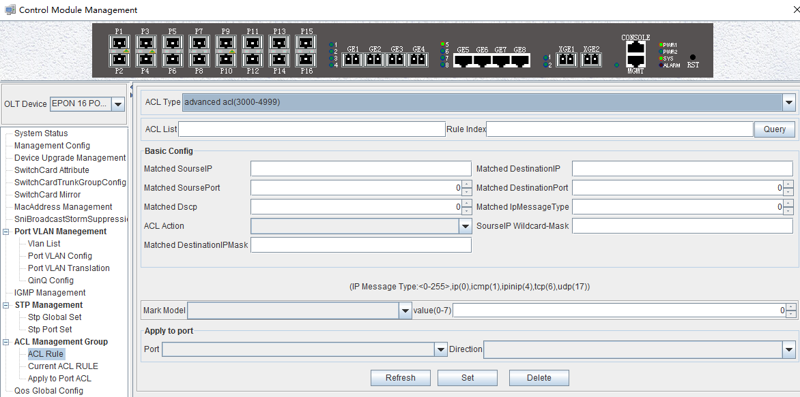

As above ‘Advanced ACL Rule’ page, compared with ‘Basic ACL Rule’ page, also set the following configuration parameters.
Basic configuration
- Matched destination IP
Configure matched destination IP address of ACL Rule, in this format: A.B.C.D.
- Matched source port
Configure matched source port Id of ACL Rule to match IP Protocol to TCP/UDP, ranging from 0 to 65535.
- Matched destination port
Configure matched destination port Id of ACL Rule to match IP Protocol to TCP/UDP, ranging from 0 to 65535.
- Matched DSCP
Configure matched DSCP of ACL Rule. DSCP is ‘Differentiated Services Code Point’ .In the TOS identification byte of each data packet IP header, taking advantage of used 6 bit and unused 2 bit to prioritize by coding value. DSCP user 6 bit, the value range of 0-63.
- Matched IP Message Type
Configure matched IP Message Type of ACL Rule, including IP, ICMP, IPINIP, UDP, TCP and so on, the value range of 0-255.
- Matched Destination IP Wildcard-Mask
Configure matched destination IP Wildcard-Mask address of ACL Rule. IP Wildcard-Mask address is reverse address of IP sub-net mask. Example for: IP is 192.168.5.205, and its IP Wild-Mask is 0.0.0.255.

【Example of Advanced ACL configuration 】
Example：Configure a advanced ACL, and ID is 3001. Rule Action is ‘Permit’ ,as show below:
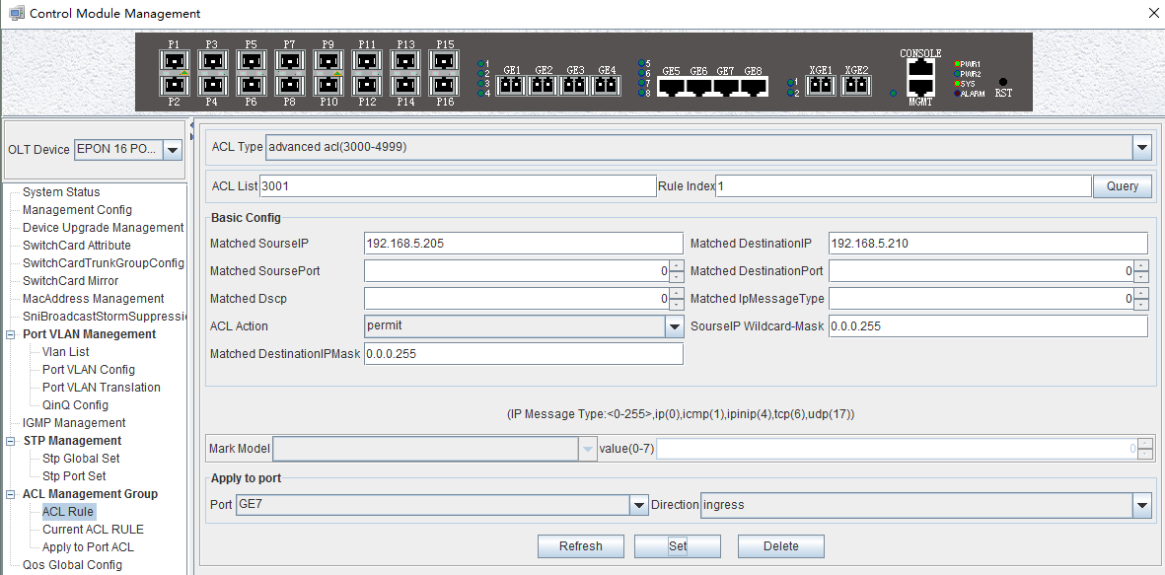
After completing those configurations,The configuration takes effect through the 'Set' button at the bottom of page, thus creating a advanced ACL Rule successfully. Deleting a ACL rule created through the ‘Delete’ button. Updating a ACL Rule created through the ‘Refresh’ button.

6.2.12.1.3 Link ACL Configuration

Double click the 'Switch Control Card' icon on the left side of the main interface, open the 'Control Module Management' window and enter the 'ACL Rule' window of ‘ACL Management’ page . Click the pull-down menu of ACL Type, and choose link acl(5000-5999) option.

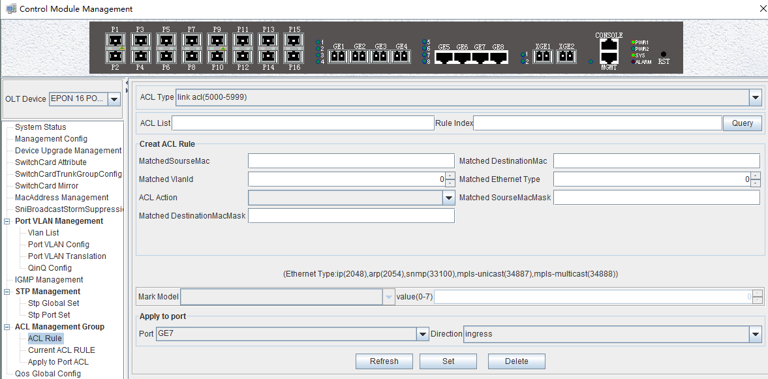
As above ‘Link ACL Rule’ page, compared with ‘Basic and Advanced ACL Rule’ page, also set the following configuration parameters.
Basic configuration
- Matched source MAC
Configure matched source MAC address of ACL Rule, only applied in link ACL Rule, in the format: AA-BB-CC-DD-EE-FF
- Matched destination MAC
Configure matched destination MAC address of ACL Rule, only applied in link ACL Rule, in the format: AA-BB-CC-DD-EE-FF。
- Match VLAN Id
Configure matched VLAN of ACL Rule, only applied in link ACL Rule. The value range of Id is 1-4094.
- Match Ethernet Type
Configure matched Ethernet data frame type of ACL Rule, only applied in link ACL Rule, including IP(2048), ARP(2054), SNMP(33100), mpls-unicast(34887), mpls-multicast(34888) and so on.
- Matched source MAC wildcard mask
Configure matched source MAC wildcard mask of ACL Rule, only applied in link ACL Rule. MAC wildcard mask of a single host is 00-00-00-00-00-00. MAC wildcard mask of any host is FF-FF-FF-FF-FF-FF.
- Matched destination MAC wildcard mask
Configure matched destination MAC wildcard mask of ACL Rule, only applied in link ACL Rule. MAC wildcard mask of a single host is 00-00-00-00-00-00. MAC wildcard mask of any host is FF-FF-FF-FF-FF-FF.

【Example of LINK ACL configuration】
Example：Configure a link ACL, and ID is 5001. Add outer VLAN 500 to MAC address. As shown below:
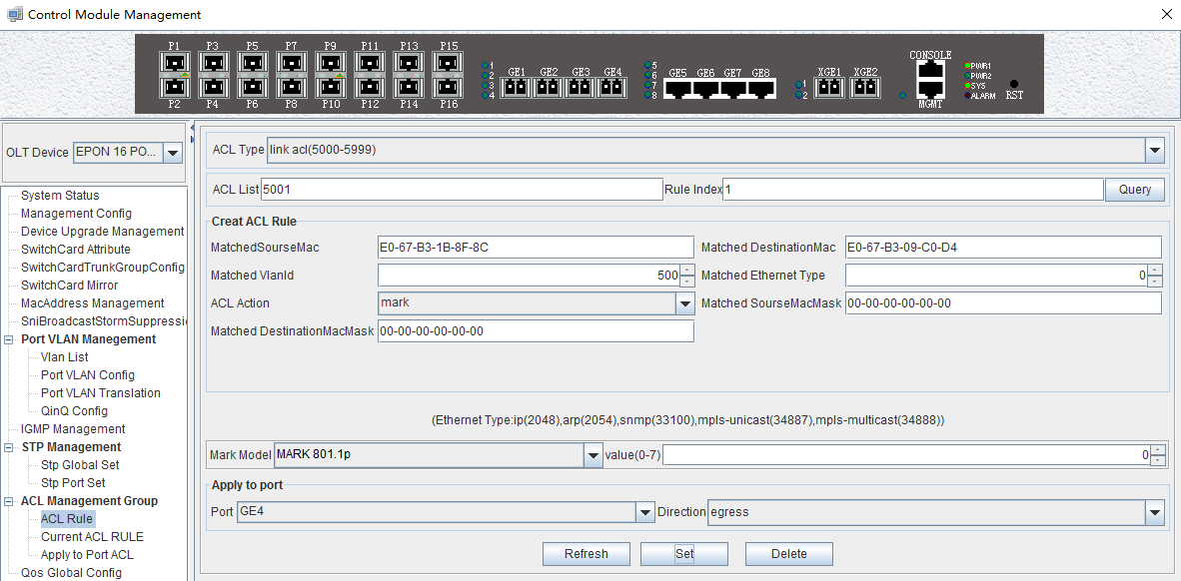
After completing those configurations,The configuration takes effect through the 'Set' button at the bottom of page, thus creating a link ACL Rule successfully. Deleting a ACL rule created through the ‘Delete’ button. Updating a ACL Rule created through the ‘Refresh’ button.

6.2.12.2 View OLT ACL Rule

Double click the 'Switch Control Card' icon on the left side of the main interface, open the 'Control Module Management' window and enter the ' Current ACL Rule' window of ‘ACL Management’ page .
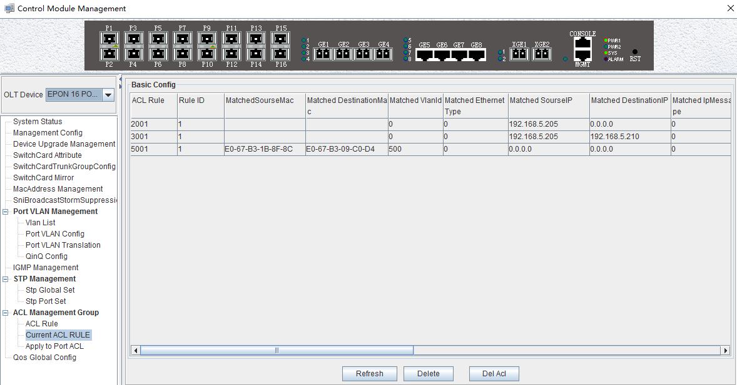

As shown in the figure above, you can view the previously created ACL rule entries on the 'Basic Configuration' page, where the contents are set on this page.On this page can also delete a ACL, first select an ACL rules, and then click ‘Delete’ or ‘Delete ACL’ button to delete the ACL rules which not applied directly to the port , if you want to delete the ACL which has been applied to the port, can only remove the binding with the port, and then delete. Update the configuration rules information by the 'Refresh' button.

6.2.12.3 View OLT Port Applied ACL Rule

Double click the 'Switch Control Card' on the left side of the main page to open the 'Control Module Management' window and enter the 'Apply to Port ACL' window on the 'ACL Management Group' page.
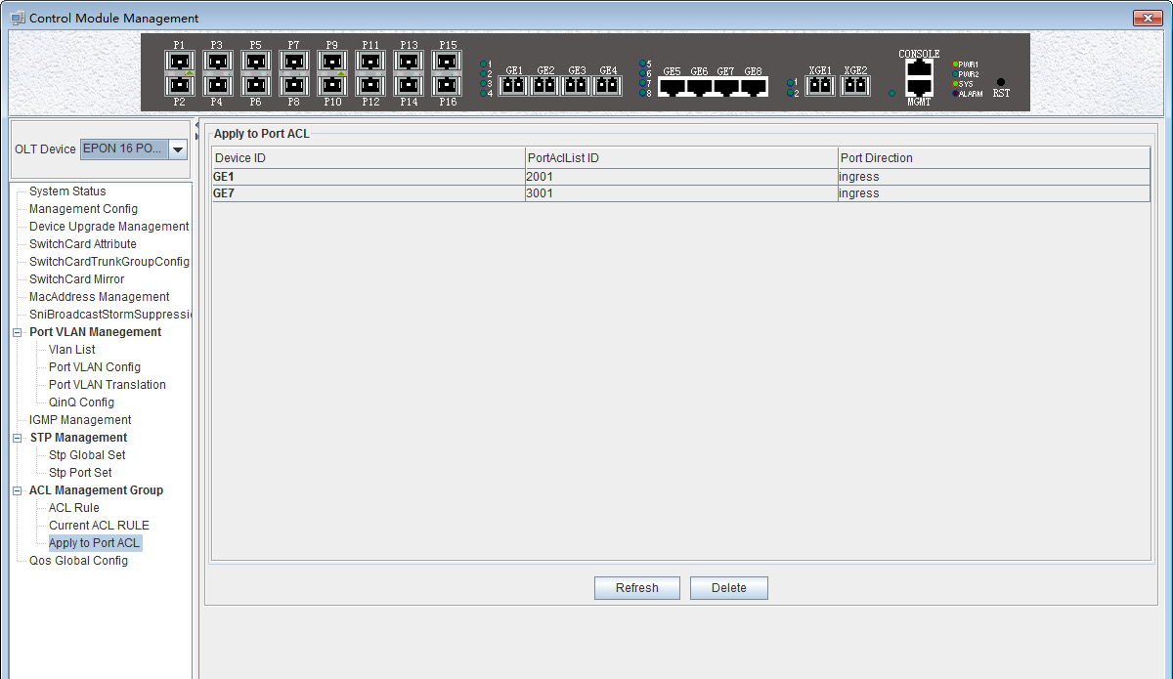
As you can see from the figure above, you can see the ACL that you created is applying to port, including the port number, ACL ID, and the direction of the application port . Through the ‘delete’ button, you can delete a ACL rule and update the rule information of the configuration through the ‘Refresh’ button.

6.2.13 OLT QoS Configure

QoS Refers to a network can use a variety of basic technology, to provide better services for the specified network communication , is a kind of network security mechanism, is used to solve the problem of network delay and blocking a technology.
Double click the 'Switch Control Card' icon on the left side of the main interface, open the 'Control Module Management' window and enter the 'Qos Global Information' management page configuration.
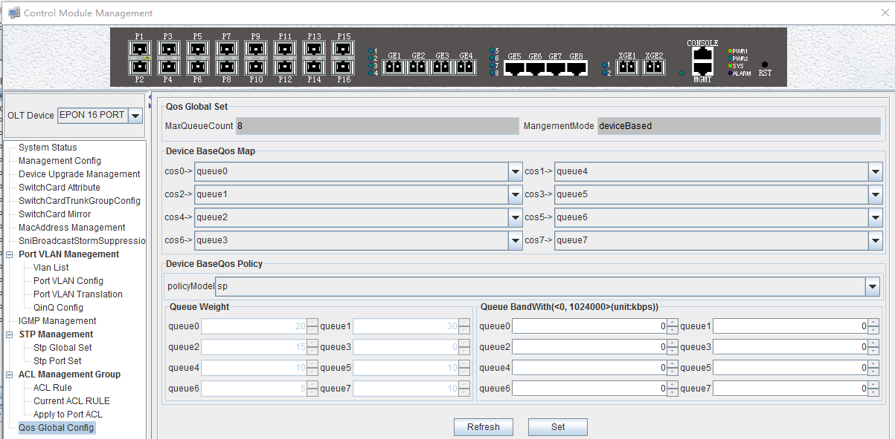

‘Qos Global Information’ management page mainly can configure ‘Device BaseQos Map’ , ‘Device BaseQos Policy’ , ‘Queue Wieght’ and ‘Queue Bandwidth’. The parameters are described as follows：
Qos system parameter
- Max queue count
System sets max queue count to 8. it’s range from queue 0 to queue 7.
- Qos management mode
System set Qos management mode to deviceBased.
Device BaseQos Map
Qos mapping table is corresponding relationship between priority and port queue. This can configure queue corresponding to the priority. The fault configuration is showing in the following table:
priority | Cos 0 | Cos 1 | Cos 2 | Cos 3 | Cos 4 | Cos 5 | Cos 6 | Cos 7
queue | Queue 0 | Queue 1 | Queue 2 | Queue 3 | Queue 4 | Queue 5 | Queue 6 | Queue 7
Device BaseQos Policy
Queue schedule has three modes, including sp- strict priority, WRR- Weighted Round Robin and SP+WRR. The details are follows.
- SP
Applying this mode, the system is scheduled to be dispatched strictly according to the priority of queue. Only when the high-priority queue is empty, the message of the low priority queue can be dispatched.
- WRR
Applying this mode, it needs to configure a weight for each queue, according to the weight between the queue scheduling in turn, ensure each queue can have a certain amount of services. When the priority is the same, the weight is not the same , the larger the weight of the queue, the longer the scheduling time.
- SP+WRR
This mode combines the advantages of SP and WRR, and adopts SP mode when dealing with some critical business, and adopts WRR mode when dealing with some business with low real time requirement.
Queue weight
Applying in the WRR and SP+WRR two modes, the sum of eight queue weight is required to be 100. And in the WRR mode, the value of weight is not be set 0.
Queue bandwidth
Set the size of bandwidth occupied by each queue, its range from 0kbps to 1024000kbps.

【Example of QoS configuration】
Example：Set Qos schedule mode to SP, the specific configuration is shown below:
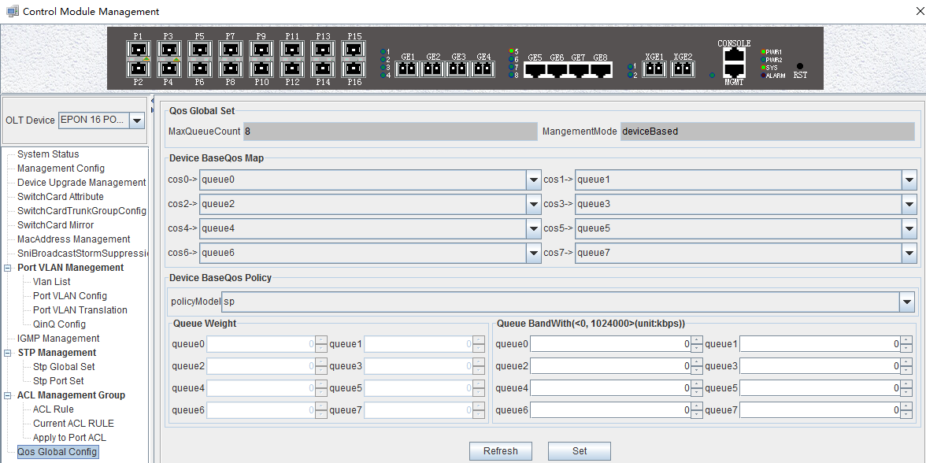

Example 2：Set Qos schedule mode to WRR, the specific configuration is shown below:
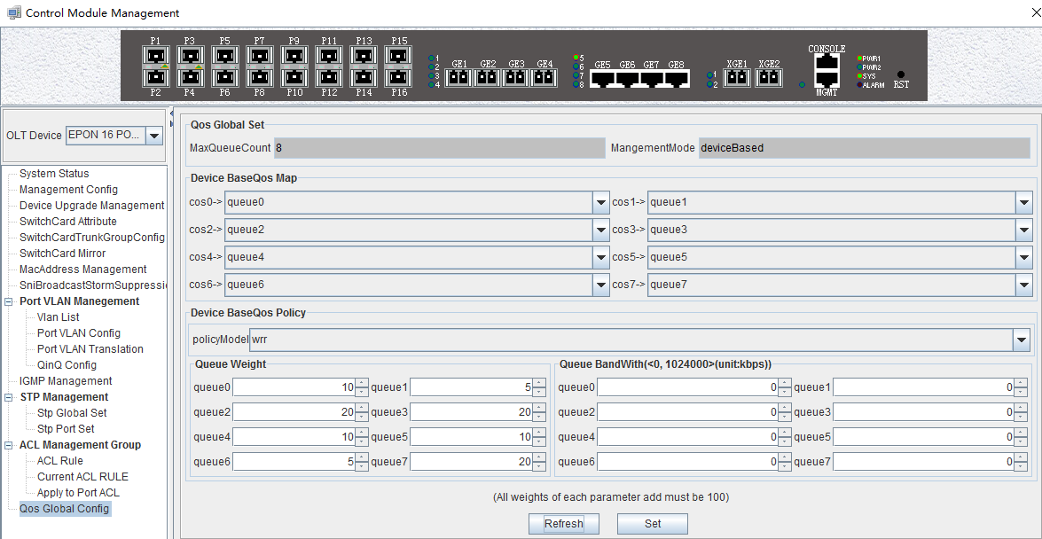

Example 3：Set Qos schedule mode to SP+WRR, the specific configuration is shown below:
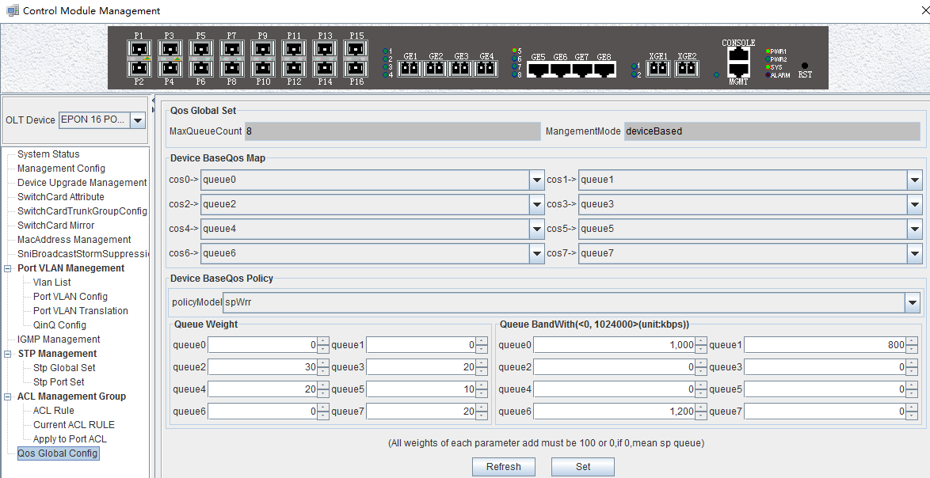

Attention：In the WRR mode, the value of weight is not be set 0. If the value of weight has 0, Qos schedule mode is SP+WRR.

OLT PON Card Management
This section introduces OLT PON Card Management function.
Double click the ‘PON card’ icon on the left side of the main page and enter the 'PON Card Management' window. The typical page is shown below:
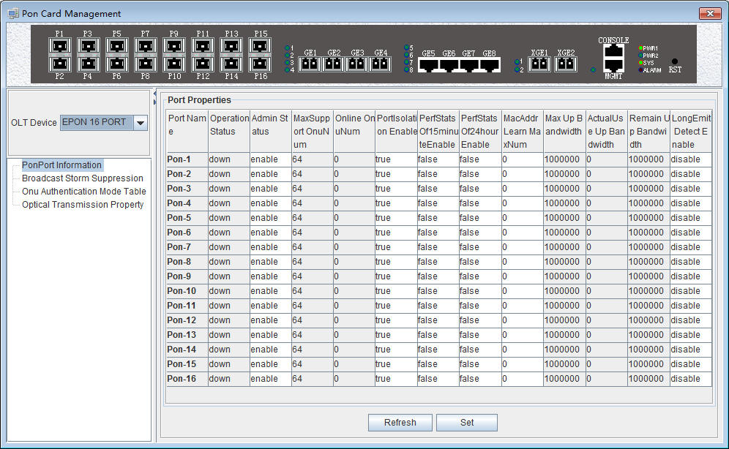
Through this window the user can do the following management:
- Some basic management of PON port of OLT;
- PON port storm suppression configuration;
- Authenticate the registration of the ONU;
- View the optical power information of the PON port;
The following sections describe the functional modules involved in the switch control module management window.

OLT PON Port Basic Management
Double click the ‘PON card’ icon on the left side of the main page to enter the 'PON port configuration information' page of the 'PON card management window':
The 'PON port configuration information' property page configures and views the PON port property parameters of the OLT. The parameters are described below:
- The PON port name
Displays the PON port name on the OLT. This parameter is an unchangeable state.
- Port operation status
Display the current PON port operation state, the status displays as ‘UP’ when connects to an ONU or the ONU has registered under the PON port; the state displays as ‘Down’ when not connected or the ONU unregistered under the PON port.
- Port management status
You can configure the PON port of the OLT to be closed or on. Configure ‘Enable’ to turn on the PON port; Configure ‘Disable’ to turn off the PON port; The default status is ‘Enable’ .
- Maximum number of ONU supported
Shows the maximum number of ONU connections that can be registered under this PON port.The current display is up to 64.
- The number of online ONU
Displays the number of ONUs that are currently registered under the PON port.
- PON port isolation enabled
Displays the managed state of the PON port isolation enabled, which administrators can configure for two states, namely 'True' and ‘False’.
When set to 'True', the ONUs under the PON port can not communicate with each other, that is, the isolation between the ONUs. When configured as 'False', the ONUs under the PON port can communicate with each other.
- 15 minutes performance statistics enabled
Displays the management status of the 15 minute performance statistics enabled, administrators can configure this option for two states, namely 'True' and ‘False'.
When set to 'True', the 15 minute performance statistics feature for the PON port is enabled; when configured as 'False', the 15 minute performance statistics for the PON port is disabled.
- 24 hours performance statistics enabled
Shows the management status of the 24 hour performance statistics enabled administrators can configure this option for two states, namely 'True' and 'False'.
When set to 'True', 24 hours performance statistics feature for the PON port is enabled; when configured as 'False', 24 hours performance statistics for the PON port is disabled.
- The maximum number of PON port MAC address learning
Configure the maximum number of mac addresses learned by the PON port of the OLT, in the range of 0 to 8092.
- maximum uplink bandwidth
Displays the maximum uplink bandwidth of the PON port .The maximum uplink bandwidth is 1000000 kbps.
- The actual use of the uplink bandwidth
Displays the actual uplink bandwidth of the current PON port, the unit is kbps.
- Remaining uplink bandwidth
Displays the remaining uplink bandwidth of the current PON port, the unit is kbps.
- ONU long persistence light-emitting alarm enable of the PON port
Display ONU long persistence light-emitting alarm enable of the PON port management status, administrators can configure this option, respectively, 'Enable' and ‘Disable 'two states.
When set to 'Enable', the ONU long persistence light-emitting alarm function of the PON port will be enabled. When the ONU is long persistence light-emitting, it will prompt the alarm and turn off the port. When configured as 'disable', the ONU long persistence light-emitting alarm function of the PON port will be disabled, when ONU is long persistence light-emitting it will not alarm.

PON Port Broadcast Storm Suppression
Double click the ‘PON card’ icon on the left side of the main page to enter the 'Broadcast Storm Suppression' page of the 'PON Card Management’ window,the typical page is shown below:
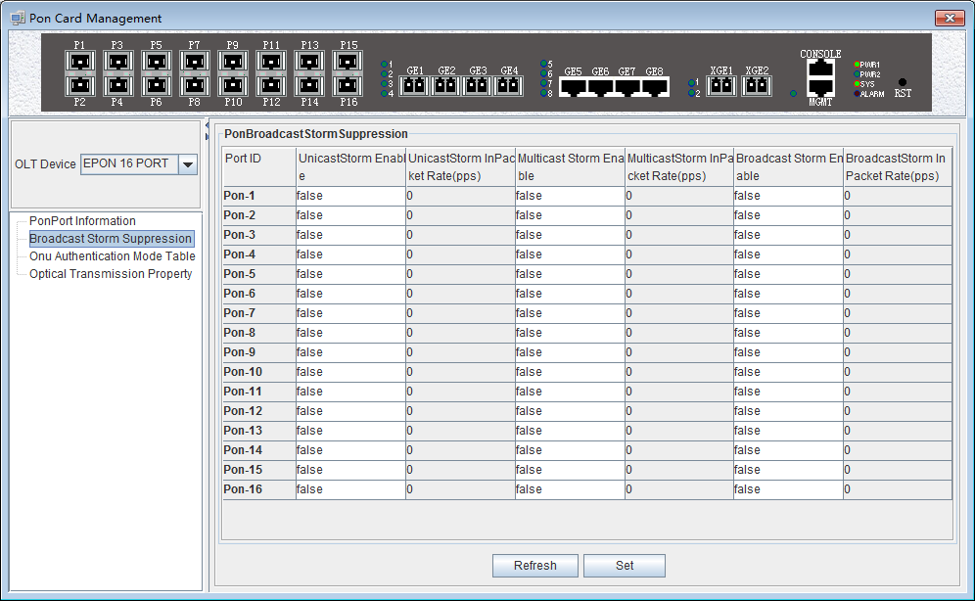

Enter this page to view and update settings, set the information about unknown unicast suppression enable status, unknown unicast storm suppression ingress rate, multicast storm suppression enable status, multicast storm suppression ingress rate, broadcast suppression enable status and broadcast storm suppression ingress rate. The explanation is as follows:
- Unknown unicast/multicast /broadcast suppression enable status
When select ‘True’, the unknown unicast / multicast / broadcast storm suppression of the port is enabled.
When select ‘False’, the unknown unicast / multicast / broadcast storm suppression of the port is disabled.
- Unknown unicast / multicast / broadcast input traffic limit
This option allows you to view the traffic limit, the units is PPS.

ONU Registration Authentication
Double click the ‘PON Card’ icon on the left side of the main page to enter the 'ONU Authentication Mode' page of the 'PON Card Management’ window,the typical page is shown below:

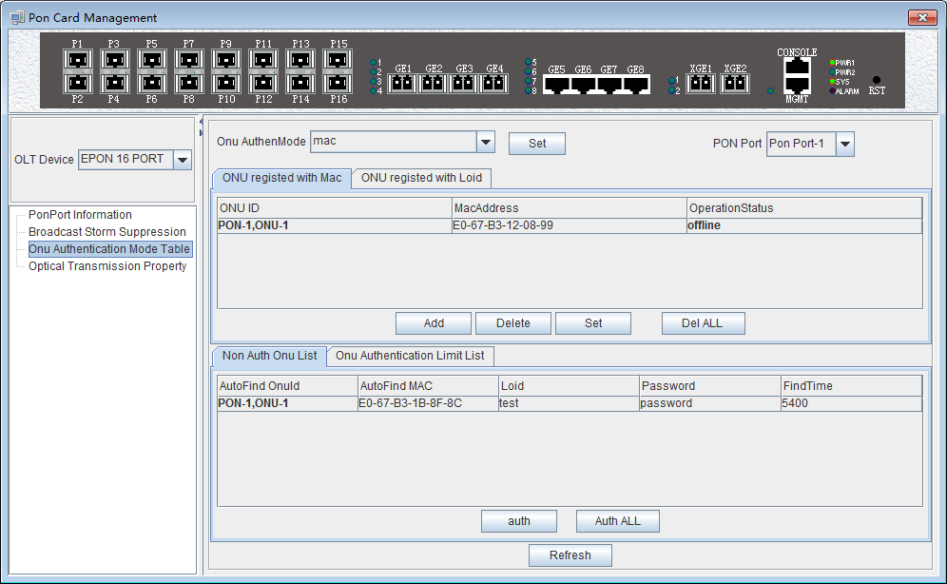
Through this page, you can perform the following management actions:
- ONU authentication mode
Through drop-down box of the "ONU Authentication Mode" of top of the page to choose the authentication mode, you can select the 'Loid-password', 'Mac_or_loid-password', 'Loid', 'Mac_or_loid', 'Mac' or 'All' in one of six ways.
- Loid-password
This function is not supported currently.
- Mac_or_loid-password
When this option is selected, the OLT will only recognize the mac or loid + password of the ONU. Only the specified mac address or loid + password ONU can be authenticated on the line.
- Loid
When this option is selected, the OLT will only recognize the loid of the ONU. Only the specified loid ONU can be authenticated on the line.
- Mac_or_loid
When this option is selected, the OLT will only recognize the mac or loid of the ONU. Only the specified mac address or loid ONU can be authenticated on the line.
- Mac
When this option is selected, the OLT will only recognize the mac of the ONU. Only the ONU of the specified mac address can be authenticated.
- All
When this option is selected, all ONUs connected to the OLT are automatically registered on and off automatically.
- PON port
This option allows you to select the specified PON port to authenticate the ONU of the PON port.
- Mac-authenticated ONU
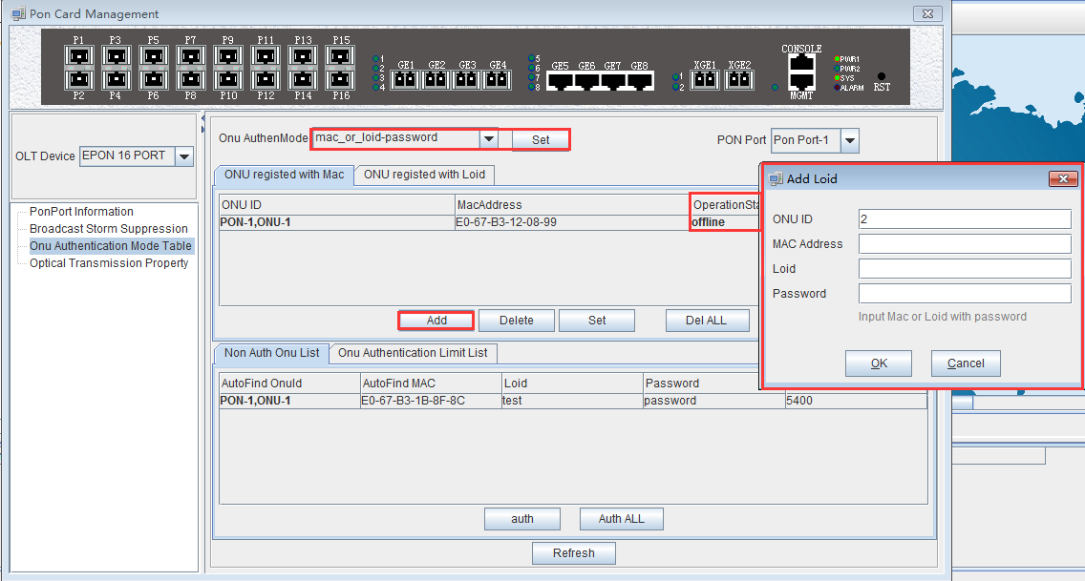
The list has 'ONU ID', 'Mac Address' and 'Operation Status' three items.
- ‘ONU ID’: Displays the PON port ID and ONU ID of the authenticated ONU.
- ‘Mac Address’: Displays the MAC address of the authenticated ONU.
- ‘Operation Status’: Displays the status of the authenticated ONU, both 'Online' and 'Offline'.
Use the 'Add', 'Delete', 'Set', and 'Delete All' menus to perform the corresponding operation for the mac address or the loid-authenticated ONU.
- Loid-authenticated ONU
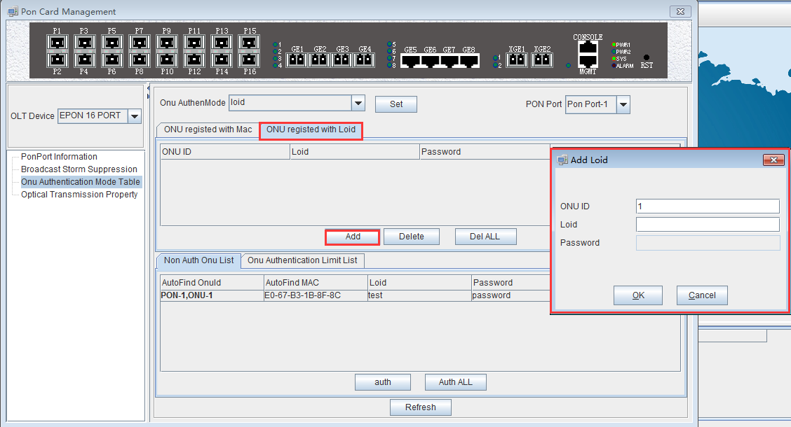
The list has 'ONU ID', 'Loid', 'Password' and 'Operation Status' four items.
- ‘ONU ID’：Displays the PON port ID and ONU ID of the authenticated ONU.
- ‘Loid’：Displays the Loid of the authenticated ONU.
- ‘Password’: Displays the password for the authenticated ONU.
- ‘Operation Status’：Displays the status of the authenticated ONU which is 'Online' and 'Offline'.
Use the 'Add', 'Delete', and 'Delete All' menus to perform the corresponding operations for the loid or loid-password authenticated ONU.
- List of Unauthenticated ONU
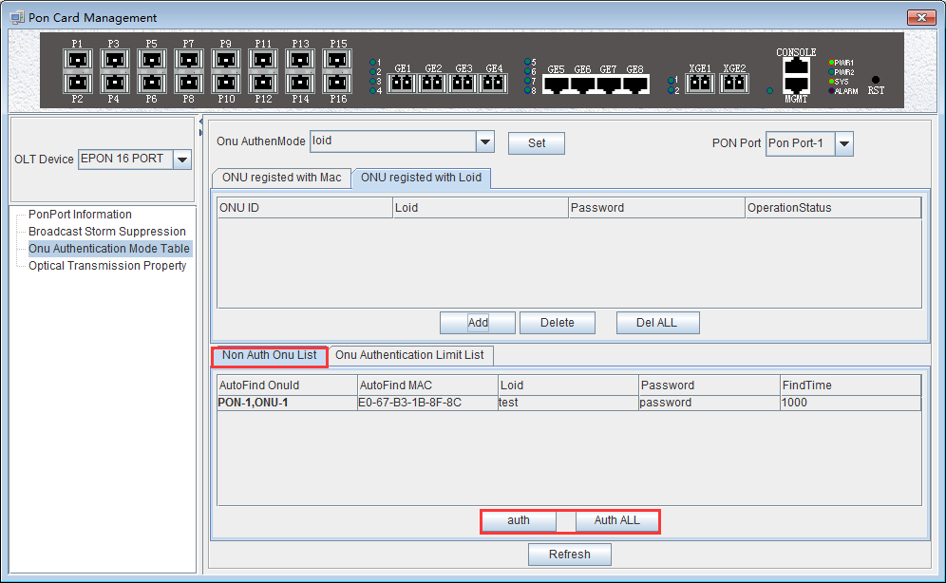
The list shows all the ONU messages that have not yet been authenticated. Which has 'Auto Find ONU ID', 'Auto Find MAC', 'Loid', 'Password', 'Find Time' of these items.
- ‘Auto Find ONU ID': Displays the PON port ID and ONU ID of the ONU that have not been authenticated.
- 'Auto Find MAC'：Displays the MAC address of the ONU that has not yet been authenticated.
- ‘Loid’：Display the ONU that has not yet been authenticated.
- ‘Password’：Displays the password of the ONU that has not yet been authenticated.
- 'Find Time'：Displays the find time of the unauthenticated ONU, the unit is milliseconds.
In addition, the ONU is authenticated by the two buttons, ‘Auth’ and ‘Auth all’, for the ONU of the list that has not been authenticated.
Update the ONU which authenticated in the OLT through the refresh button.
- List of ONU authenticated restriction
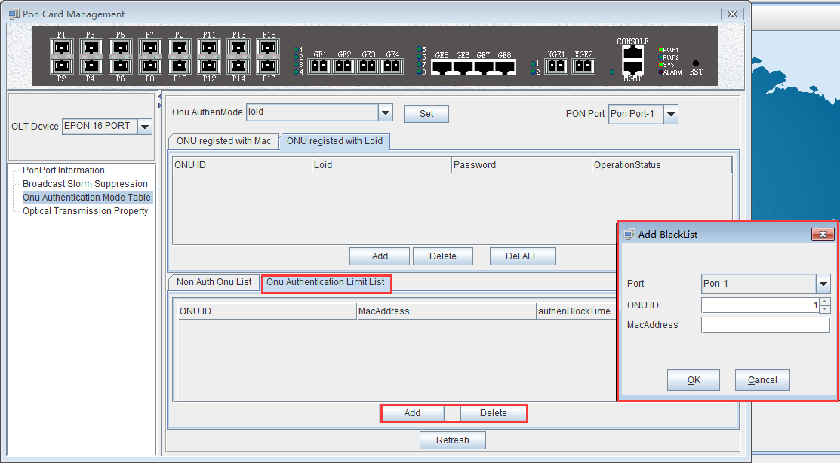
The list shows all ONU authenticated restriction, namely the ONU authenticated blacklist, and the ONU on which will not be authenticate online. There are ‘ONU ID’, ‘Mac Address’, ‘AuthenBlockTime’ these items.
- ‘ONU ID’：Displays the specific PON port and ONU ID of the blacklist ONU
- ‘Mac Address’：Displays the blacklist ONU Mac address
- ‘AuthenBlockTime’：Displays the join time of the blacklist, the unit is milliseconds.
In addition, the 'Add' and 'Delete' buttons are used to add or remove blacklisted ONUs.
Use the 'Refresh' button to update the ONU authentication restriction list.

[ONU Mac_or_password authentication mode configuration example]
Example 1: Register a ONU in the Mac_or_password authentication mode under the PON 1 port. Steps are as follows:
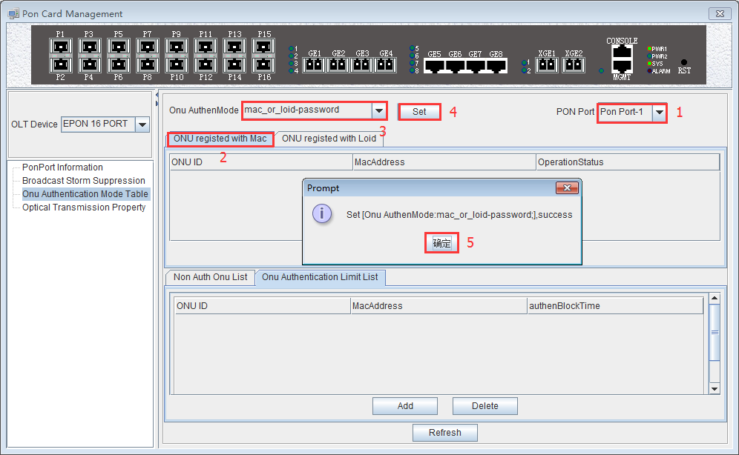
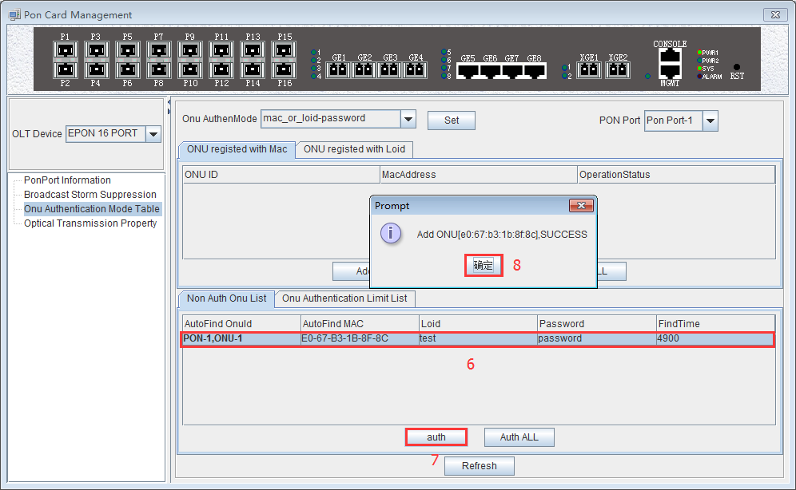
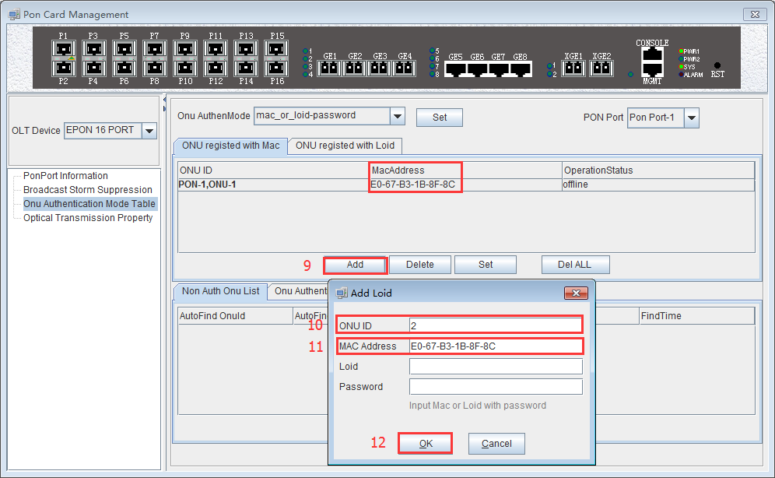
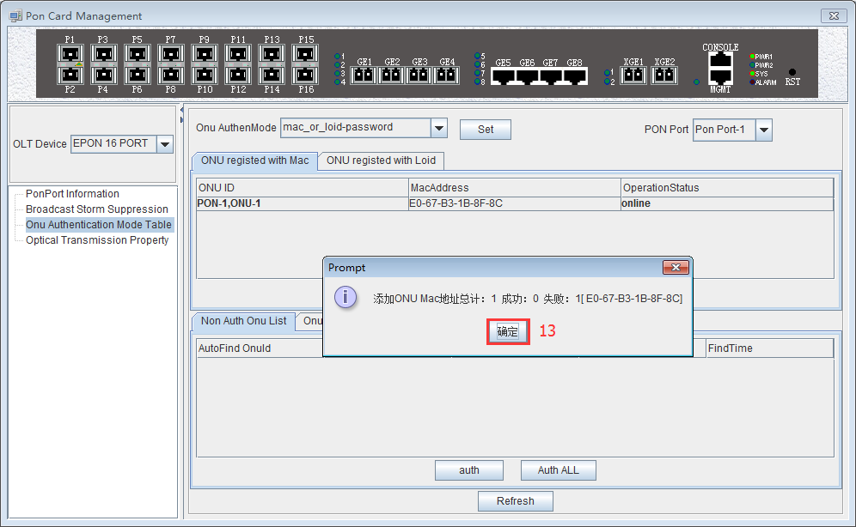
Added successfully. ONU operation status is online.
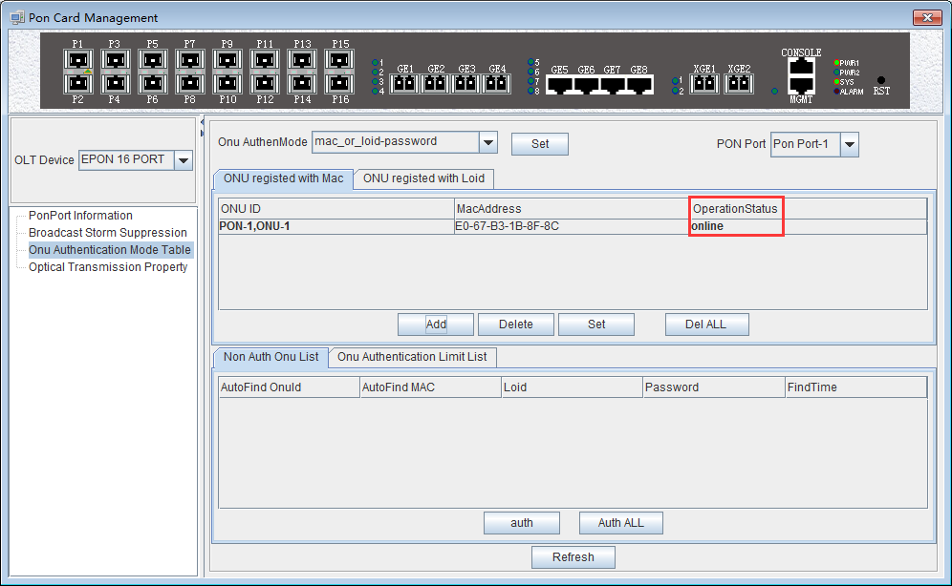

[ONU loid authentication mode configuration example]
Example 1: Register a ONU in Loid authentication mode under the PON 1 port. Steps are as follows:
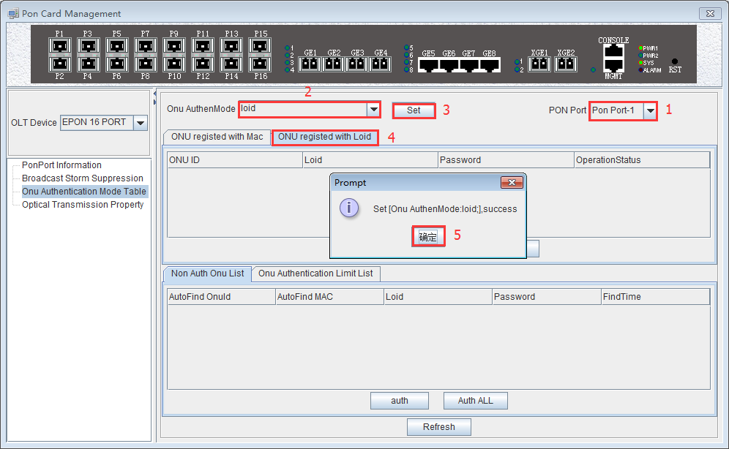
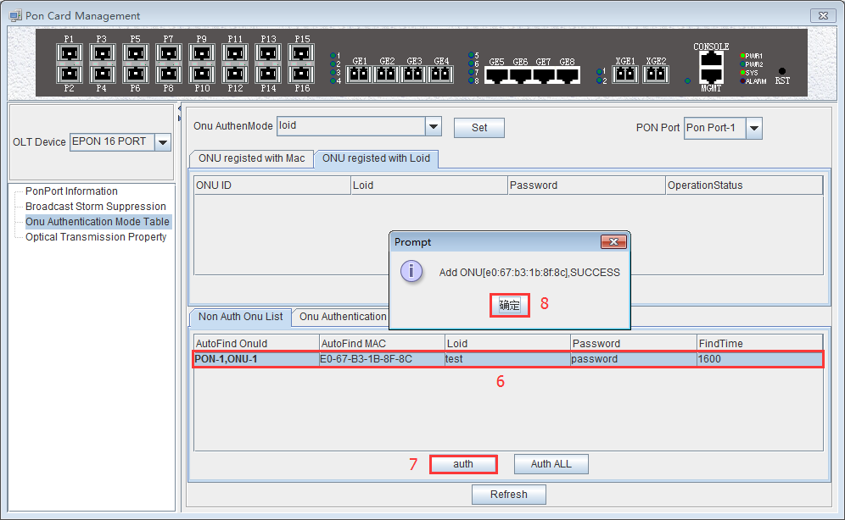
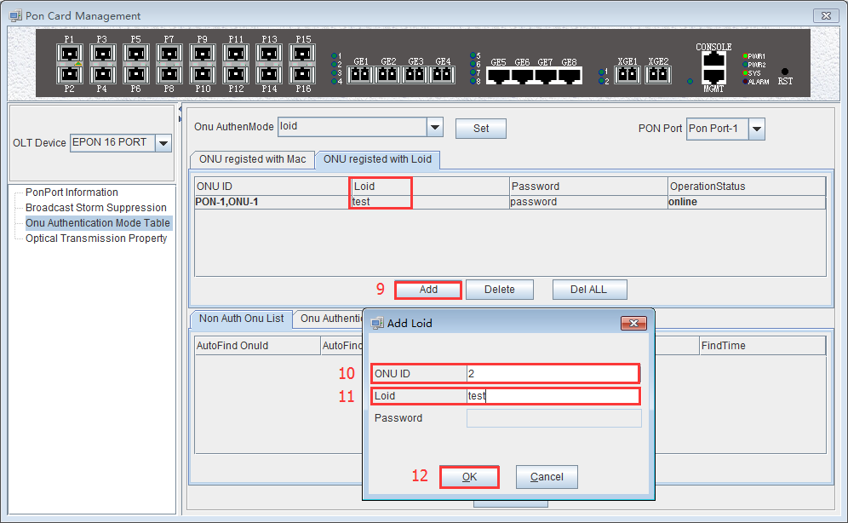
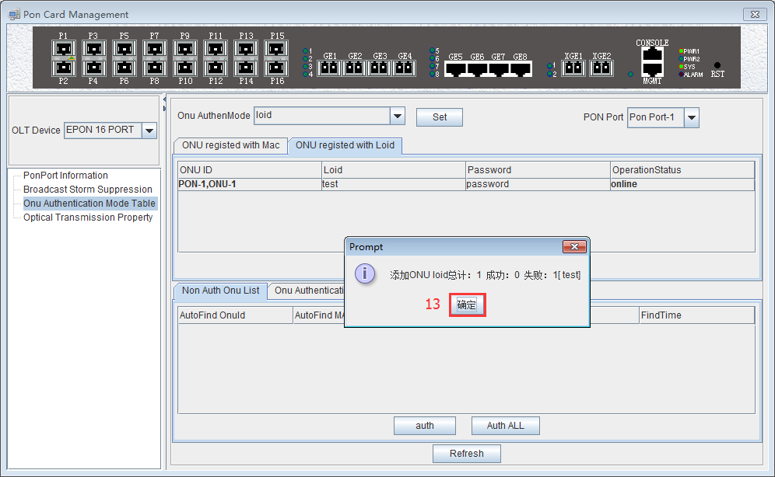
ONU operation status is online.
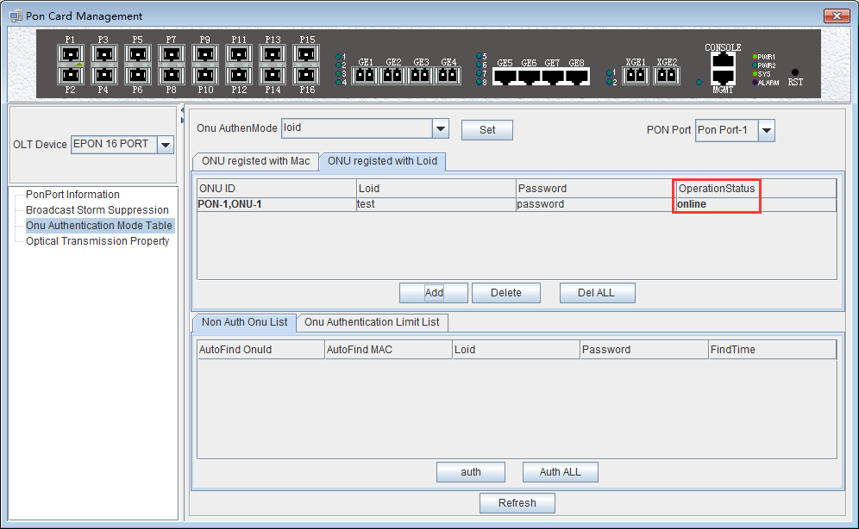

[ONU blacklist authentication mode configuration example]
Example 3: Add a ONU blacklist at the PON 1 port. Steps are as follows:
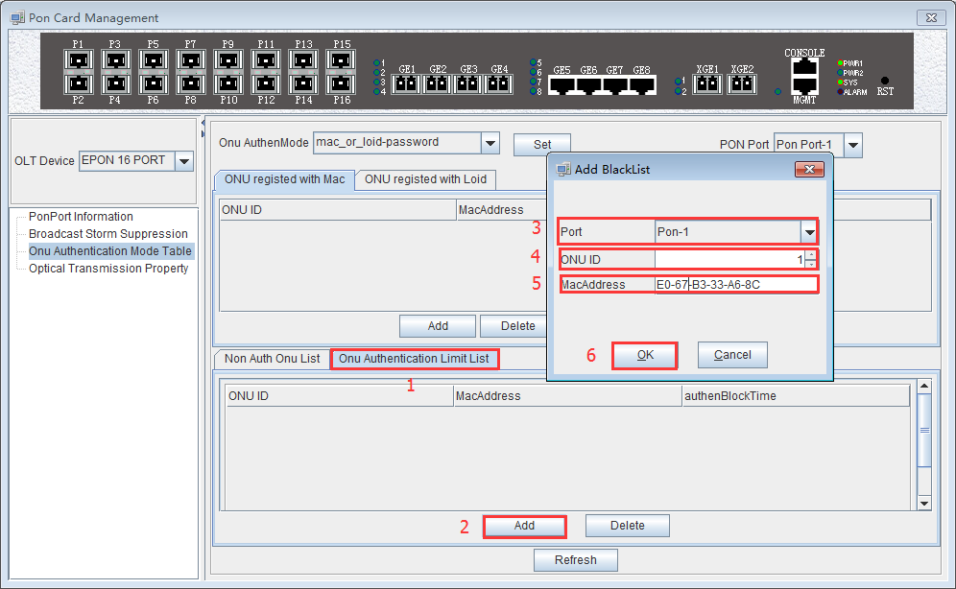
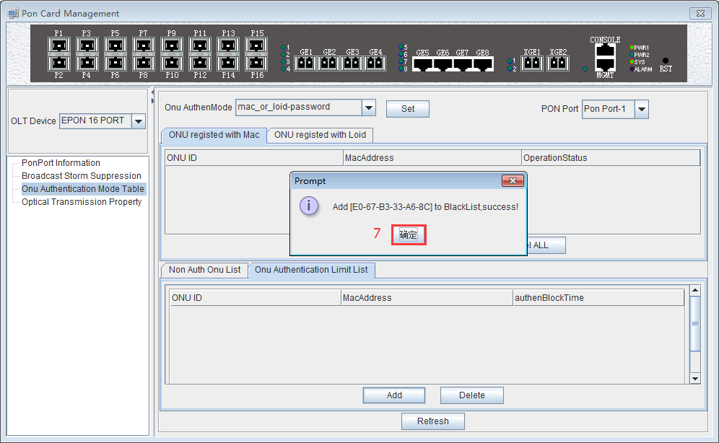
Added a ONU blacklist successfully.
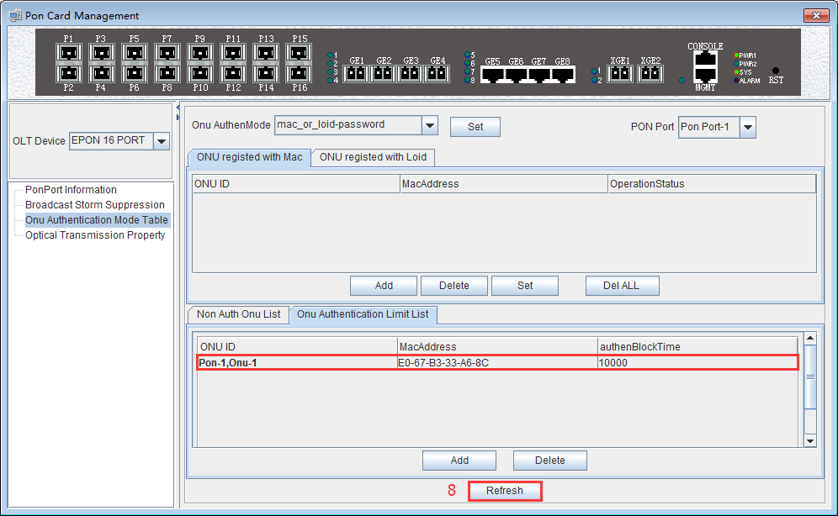

View OLT PON port optical Power Information
Double click the ‘PON Card’ icon on the left side of the main page to enter the ‘Optical Transmission Property’ page of the 'PON Card Management’ window. The typical page is as follow: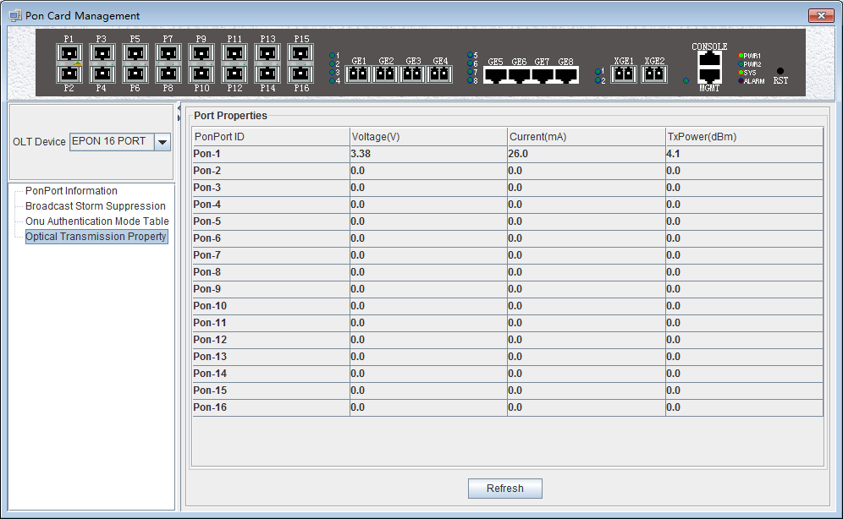
Enter this page to view and update the voltage, current, and transmit power of each PON port module.
- Voltage
Current OLT PON port optical module operating voltage, the unit is V.
- Current status
Current OLT PON port optical module operating current, the unit is V.
- transmission power
Current OLT PON port optical module transmission power, the unit is dbm.

Single PON Ports Manage
Double click the ‘Port -1’ icon under the ‘PON Card’ on the left side of the main page and enter the 'PON Card Management' page. The typical page is as follows:
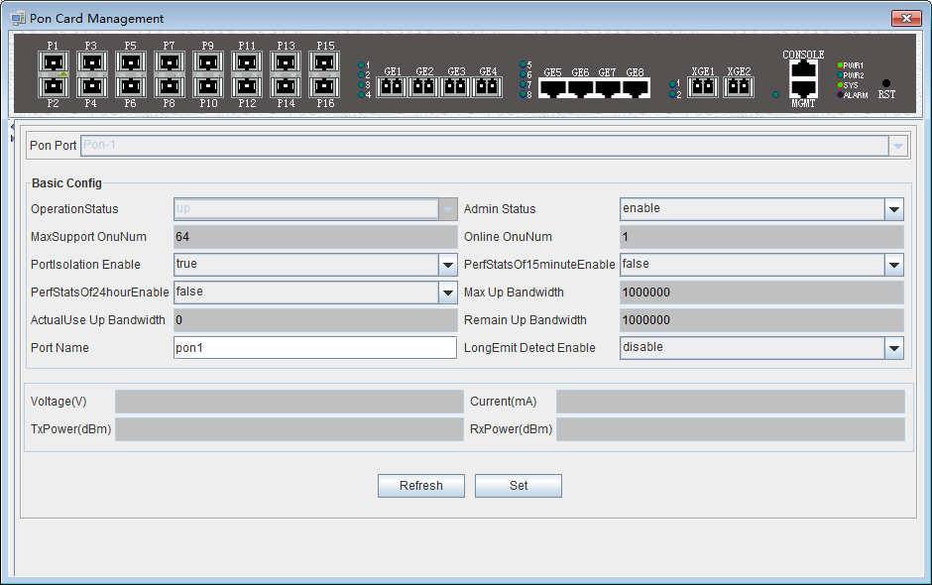
In this page, you can view the PON port, port operation status, port management status, the maximum number of ONU supported, online ONU number, PON port isolation enable, 15 minutes performance statistics enable, 24 hour performance statistics enable, maximum uplink bandwidth, Actual use of bandwidth, the remaining uplink use bandwidth, PON port name, ONU long persistence light-emitting alarm enable of the PON port, voltage, current, transmission power, receive power and other information. The following is a brief introduction to these parameter:
- Pon port
Display the port to which the Pon port page belongs. The current port belongs to the PON1 port.
- Port operating state
The status of the port is shown as 'Up' and 'Down' respectively. When the status is 'Up', it indicates that the port is working normally. When the status is 'Down', it indicates that the port is offline and does not work.
- Port management status
Display the management status of the port, administrators can configure this option, there are ‘Enable' and ‘Disable 'two states.
When set to 'Enable', the port is enabled, which means the port can communicate normally. When configured as ‘Disable’, the port will be disabled, and the port will not be able to communicate.
- Maximum number of ONUs supported
It shows the maximum number of ONU connections that can be registered under this PON port. The maximum current display is 64.
- Number of online ONU
Display the number of ONU currently registered under the PON port.
- Enable ONU port isolation
Displays the managed state of the PON port isolation enabled, which administrators can configure for two states, namely 'True' and ‘False’.
When set to 'True', the ONUs under the PON port can not communicate with each other, that is, the isolation between the ONUs. When configured as 'False', the ONUs under the PON port can communicate with each other.
- 15 minutes performance statistics enabled
Displays the management status of the 15 minute performance statistics enabled, administrators can configure this option for two states, namely 'True' and ‘False’.
When set to 'True', the 15 minute performance statistics feature for the PON port is enabled; when configured as 'False', the 15 minute performance statistics for the PON port is disabled.
- 24 hours performance statistics enabled
Shows the management status of the 24 hour performance statistics enabled administrators can configure this option for two states, namely 'True' and 'False'.
When set to 'True', 24 hours performance statistics feature for the PON port is enabled; when configured as 'False', 24 hours performance statistics for the PON port is disabled.
- maximum uplink bandwidth
Displays the maximum uplink bandwidth of the PON port .The maximum uplink bandwidth is 1000000 kbps.
- The actual use of the uplink bandwidth
Displays the actual uplink bandwidth of the current PON port, the unit is kbps.
- Remaining uplink bandwidth
Displays the remaining uplink bandwidth of the current PON port, the unit is kbps.
- The PON port name
Displays the PON port name on the OLT. The administrator can set the name of the port for administrator management. Supports 1-17 characters.
- The PON port of the ONU long persistence light-emitting alarm enable
Display PON port of the ONU long persistence light-emitting alarm enable management status, administrators can configure this option, respectively, 'Enable' and ‘Disable’ two states.
When set to 'Enable', the ONU long persistence light-emitting alarm function of the PON port will be enabled. When the ONU is long persistence light-emitting, it will prompt the alarm and turn off the port. When configured as 'Disable', the ONU long persistence light-emitting alarm function of the PON port will be disabled, when ONU is long persistence light-emitting it will not alarm.
- Voltage
Displays the operating voltage of the current PON module, the unit is V.
- Current
Displays the operating current of the current PON module, the unit is mA.
- Transmission Power
Displays the transmission power of the current PON module, the unit is dBm.
- Received Power
Displays the received power of the current PON module, the unit is dBm.

ONU Device Management

ONU Device Management Introduction
ONU is the user end device in EPON system. EMS software manages the accessed ONU devices through their registered OLT device. OLT device transmits management operations received from EMS software to accessed ONUs through OAM frames defined based on IEEE802.3ah standard.
EMS software supports a variety of types and models of ONU equipment management, such as 1FE port ONU, 4FE port ONU, 8FE port ONU, 24FE port ONU, 1FE+1GE port ONU, 4FE+2POTS ONU, 4FE+1CATV ONU, 4FE+2POTS+1CATV ONU and so on .
This part use the 4FE+CATV port type ONU as an example to introduce EMS management software on ONU equipment, pure data ONU which is configured under different port and data part of the multi service ONU are basically managed in the same way through the EMS software , different sections are introduced in the relevant document for the type of device that should be available.
Double click the selected ONU device icon on topology-tree list to open ‘ONU Management’ window. The function pages located on this window contain all the management features for this type ONU device.The typical ONU management window page is shown as follows:
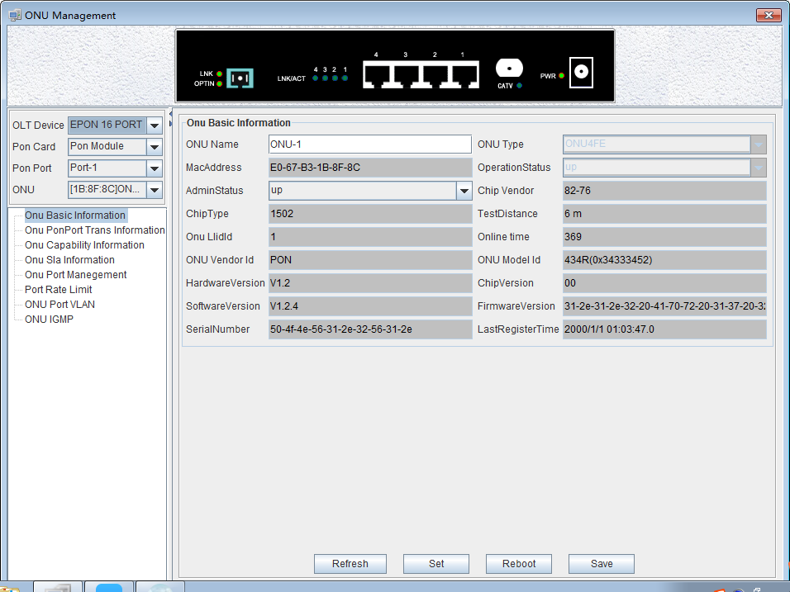
As shown above, the ONU device management includes the following:
- Device interface indicate lamp working condition
- ONU Basic Information
- ONU basic operations, such as refresh, configure, restart, etc.
- ONU Port Transfer Information
- ONU Capability Information
- ONU Sla Information (upstream/downstream rate limit configuration)
- ONU Port Management
- ONU Port rate limit
- ONU Port VLAN
- ONU IGMP
Following sections introduce these ONU management features.

ONU Basic Information Management

ONU Indicator Status
Usually, the device panel diagram will be displayed on the ONU management window. On this diagram, all the working LED indicators show the actual working EPON OLT User Manual- EMS Software status. See the following example figure.
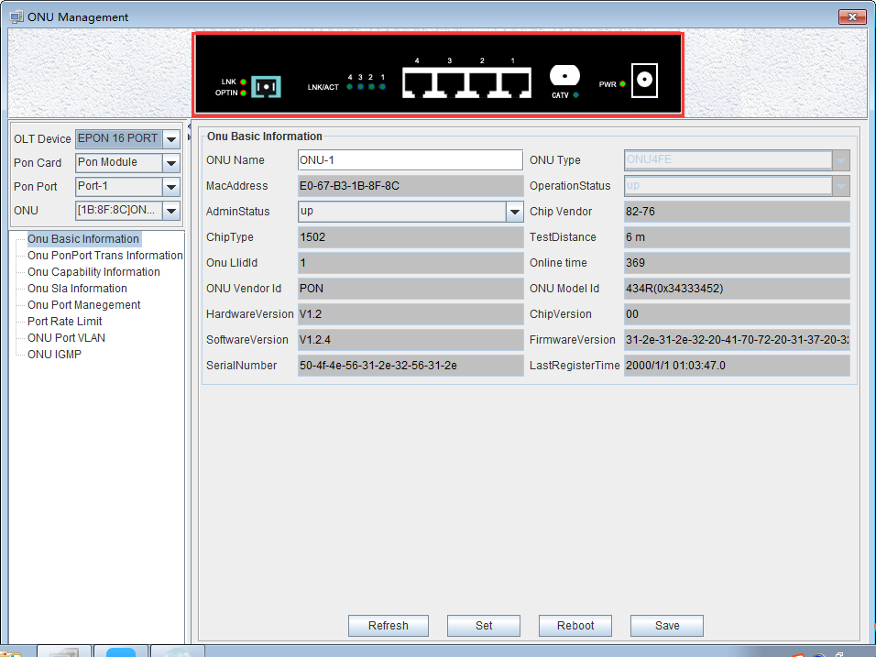

ONU Basic Information View
Double click the ONU which you wanted to manage on the left side of the main page , enter the ONU management page , click on ‘Basic Information’ into the ‘Basic Information’ page, the page displays the basic information of the device.
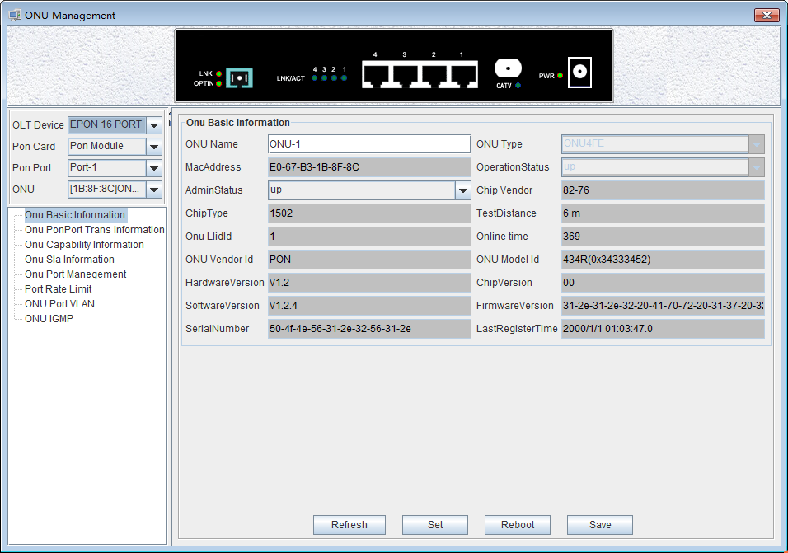
On this page, user can view ONU name, ONU type, ONU MAC Address, ONU Operation Status, ONU Chip Vendor, ONU Chip Type, ONU Test Distance, ONU LLID ID , ONU Online time, ONU Vendor Id, ONU Mode Id, ONU Hardware Version, ONU Chip Version, ONU Software version, ONU Firmware Version , ONU Serial Number, Last Register Time. Following are explanations for some special parameters.
- ONU Name
This configuration can name ONU and distinguish the role of each ONU.
- ONU Testing distance
Shows the fiber distance between the ONU and the OLT, distance below 6 meters shows the initial distance to 6 meters by default.
- ONU Management Status
There are three ONU management states to set ONU port status enabled or disabled. Set to ‘Up’ to open the port, set to ‘Down’ to close the port , ‘Testing’ state cannot be used at present,You can refresh, setup, restart and save the configuration operation on ONU through the function button at the bottom of the page.

ONU PON Port Optical Power Information
Double click ONU which is managed in the left of main interface , then enter ONU management interface. Click ‘ONU PON Port Trans Information ’ , then enter ‘ONU PON Port Trans Information’ page.
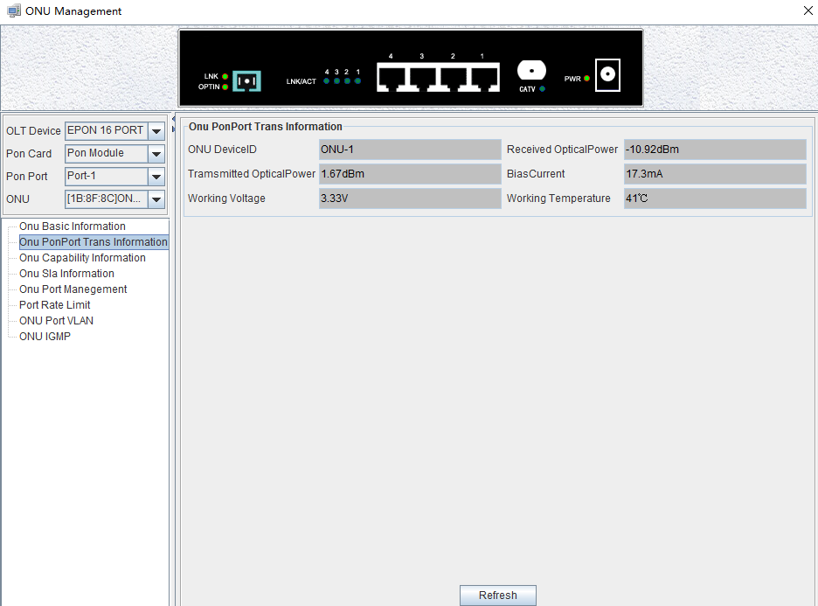

This page displays ONU Device ID, ONU Received Optical Power, ONU Transmitted Optical Power, ONU Bias Current, ONU Working Voltage, ONU Working Temperature.
- ONU Device ID
The index name of ONU corresponding to pon port for user to view ONU’s location.
- ONU Received Optical Power
This displays ONU received Optical Power, in dBM.
- ONU
This displays ONU transmitter Optical Power, in dBM.
- ONU Bias Current
This displays ONU Bias Current, in mA.
- ONU Working Voltage
This displays ONU Working Voltage, in V.
- ONU Working temperature
This displays ONU Working temperature, in ℃.

ONU Capability Information
Double click ONU which is managed in the left of main interface , then enter ONU management interface. Click ‘ONU Capability Information’ , then enter ‘ONU Capability Information’ page.
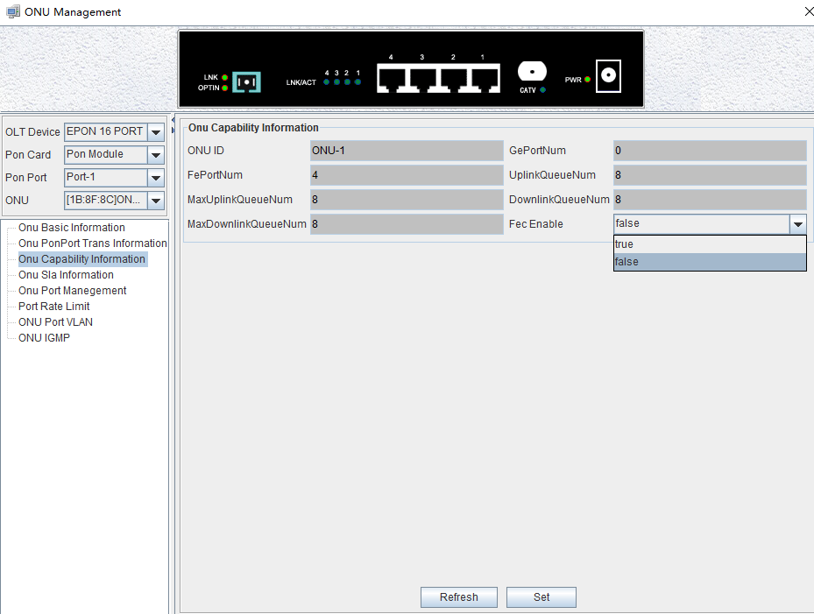
This page displays ONU ID, ONU Ge Port Number, ONU Fe Port Number, Uplink Queue number, Max Uplink Queue number, Downlink Queue number, Max Downlink Queue number, also can set fec function .
Explain:
Setting ONU FEC function has two options, including ‘True’ and ‘False’. ‘True’ is on FEC function. ‘False’ is off FEC function. Choose ‘True’ or ‘False’, and click ‘Set’ button on the page to complete the settings.
FEC is a very important anti-interference algorithm. Open FEC to reduce symbol error rate of digital signal and improve reliability of signal transmission.

ONU Sla Configuration
Double click ONU which is managed in the left of main page, then enter ONU management page. Click ‘ONU Sla Information ’ , then enter ‘ONU Sla Information’ page.
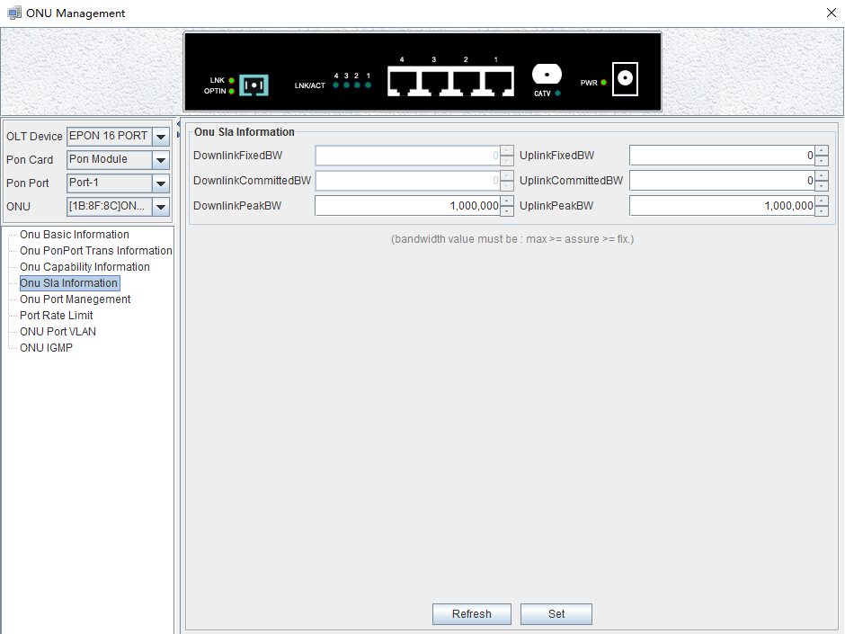
In the EPON network, after ONU registers successfully, it’s uplink OLT device will assign one logic link for it, identified by LLID. In downstream direction, OLT add LLID filed to the received standard Ethernet frame then send them to all registered ONU devices. In upstream direction, OLT schedule and forward upstream packets based on the logic links registered by ONU devices.
On the page, network manager can view and configure SLA up/down link Fixed BW, SLA up/down link Committed BW, SLA up/down link Peak BW. Attention: bandwidth value must be: max>=assure>=fix.
Following subsections introduce the logic link management parameters:
- Min assure bandwidth
Min assure bandwidth is the min bandwidth of dynamic bandwidth allocation algorithm for the link assigned. DBA also assure that the link can achieve min assure bandwidth. It’s the lower limit of dynamic bandwidth allocation.
The setting range of Min assure bandwidth is : 0~1000000, in kbps, and fault value is 0.
Attention：The SLA configuration failed when the min assure bandwidth of all links under a PON was greater than 1G.
- Max assure bandwidth
Max assure bandwidth is the max bandwidth of dynamic bandwidth allocation algorithm It’s the upper limit of dynamic bandwidth allocation. If the link bandwidth is not limited, it is recommended to set it to 1000Mbps.
The setting range of Max assure bandwidth is : 0~1000000, in kbps, and fault value is 10000.
- Max burst byte
The setting range of Max burst byte is : 1~256, in Kbytes.

ONU Port Configuration
Double click the ONU which you want to manage on the left of the main page, enter the ONU management page, click on ‘ONU Port Management’.
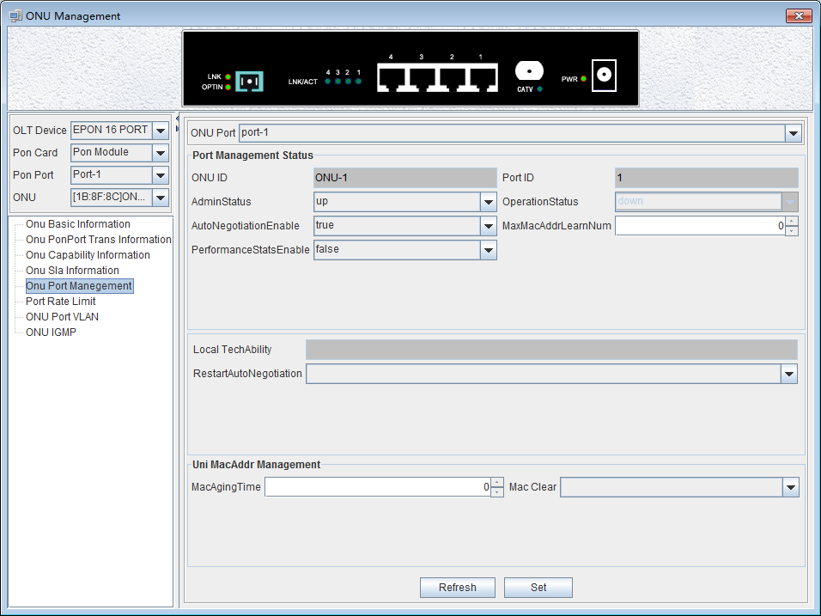
This section describes the management function and parameter configuration for ONU user ports.ONU user port management includes the following:
Port Management Status
‘Port Management Status’ You can view ONU ID,port ID, operation status, local equipment ability, admin status, port auto negotiation enable, max MAC address learning number, performance status enable, restart the auto negotiation and so on of the selected port.
Through this page, you can set the management status which are up, down, and testing three options, the maximum number of MAC address learning, the port auto-negotiation enable, the current performance acquisition enable , start auto-negotiation and other parameters of the selected port. When the port enable status is ‘False’, the port corresponding function is turned off. When the port enable state is ‘True’, the port corresponding function is turned on.
- Admin Status
The port management state has three options: up, down, testing, which means port activation, port is not activated, and the testing option is not available .
- Auto Negotiation Enable
Auto Negotiation Enable has true and false options, true means to enable auto negotiation, and false to disable auto negotiation.
The port auto-negotiation mode is that determines the port rate and duplex mode according to the actual speed of the device connected to the ONU.
- Performance Status Enable
Configure the ONU performance statistics switch, 'False' means to disable the ONU performance statistics, and 'True' means to enable ONU performance statistics.
- Max MAC Address Learning Number
Configure the maximum number of MAC addresses learned by the ONU, and that will not be learned when the maximum number of MAC addresses in the MAC address table of the ONU reaches the maximum number of the maximum settings.
- Restart Auto Negotiation
You can restart the auto negotiation manually by selecting restart.

Uni MAC Address Management
You can configure the MAC aging time and MAC clear of the OLT as follows.
- Mac Aging Time
Set the MAC aging time of the ONU, the MAC addresses learned by ONU will automatically be cleaned up after this time.
- Mac Clear
Select allDynamc, and click the 'Set' button to clean up the MAC address.

ONU Port Rate Limit Configuration
Double click the ONU to be managed on the left side of the main page, enter the ONU management page, and click 'Port Rate Limit'.

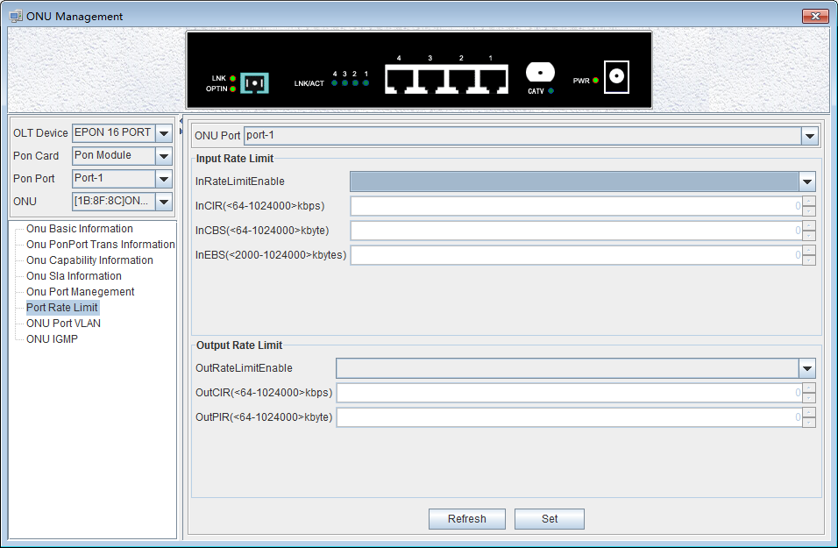

Input Rate Limit
The figure above can set port input rate limit to enable state,committed information rate(64-1024000kbps), committed burst size(64-1024000kbyte) and excess burst size(2000-1024000 kbytes). When the enable status is ‘False’, the port function is turned off and the port function is turned on when the enable status is ‘True’.

Output Rate Limit
The figure above can set port output rate limit to enable state,committed information rate(64-1024000kbps),peak information rate(64-1024000kbyte). When the enable status is ‘False’, the port function is turned off and the port function is turned on when the enable status is ‘True’.

【Example of ONU Port Rate limit configuration】
Example: Enable the rate limit on the fourth port of the ONU. The committed information rate of the input limit is 200 kbps. The committed burst size is 300 kpbs. The excess burst size is 3000 kpbs. The committed information rate of the output limit is 200 kpbs and the peak information rate is 3000 kbps.
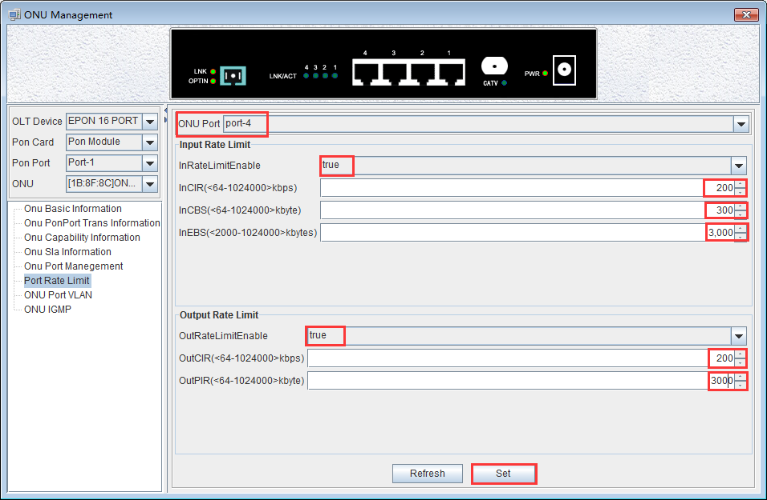

ONU Port VLAN Configuration
Double click the ONU which you want to manage on the left of the main page, enter the ONU management page, click on ‘ONU Port VLAN ’.
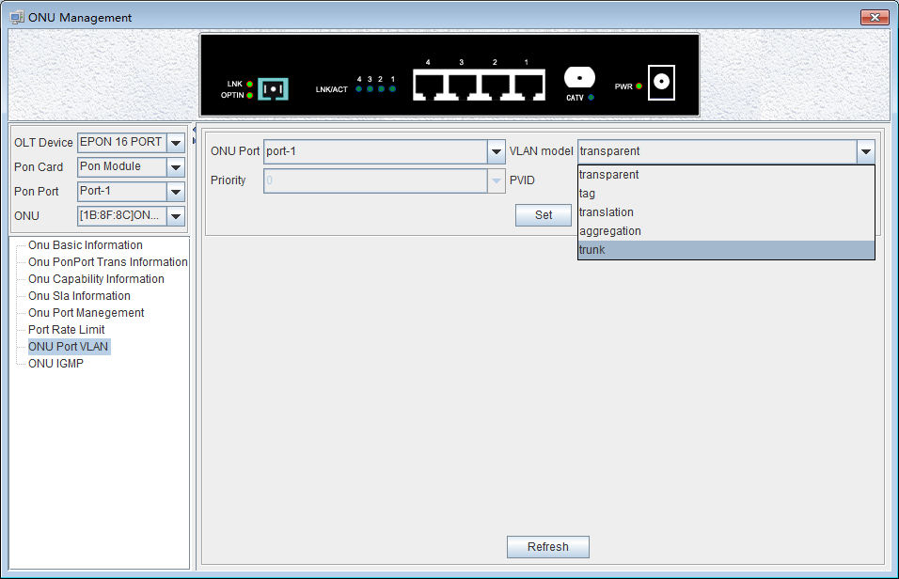
In this page, you can view and configure the selected ports VLAN mode, priority, port, VLAN, ID and so on.
ONU supports five port VLAN modes: Transparent mode, Tag mode, Translate mode, Aggregation mode, Trunk mode. These five modes are introduced as follows.
Transparent mode
ONU equipment for processing the received uplink Ethernet frame mode is not any treatment of the Ethernet frame (regardless of whether the Ethernet frame with VLAN Tag) transparent to the Ethernet frame forwarding; for downstream is transparent forwarding mode.
Direction | With VLAN Tag | Operation
Upstream | YES | Make no changes to Ethernet packets (keep the original VLAN Tag), forward.
Upstream | NO | Make no changes to Ethernet packets, forward.
Downstream | YES | Make no changes to Ethernet packets (keep the original VLAN Tag), forward.
Downstream | NO | Make no changes to Ethernet packets , forward.
Tag mode
The ONU device processes the received uplink Ethernet frame by adding a VLAN tag to it; for the downstream Ethernet frame, stripping its VLAN tag.
Direction | With VLAN Tag | Operation
Upstream | YES | Discard this packet.
Upstream | NO | Add default VLAN Tag to this packet and forward.
Downstream | YES | If the VID is not equal to the port default VLAN ID, discard this packet. Otherwise strip the VLAN Tag of this packet and forward.
Downstream | NO | Discard this packet.
Translate mode
The ONU device translates the user-tagged VLAN tag (the VID may not be its own, and may have the same VID among other users in the same system) to the unique VLAN tag. Downstream to perform the opposite operation.
Direction | With VLAN Tag | Operation
Upstream | YES | If the VID of a packet equal to the CVLAN ID of a certain translation entry, overwrite the packet VID with this entry’s SVLAN ID and forward this packet’s; If the VID of a packet is not equal to any translation entry’s CVLAN ID,discard this packet.
Upstream | NO | Add default VLAN Tag to this packet and forward this packet.
Downstream | YES | If the VID of a packet equal to the SVLAN ID of a certain translation entry, overwrite the packet’s VID with this entry’s CVLAN ID and forward this packet;If the VID of a packet is not equal to any translation entry’s SVLAN ID.  discard this packet.
Downstream | NO | Discard this packet.
Aggregation mode
The ONU device aggregated the upstream multiple VLAN into the only network side VLAN ID, and mapped the upstream traffic (VLAN Y) to the corresponding multiple VLAN.
Direction | With VLAN Tag | Operation
Upstream | YES | If the VID of a packet equal to a ‘ aggregated VLAN ’ of the port of VLAN polymerization table , overwrite the packet’s VID with ‘VLAN to VID be aggr.’,recorded the source MAC address of the service flow and forward this packet; If the VID of a packet not equal to a ‘ aggregated VLAN ’ of the port of VLAN polymerization table,discard this packet.  The only requirement for VID conversion equipment and other fields (such as TPID, CFI and Pri) conversion temporarily, the equipment should be converted to the default TPID (TPID=0x8100), Pri keep original value.
Upstream | NO | Add default VLAN Tag to this packet and forward this packet.
Downstream | YES | If the VID of a packet equal to a ‘VLAN to VID be aggr.’ of the port of VLAN polymerization table , according to the MAC address or Cos to the converted VID to corresponding ‘ aggregated VLAN ’ and forward this packet; if VID is the default VID, stripping the Tag and forward; if the VLAN ID is not equal to ‘VLAN to be aggr.’ or default VLAN ID, discard this packet.  Currently, only VID conversion is required for the device, and conversions to other fields (such as TPID, CFI, and Pri) are not required. The equipment should set transformed TPID of the VLAN Tag to the default value (TPID=0x8100), Pri maintains the original value.
Downstream | NO | Discard this packet.
Trunk mode
The port VLAN configure to Trunk mode allows the port to pass through multiple VLAN at the same time, and is generally used for connections between network devices. The packet handling mode of the port in Trunk mode is shown in the following table.
Direction | With VLAN Tag | Operation
Upstream | YES | If the packet’s VID exist in the VLAN Trunk allow list or equal to the port default VLAN ID, forward this packet, otherwise discard this packet.
Upstream | NO | Add default VLAN Tag to this packet and forward this packet.
Downstream | YES | If the packet’s VID equal to the port default VID, strip the VLAN Tag of this packet and forward this packet.  If the packet’s VID not equal to the port default VID but exist in the VLAN Trunk allow list, forward this packet.If the packet’s VID not equal to the port default VID and not exist in the VLAN Trunk allow list, discard this packet.
Downstream | NO | Discard this packet.

【Example of ONU transparent mode VLAN configuration】
Example: Set the VLAN mode of the ONU port 1 to transparent mode.
In the drop-down menu on the right side of the VLAN mode, select transparent and click the 'Set' button to complete the setup.
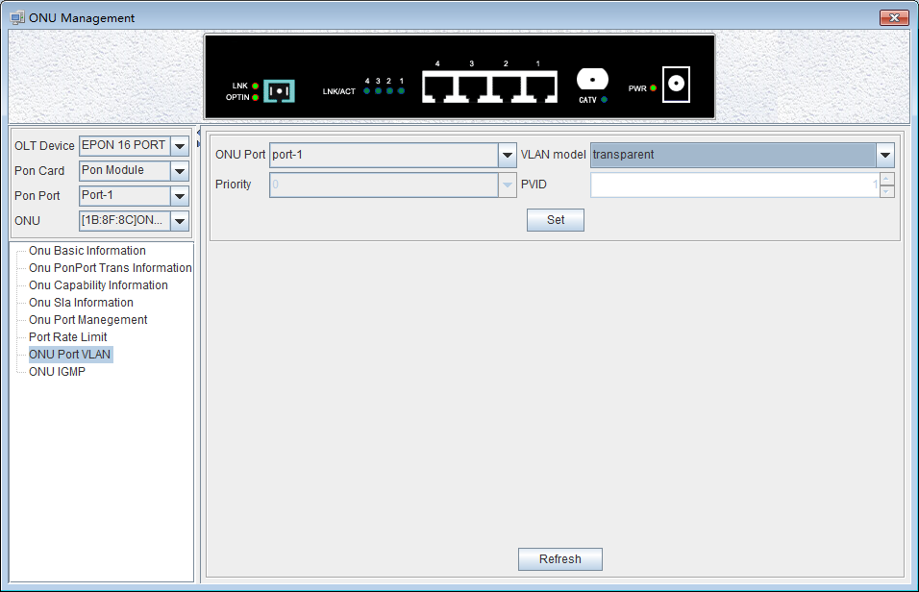
【Example of ONU tag mode VLAN configuration】
Example: Set the VLAN mode of the ONU port 1 to tag mode, pvid to 100.
In the drop-down menu on the right side of the VLAN mode, select tag and click the 'Set' button to complete the setup.
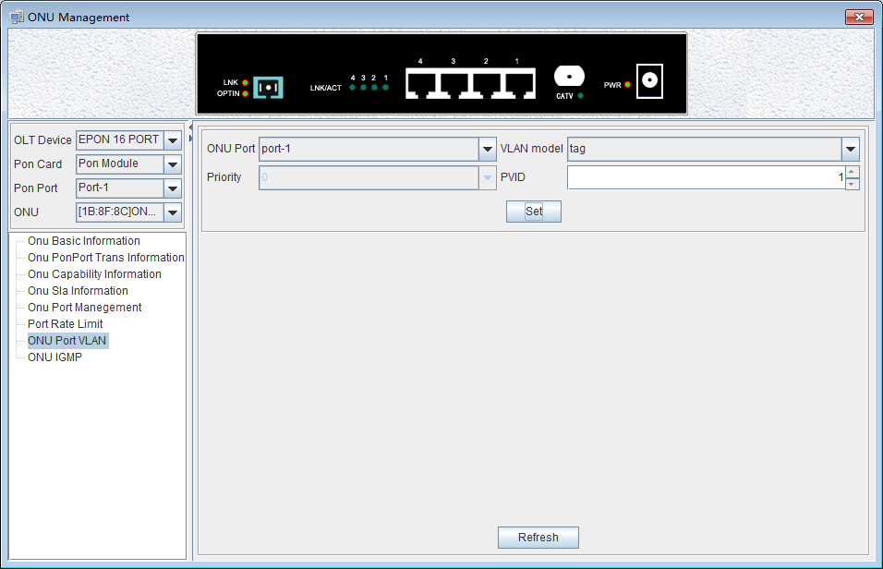
【Example of ONU translation mode VLAN configuration】
Example: Set the VLAN mode of the ONU port 1 to the translation mode, PVID to 100, CVLAN to 400, and SVLAN to 500. Proceed as follows:
In the drop-down menu on the right side of VLAN mode, select translation, click the 'Set’ button, set the PVID to 100, and then the port VLAN conversion entry, click the 'Add' menu, in the pop-up 'Add VLAN Translation' dialog box, enter the value of CVLAN and SVLAN, and then click the 'OK' menu to complete the setup. In addition, click the 'Delete' menu to delete this setting. Click the 'Refresh' menu to update these actions.
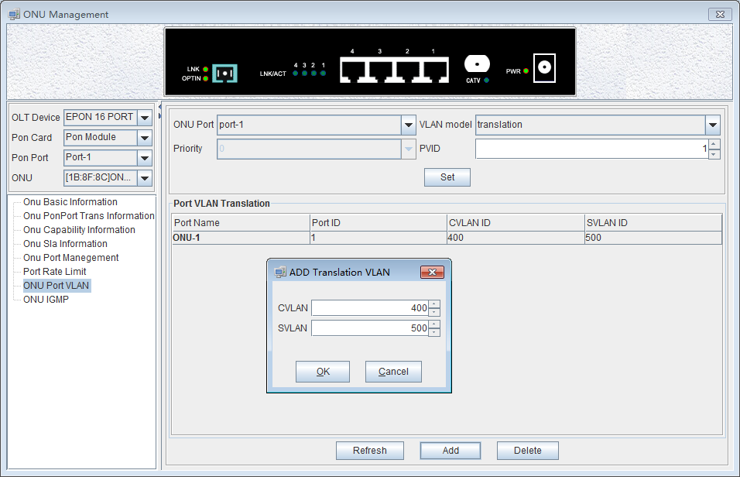
【Example of ONU aggregation mode VLAN configuration】
Example: Set the VLAN mode of the ONU port 1 to Aggregation mode, PVID to 1, CVLAN to 900, and SVLAN to 901-905.
Select Aggregation from the drop-down menu on the right side of the VLAN mode, click 'Set', then the contents of the port VLAN aggregation management entry, click the 'Add' menu, and in the pop-up 'Add Aggregate VLAN' dialog box, you can select the mode of 'Multiple VLAN' and 'Single VLAN'. The input mode of 'Single VLAN' is similar to the translation mode, here to select the input of 'Multiple VLAN' Mode, for example, enter the aggregate VLAN ID , the starting VLAN and terminate the VLAN value, then click on the 'OK' menu to complete the settings. In addition,click the 'Delete' menu to delete the entry for this setting . Click the 'Refresh' menu to update these actions.
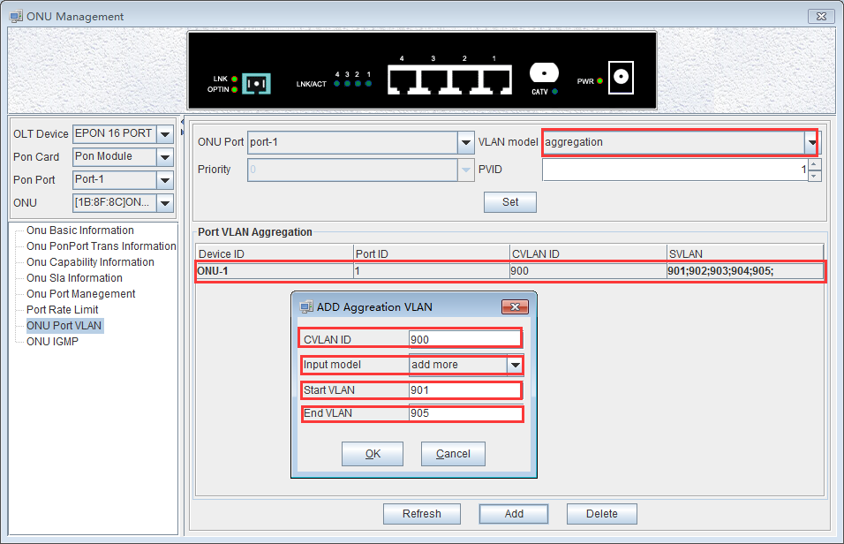
【Example of ONU trunk mode VLAN configuration】
Example: Set the VLAN mode of the ONU port 1 to trunk mode, PVID to 1, and trunk VLAN to 7-8.
Select trunk from the drop-down menu on the right side of the VLAN mode, click the 'Set' button, and then the contents of port VLAN Trunk entry. Click 'Add' menu. In the ‘Add VLAN Trunk’ dialog box, enter the value of the VLAN ID , Then click the 'OK' menu to complete the setup. In addition, click the 'Delete' menu to delete this setting. Click the 'Refresh' menu to update these actions.
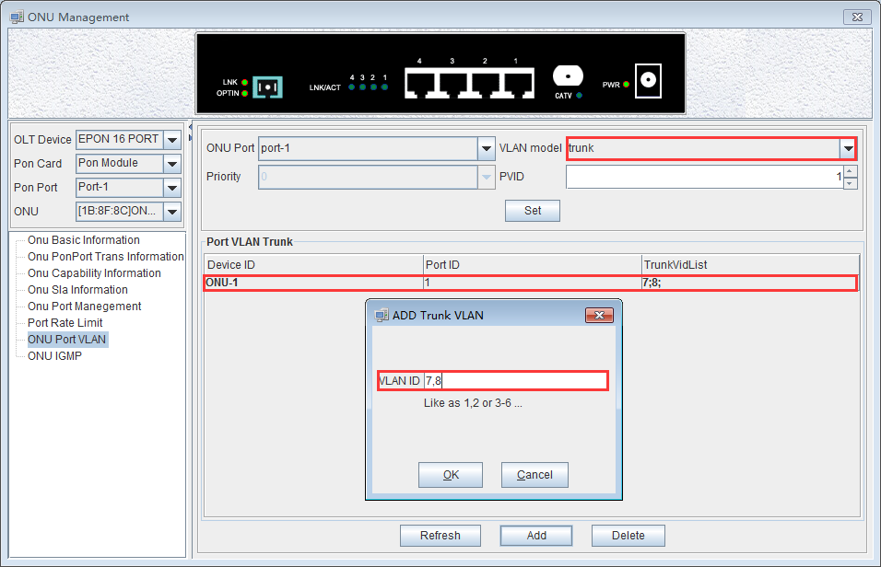

ONU IGMP
Double click the ONU which you want to manage on the left of the main page, enter the ONU management page, click on ‘ONU IGMP’.
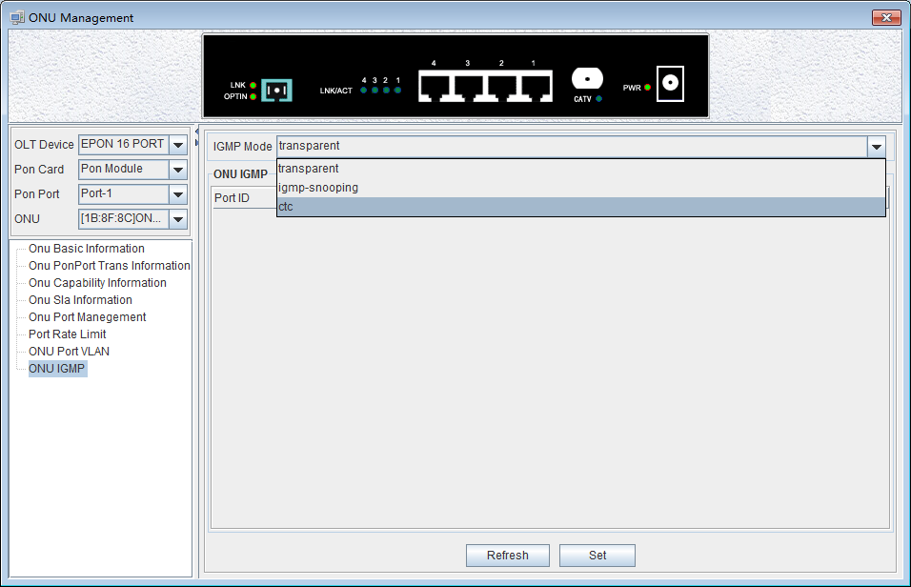
Set the IGMP working mode, there are transparent, IGMP-snooping and ctc , here is IGMP-snooping mode of operation by default.
IGMP snooping is used to listen to IGMP messages between hosts and routers. The primary function is to receive IGMP messages, send member queries to the host, send proxy report messages to multicast routers ,manage, create and delete a multicast group , restricts the spread of multicast data on the second floor of the switch and enables filtering of unknown multicast data. The following is a detailed description of three modes.
Transparent mode：
ONU does not do any processing of multicast messages and broadcasts multicast messages to all ports of ONU in a broadcast manner.
IGMP-snooping mode:
You can set the multicast VLAN for each user port, the maximum number of multicast groups supported and the multicast VLAN tag processing mode of the ONU.
Multicast VLAN tag processing mode refers to the processing of VLAN tags when multicast packets are output from the user port：
- NoStrip：Multicast messages are not stripped VLAN tag when they are output from the ONU user port.
- Strip：Multicast messages are stripped VLAN tag when they are output from the ONU user port.
The IGMP snooping function of the ONU is based on VLAN. Therefore, you need to add the ONU user port to the corresponding multicast VLAN and add the same VALN to the VLAN configuration of the ONU port. When IGMP snooping is disabled, all multicast packets are broadcast to the ONU user port.
CTC mode：
Multicast messages are broadcast to all ports of ONU, and unlike the transparent mode, multicast VLAN tag packets can be processed and selected whether to strip the VLAN tag.
【Example of ONU IGMP configuration】
Example: Configure the IGMP working mode of the ONU to IGMP-snooping mode. The multicast VLAN of port 1 to 1 and 8, and multicast messages are stripped of the VLAN tag when they are exported from the port 1 .
Select IGMP-snooping from the drop-down menu on the right side of the IGMP operation mode, click on the lower side of the 'Set' button, select strip under stripping / non-stripping, click on the lower side of the 'Set' button, then click the 'Add' button, In the pop-up dialog box, select port1, enter '1,8' in MVLAN, and finally click on the 'OK' to complete the set.
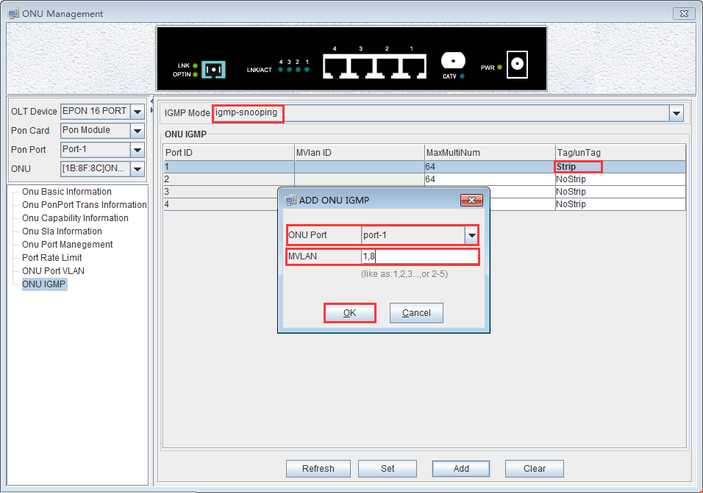

Operation Logs Management
It’s convenient for administrator to view historic records of EMS operation. EMS provides operation logs query function. Open ‘Operation Logs’ window of ‘Alarm’ menu to view historic operation records. The typical interface is shown below:

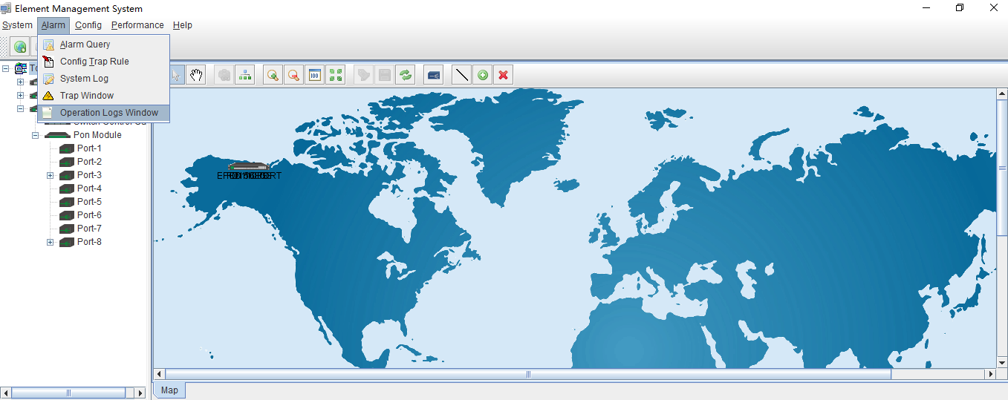

The following ‘Operation Logs ’ window shows :
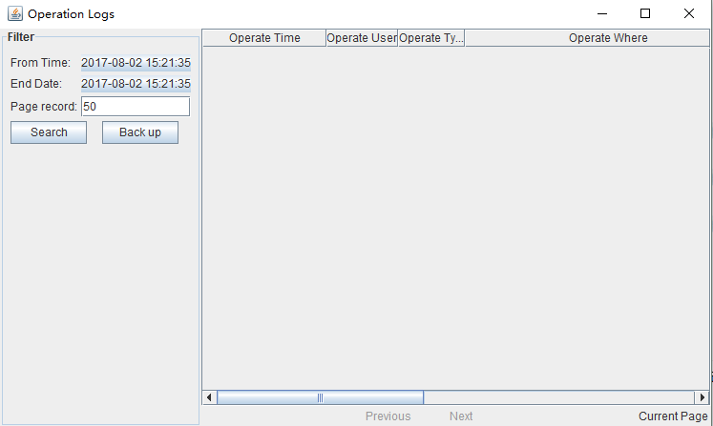

As pictured above, inquiring operation logs according to operation period and operation users, the result of query can be saved as a single file.
【Example of operation logs】
Example：Inquire and save admin user’s operation event from June 2,2017 20:40:40 to August 2,2017 20:40:40.
Step 1：
Choose specified time from left drop-down menu of From Time and End Date. User name chooses ‘Admin’ . page record chooses ‘50’ , then click ‘Search’ button, displaying log events in the right, and click ‘Back up’ .
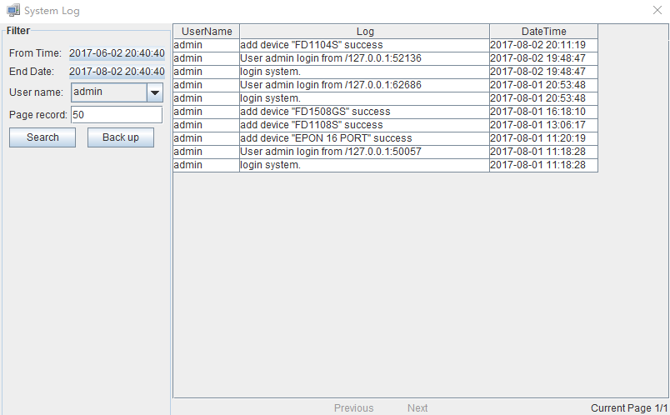

Step 2：
Choose specified dictionary to make a backup of admin user’s operation logs.

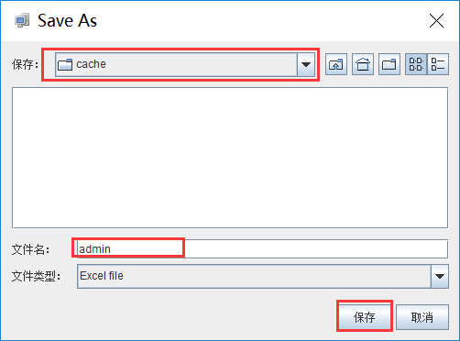

Alarm Logs Management
It’s convenient for administrator to search alarm record of EMS operation. EMS provides alarm filter ,backup and query function.
As shown below, open ‘Alarm Query’ window of ‘Alarm’ menu to search alarm information. You can set alarm filter conditions in the left page, including alarm time, alarm status, alarm severity, alarm element, alarm page record count and alarm type. Clicking ‘Filter’ menu can view alarm information meeting filter conditions in the right. Clicking ‘Save As’ menu can save query information to chosen dictionary.
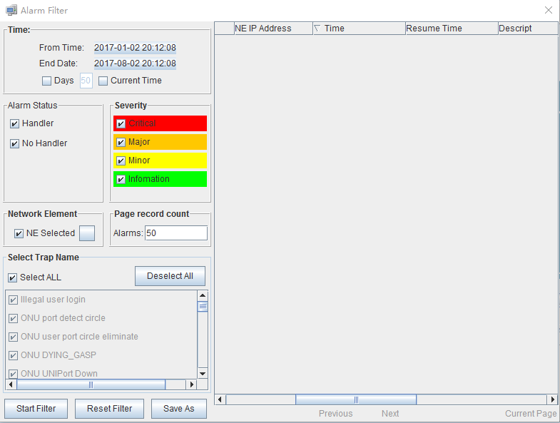
As shown below, open ‘Config Trap Rule’ window of ‘Alarm’ menu to configure alarm rule. Choose device type in the left. On the right is corresponding alarm rule information. Firstly ,You can choose ‘Yes’ or ‘No’ of filter menu to modify alarm rules. Secondly, click ‘Apply’ menu. Finally, choose ‘Yes’ button from the pop-up menu. Clicking ‘Refresh’ button can update alarm rule information. Clicking ‘Close’ button can close current page.
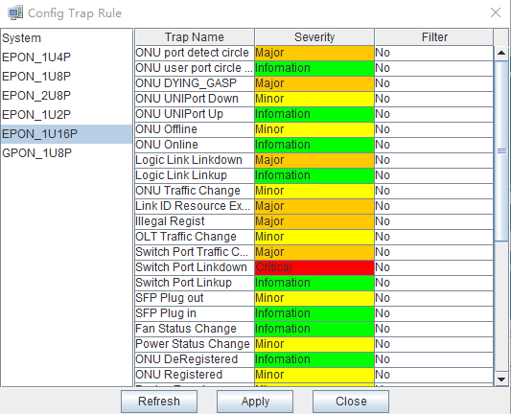

As shown below, open ‘Trap Window’ of ‘Alarm’ menu to inquire all alarm information. You can set alarm From Time, End time and Page record. Clicking ‘Search’ button can view alarm information on the right. Clicking ‘Backup’ button can save alarm information to chosen dictionary.
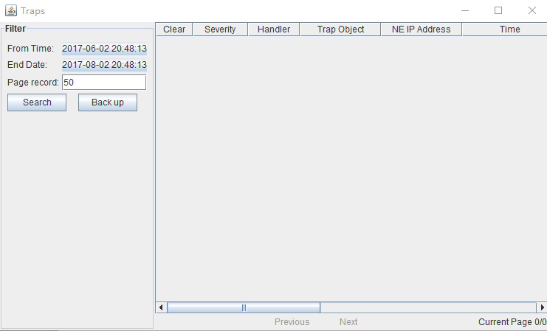

Database Backup And Restore
EMS database management function includes database backup , database restore, ONU name backup, ONU name restore .
EMS configuration information, such as added device node, device port id name, user name and so on, is saved in EMS database file. In order to configurations not to be lost when system is abnormal, users can backup database regular intervals. Users have access to past configuration information via restoring database in case of software upgrade, operation system installation, system error or management server change.
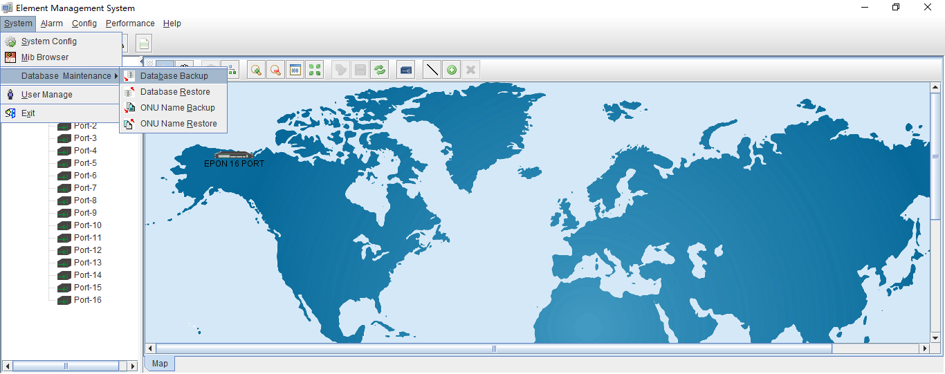

Choose ‘Database Backup/Restore’ bar of ‘System’ menu to execute database backup and restore operation. Database backup by fault database filename, as shown below:

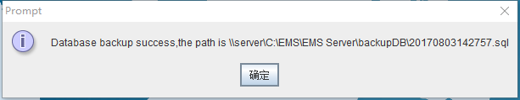

Backup database file type is ‘ .sql’ file. Filename by system auto-generated, and file is saved fault database document folder. After database backup, users can copy those database files to other location.
Open ‘Database Restore’ window when database restore, as shown below:
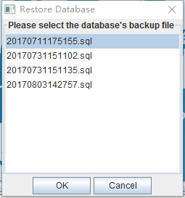
This window lists all database files by user backup before, choose a database file to execute database restore operation. If user’s backup database is not in fault location, user need to copy the file to EMS fault saving path, then restore database file. EMS fault database saving path is ‘..\EMS\EMS Server\backup DB’ dictionary.
ONU name backup and restore method is the same as database backup and restore method.

User Management
EMS support multi-user operation and set different operation rights for different users, thus improving system operation security. By user management operation, administrator can add, delete and modify existing user information.
Open ‘User Manager’ window of ‘System’ menu to execute user information management. As shown below:
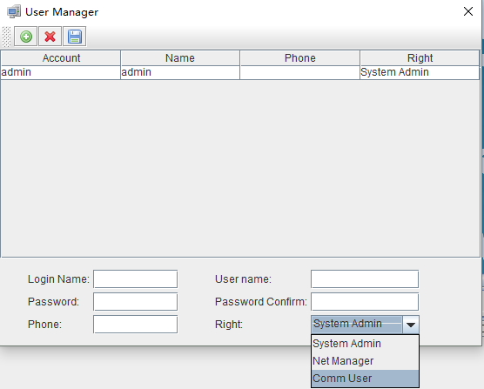

As shown above, the following is user management operations:
Add user
Input login name , user name and password into text-box at the bottom of window, and choose operation right, then click ‘Add User’ button, thus account set up successfully. Click ‘Save’ button to save updated user information.

Delete user
Choose a user account which needs to delete from current user lists, click ‘Delete User’ button to delete the user.

Modify user information
Choose a user account which needs to modify from current user lists, and can view current the user’s information at the bottom of window. After modifying user information, clicking ‘Save User’ button to save changed user information.

User account privilege
EMS Support ‘System Admin’ , ‘Net Manager’ and ‘Comm User’ three user rights. ‘System Admin’ level is the highest privilege, has all the operation rights of EMS software. ‘Net Manager’ level has all of operation rights, expect of user account management function. ‘Comm User’ is the lowest privilege, the users with this privilege only can view management information and have not the rights to do any set operations.

Device Upgrade
EMS software support device firmware on-line upgrade. The main procedure for device upgrade has two step. First, download firmware files to target device via FTP server to be upgraded. The target device will go through the whole firmware upgrade process according to upgrade commands received from EMS.
Device upgrade steps are introduced as follows：
- FTP Server configure
First open FTP server, then configure file path and IP address. IP address and OLT mgmt port’s IP address should in the same network segment.
As shown below：
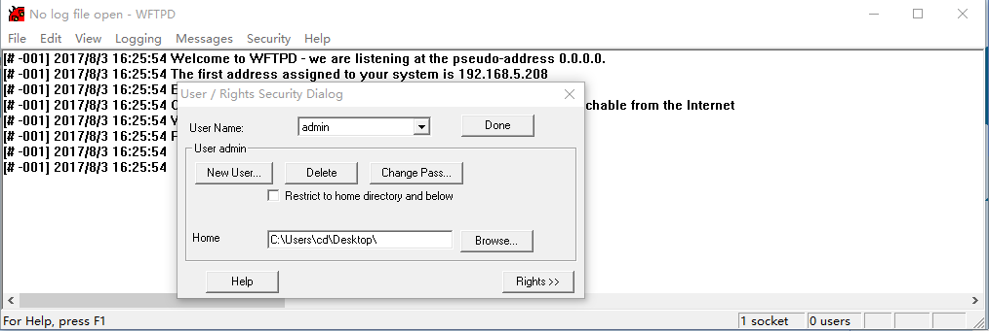

- Copy upgrade file to root dictionary of FTP Server
- Parameter configure
- Choose ‘Configure’ -> ‘Device Upgrade’ from main interface, as shown below：
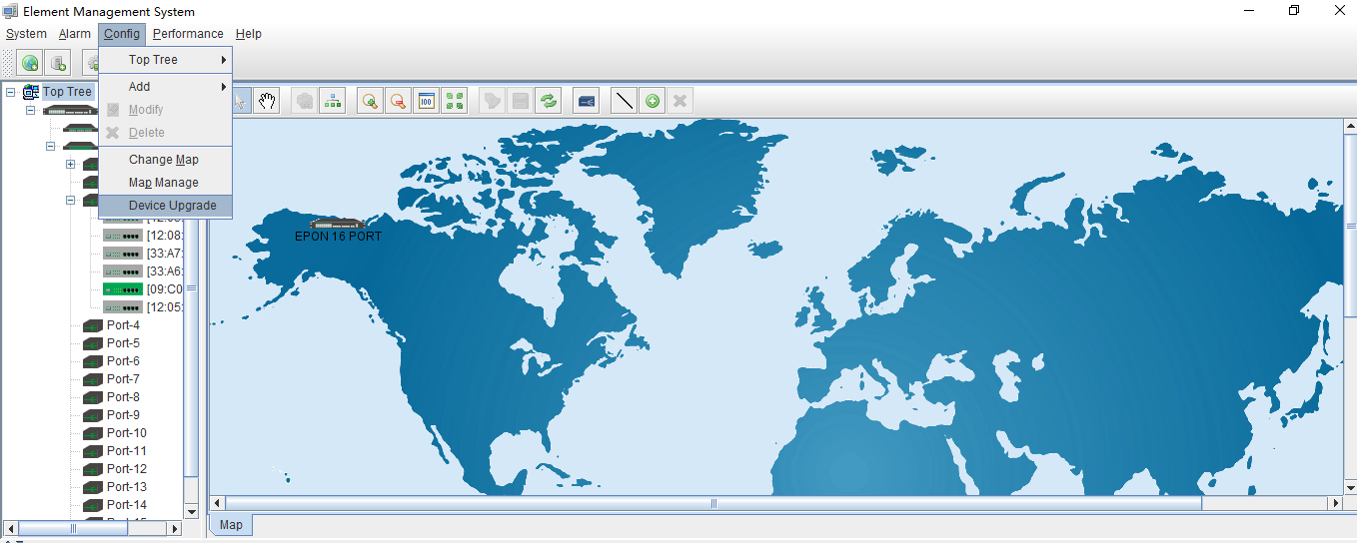
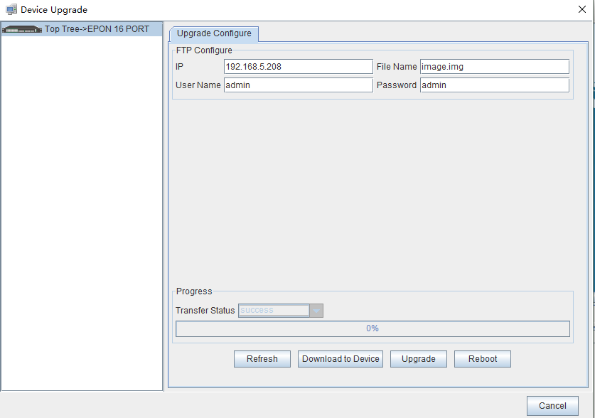Figure 1: Device upgrade

- Input FTP Server’s IP address and upgrade filename in the interface.
- Input FTP Server’s user name and password.
- Click ‘Download Device’ button , ‘Upgrade’ button and ‘Reboot’ button in turn, completing OLT’s upgrade.

Device Search Function
EMS support device search function. When there are more OLT and ONU devices connected EMS, we can find a device from a number of devices via EMS ’s search function.
The specific operation method is as follows:
Right-click ‘Top Tree’ of EMS main page , and click ‘Search’ , then input device name in ‘Key Word’ of pop-up ‘Search Box’.
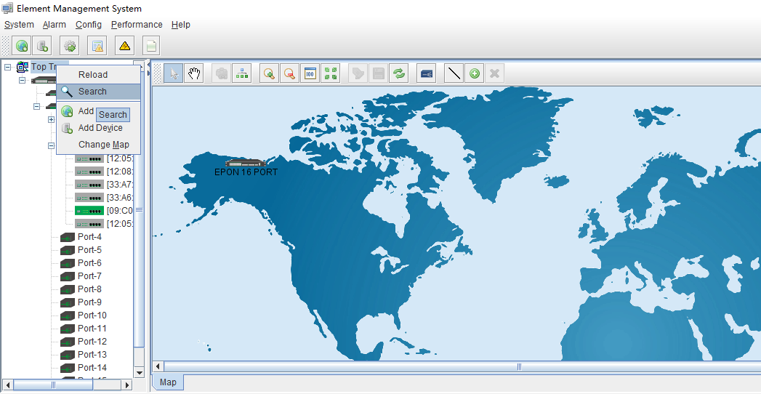
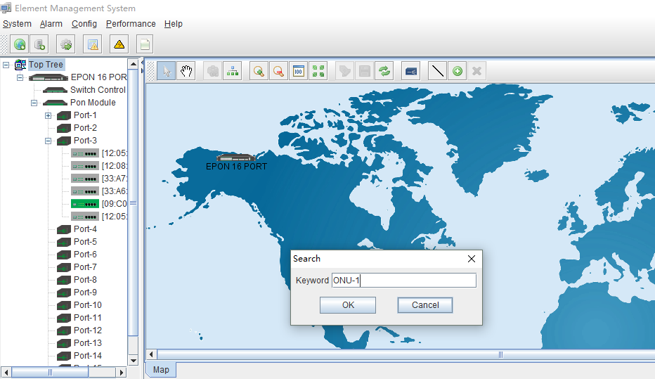

End
Thanks for choosing the products designed by C-DATA Technology !
Contact：
Company Address：Room 601, Floor 6, Building F, Songbai Road 1008, Sunshine Community，Xili Street, Nanshan District, Shenzhen(518108)
Factory Address：Fl1, Bldg B, Wentao Industrial zone,Yingrenshiyongxin Village, Shiyan Street, Baoan district, Shenzhen, Guangdong, China (518055)
Tel：0755-26014509/26014710/26014711
Mail：0755-26014506
Website：www.cdatatec.com
www.cdatatec.com.cn

